**Part 1**

**============**

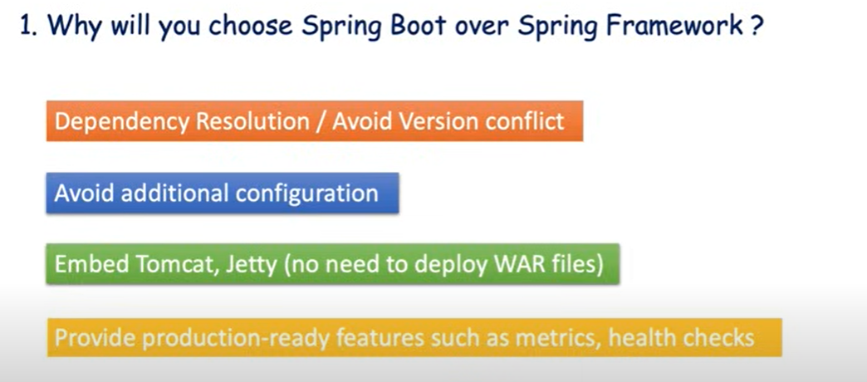

**Explanation**

* Before spring boot when i want to design some crud application let's say i want to use the spring and hibernate then i need to manually add the dependency right i need to add the **spring core**, **spring context**, **spring mvc** and **spring hibernate, spring transaction**, **mysql-connector**, **servlet-api** and lot of dependency i need to add it manually.
* also, if you will observe I have specified the dependency version manually. so again, there is another challenge to get the version conflict. I want to either downgrade or upgrade. So, there may be a chance to not support the backward compatibility because we have specified the dependency manually that is another challenge in spring framework and the biggest challenges, I feel that you need to remember what all dependency you need to add while creating a project.
* if I will go to the pom.xml so just observe carefully what all dependency I have added. Spring boot starter data JPA, spring boot starter web then which driver I want to use that is mysql connector.
* So, if you observe in the old project using the spring, we have added minimum 10 dependency right and that too we have specified the version manually but in case of spring boot these two dependencies is enough to handle the spring MVC crud application and also we have not specified the dependency version. How then dependency will be managed here based on the parent version. So if you will specify that ok this particular parent version of spring boot starter I want to use then internally spring boot will be bring all the corresponding or transitive dependency for these two particular key dependency.
* if you are using spring boot then you can avoid additional configuration to perform any task. if you observe in the web app, I have three XML configuration application-context.xml. I need to create the **data source object** by defining all the required properties of data source then I need to create the **session factory** and **transaction object**. inside the web-INF I have the web.xml to kicked up my **dispatcher servlet** manually.
* we are defining the base-packages to scan and load all the defined bean in application-context.
* In spring boot go to the **application. properties** go to the **application.yml** file. Here is my configuration in spring boot. I no need to care about creating the data source transaction manager session factory manually everything will be handled by spring boot itself.

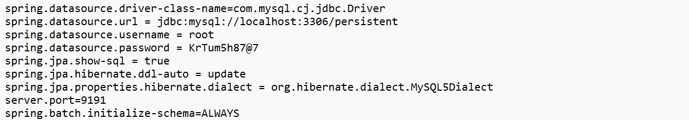

Let's move to the next bullet point that is embedded Tomcat Jetty is given by spring boot to quickly deploy your jar or war file to the perform quick testing in spring boot. Now if you are running any application in the spring framework then manually you need to build a jar or war file. Then you need to. Host it to your external Tomcat server to just verify your features or to just access the application functionality. spring boot by default will give you an internal embedded Tomcat server which will quickly picked up your jar and will kickstart your application.

* so, it must take two to three second for me to get the jar from the target folder and load it into the application context and kicked up the embedded server for me.
* let's go to the fourth bullet point that provide production ready features such as matrix health and check. I spring boot we are having an actuator using that actuator you can easily monitor your application in each and every environment. so, if you add that dependency, you will get couple of endpoints like /beans, /health, /matrix. You need to rely on couple of dashboard to monitor your application or to monitor your health of your application in each and every environment.

====================================================

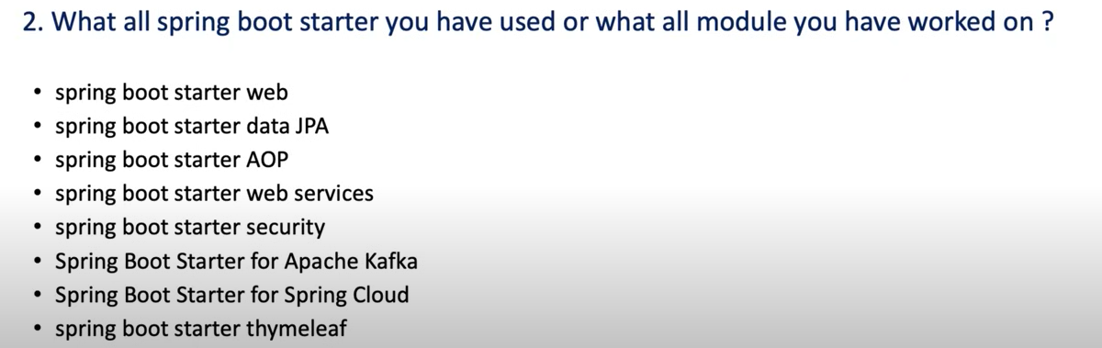

====================================================================

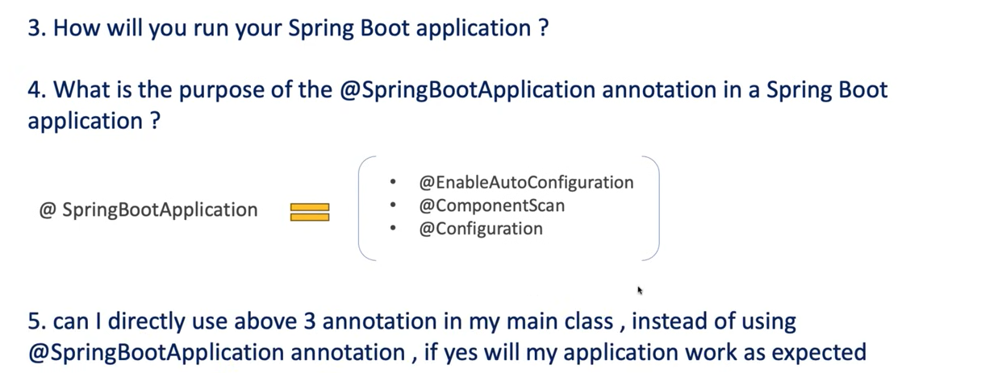

**Explanation**

Now let's move to the next question that is how you will run your spring boot application. So, this question looks very simple but there are something you need to know. interviewer don't want to know how you are starting your application he just asked this question to know that -

* how internally it loads your jar or from where it will load your jar those things he just wanted to know. just go to your main class just open that class. Spring boot application I mean it will just run from the main method. Now what is the next way if I don't want to run the application from the ID then there is a mvn plugin given by spring boot itself that you need to run. So can you see here **mvn spring-boot: run** so this **mvn spring-boot: run** is a just a plug-in as part of the maven.
* Now the interesting fact to know here how this particular command **mvn spring-boot: run** load my jar file and execute the jar or from where it will load the jar file. So, forget about any framework if it is a java application and you are using the maven build tool then by default the jar will be placed inside the target folder.
* Can I open this target folder and can you see any jar here No right. Then how come this particular command **mvn spring-boot: run** loads the jar file from where he loads the jar file. Then how it works without the jar file. So, what it does when you run this particular command **mvn spring-boot: run** it executes your application directly from the target under classes. OK so it goes to this particular folder and then it picked up your main class.
* And then it triggered the execution from this main class. It does not create a separate jar file unless you explicitly package your application using maven package or some similar command like gradle or something like that.

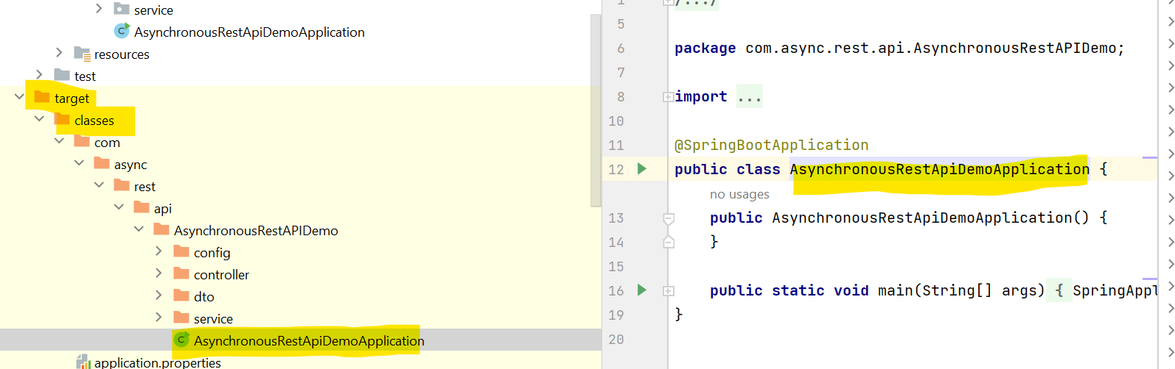

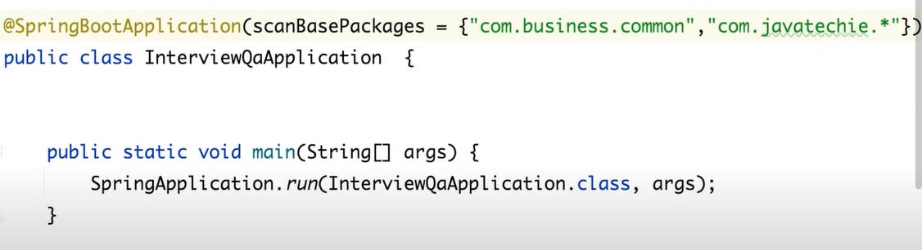

That is what is the purpose of @**SpringBootApplication** annotation in a springboot application. so first this annotation @**SpringBootApplication** is combination of these annotation @**EnableAutoConfiguration**, @**ComponentScan** and @**Configuration**.

@**EnableAutoConfiguration** now at high level just understand enable auto configuration will automatically configure various component for your application. By just scanning your dependency and class path whatever the dependency you have added in your pom.xml. this particular auto configuration will scan this dependency and will load all the required jar for you.

Now second annotation that is @**ComponentScan**. This annotation enables component scanning in the package where you have your main class and its sub packages. But if I have any class present external to this particular packages where my main class located then springboot by default will not load that particular bean or will not add that bean to the context for that what you can do you can tell to the Spring Boot go to the main class you can tell to the Spring Boot hey @**SpringBootApplication** annotation while you are executing your default component scan also include the base packages or scan the base packages

now third annotation is @**Configuration**. So, what this @**Configuration** annotation does behind the scene it allowed to register extra bin in the context or import additional configuration classes.

now let's move to the next question that is can I directly use above three annotations in my main class instead of using @**SpringbootApplication** annotation the answer is yes.

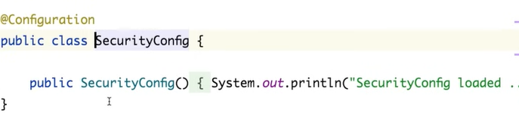

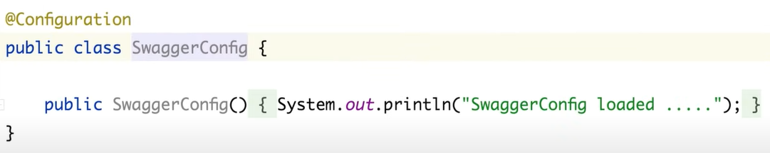

How can we use a Beans which we created externally using @Configuration and @Bean. So, the answer using **@Import.** So in @Import we just need to pass the external created bean class so spring container will automatically manage this bean.

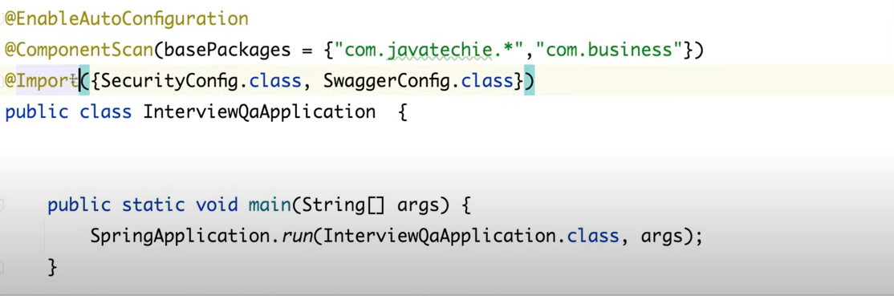

**Important**

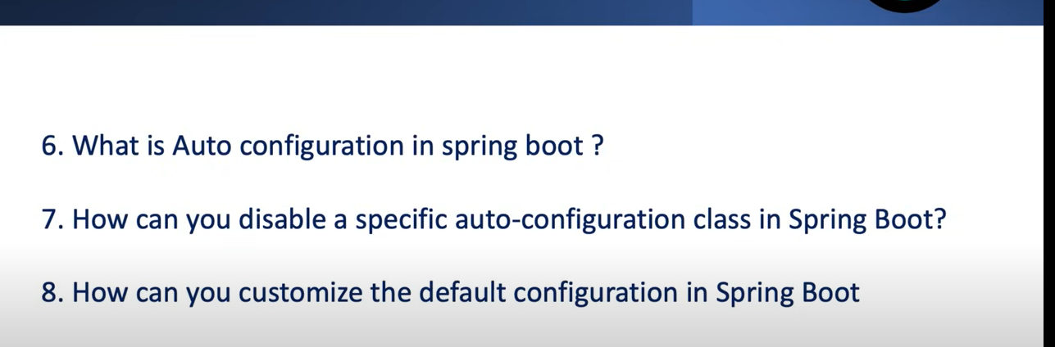

* if we do debug=true in application. properties file then we can see in log for positive matches and negative matches.
* This is really a super feature given by spring boot developer which automatically configures the application based on the class path dependency, property settings and some other conditions.
* First we'll go to the pom.xml will verify what all dependency we have added here. We have added the spring-boot-starter-web. I have added only that is spring-boot-starter-web then what all classes will be auto configured by spring boot.
* While it's starting the application, it will evaluate the condition. then it will find some positive matches, which will be enabled by default for you after scanning your dependency and classpath spring boot understand. These are the things I need to auto configure for this particular project. if you will scroll down, there is something called negative matches.These are the things I will not auto configure for you. There are two things positive matches and negative matches.
* So whatever the configuration comes under positive matches. Those will be enabled by spring boot for your application. Again that depends on with some condition. So we'll verify with the example okay. So there is something called JacksonAutoConfiguration.

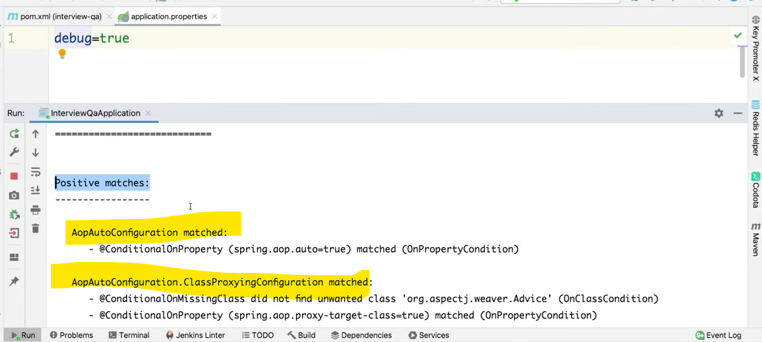

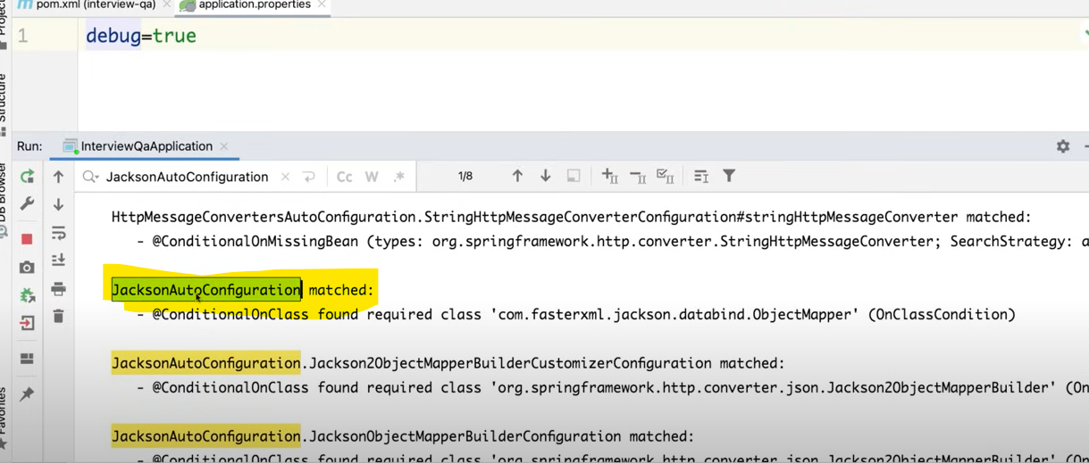

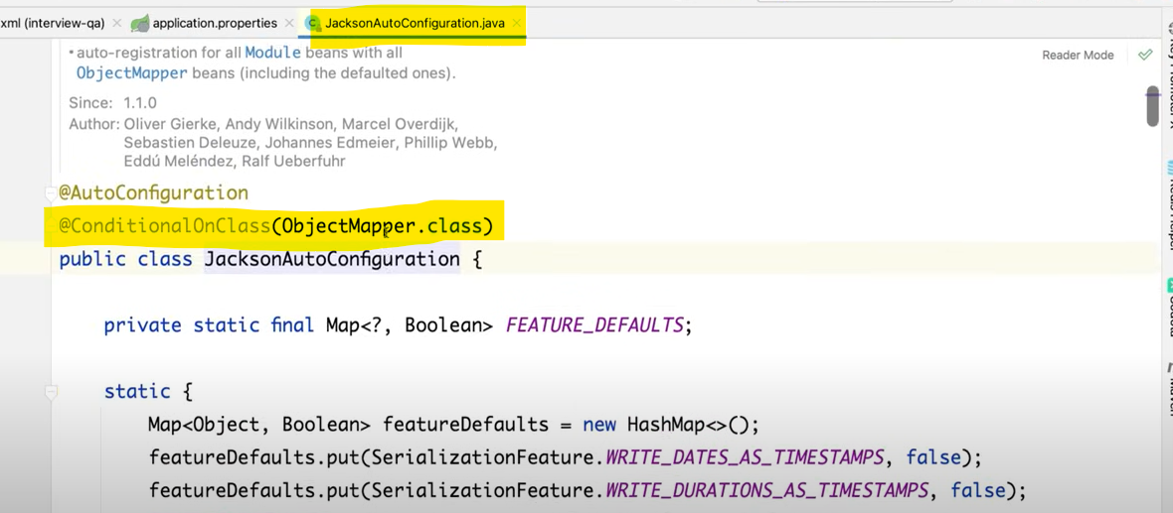

@**ConditionalOnClass** means If the **ObjectMapper** class is present in classpath then spring will configure for us.

Now let’s see for **DataSourceAutoConfiguration**.

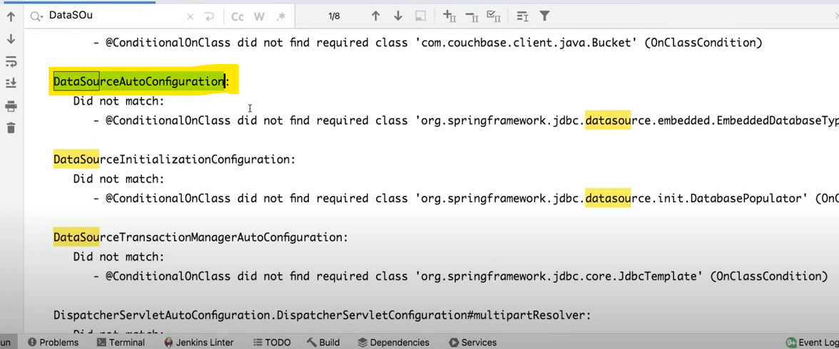

It comes under negative matches bcz 1st reason we have not added dependencies. Let’s add dependency starter-jpa and see.

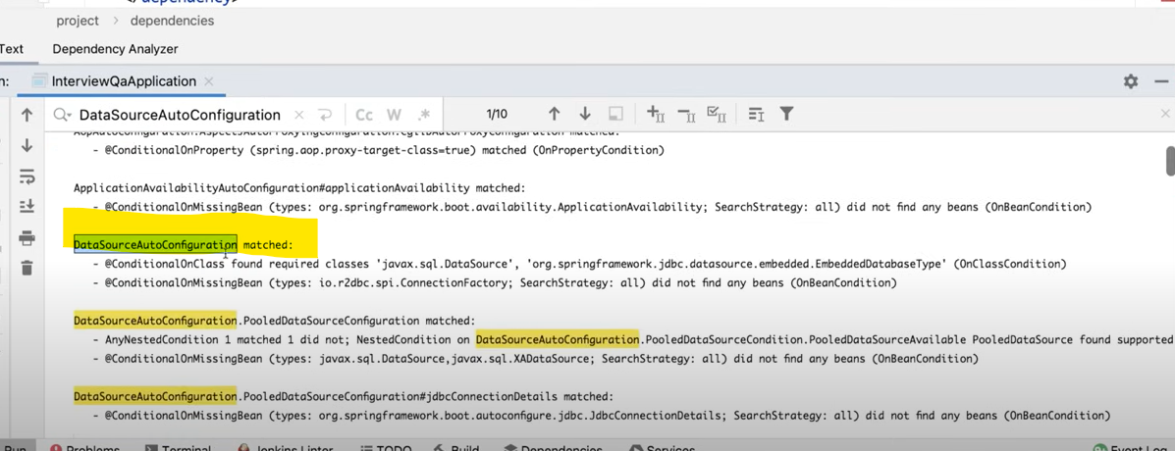

Now it come under positive matches. So, spring though we have a jpa dependencies so he need to enable that particular class for the user. But How he will decide either he need to enable that or not.

So go to this **AutoConfiguration** class and see there are so many conditions under @**Conditional** annotation whether he need to enable that class in our class path or not. So this **SpringBootAutoConfiguration** will decide whether this particular feature springboot will enable or not.

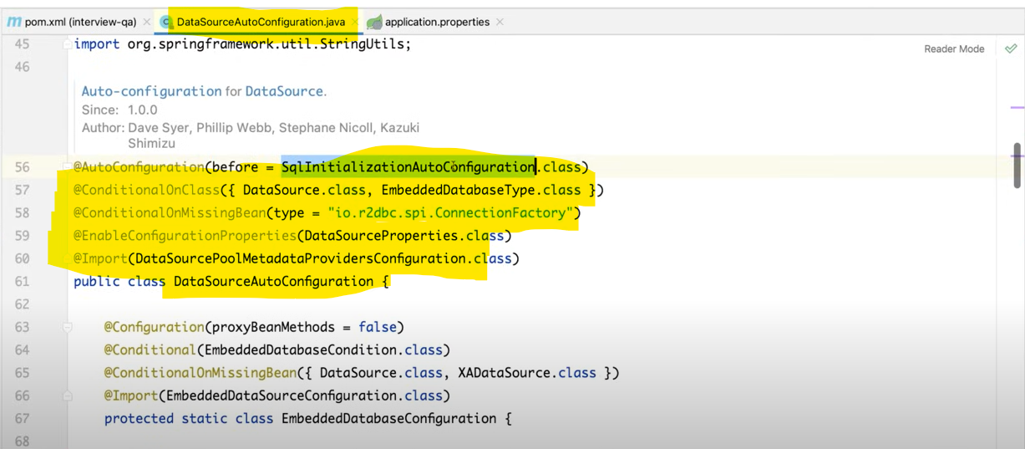

If Data Source Class is present under our classpath then enable this data source auto configuration. When this R2dbc bean is missing then do autoconfiguration for us. When datasouce properties has been configured in properties file then do autoconfiguration. When I say it will enable data source auto configuration for us means it will create data source object and it will perform all the steps to perform db operation.

*** if u want to look all the +**ve** matches and -**ve** matches for autoconfiguration then go to project folder. Just go to class path **org. springframework. boot: spring-boot-autoconfiguration.**

Go to **META-INF/spring.factories**

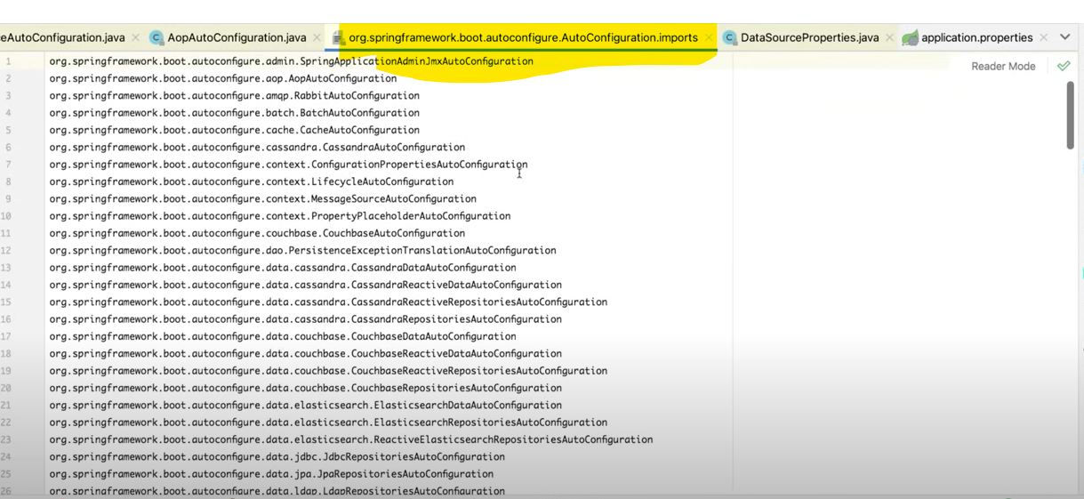

here we can find all the + and -ve matches. Just go to any auto configuration class and see how the Condition has implemented.

***********How can we disable specific autoconfiguration in spring boot. Using exclude.

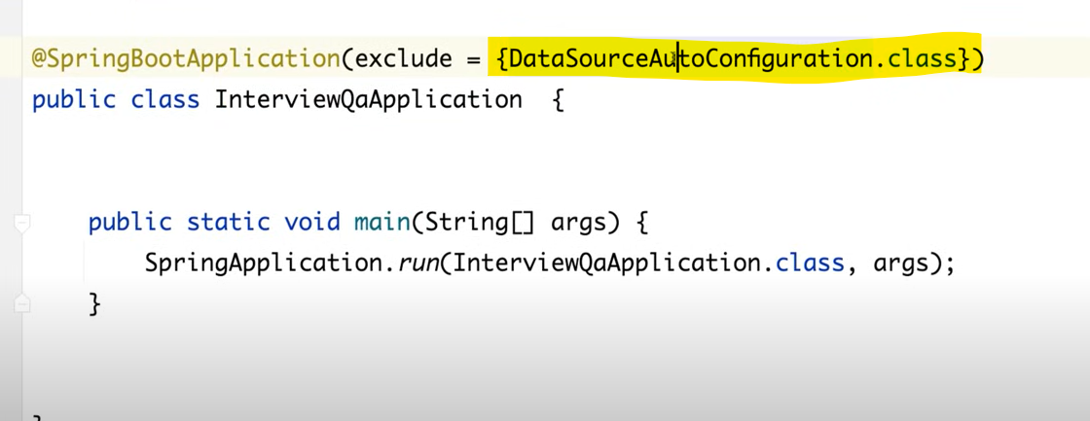

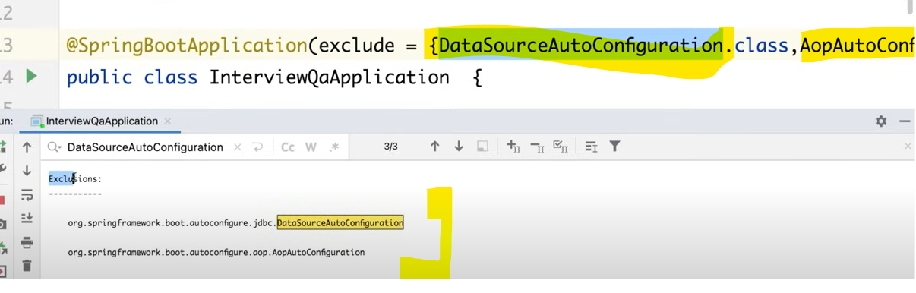

Even we can disable from properties file as well.

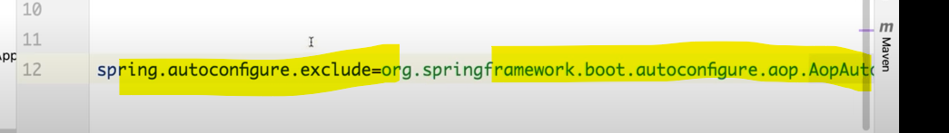

=====================================================================================

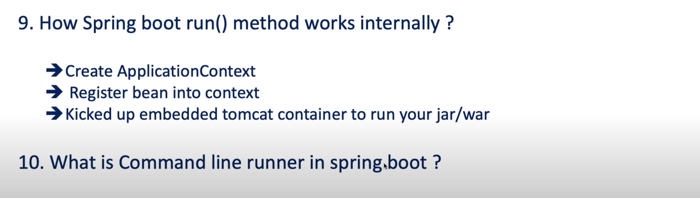

**Part 2**

**=============**

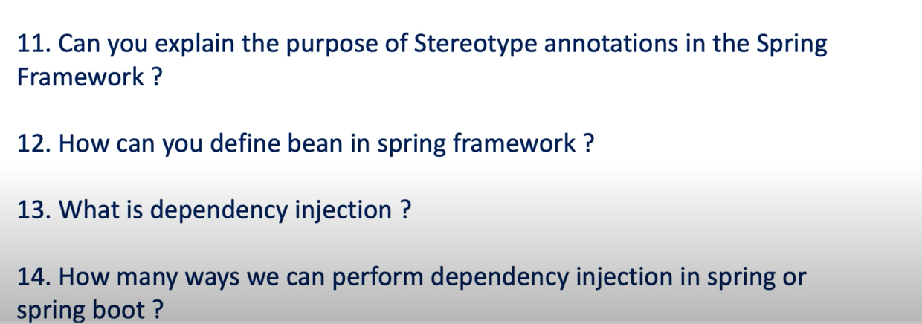

====================================================================

DI Is a Design pattern used to achieve loose coupling within application by removing a direct coupling between them.

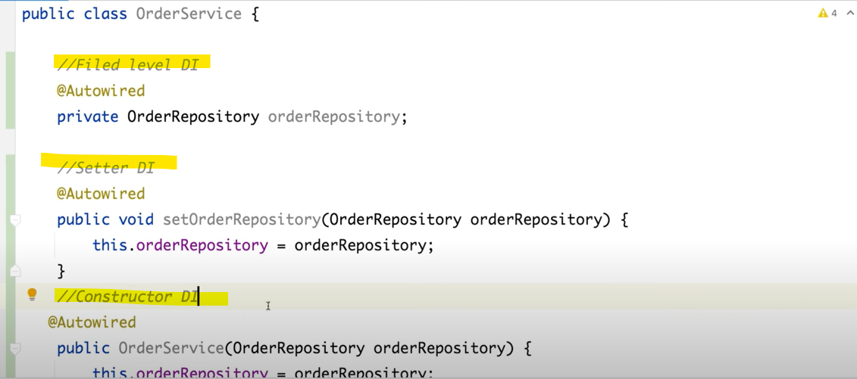

If we have only one dependency, then in constructor DI @**Autowired** not required. If we have multiple dependencies, then only req. @**Autowired**.

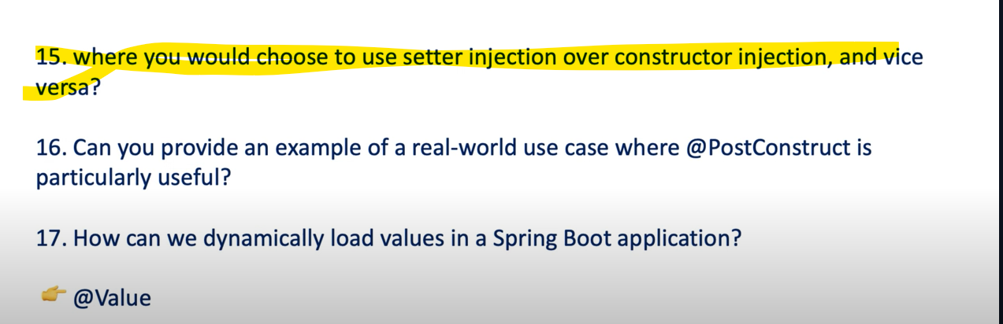

====================================================================================

**Constructor DI**-

* When you want your dependencies is mandatory for your Bean. For Order service order repository must need to be inject at runtime. Then you can go for the Constructor DI. It ensures that all required dependencies are provided at time of object creation if any mandatory bean are missing your object won’t be created and you will get an error.
* Constructor DI is **Immutable** in Nature. It won’t be modified after object creation.
* If you are using **constructor** DI, then you can’t resolve the **Circular Dependencies**.

**Setter DI**-

* If you want your dependencies is **Option** for your service or Bean, then you can go for setter injection.
* Constructor DI is not **Immutable** in Nature. It can be modified after object creation bcz it has setter method.
* If you are using setter DI then **Circular Dependencies** can be remove or resolved.

Circular DI using constructor…-

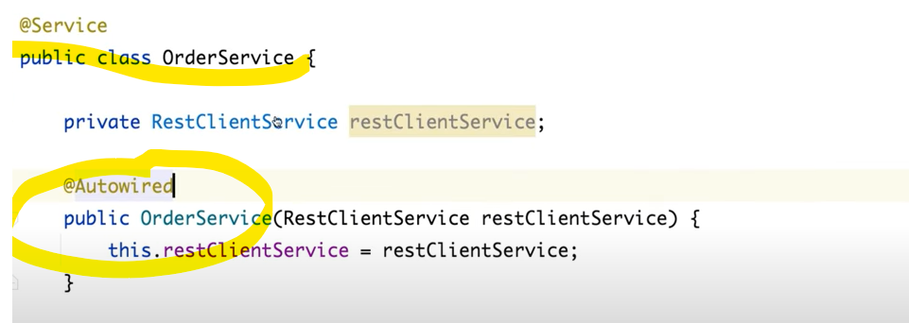

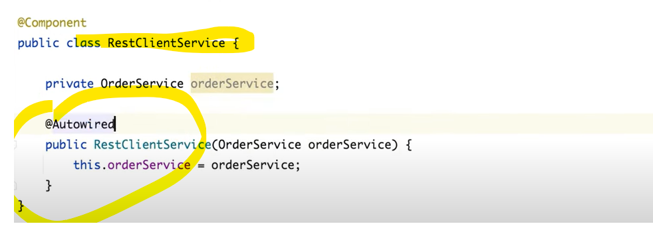

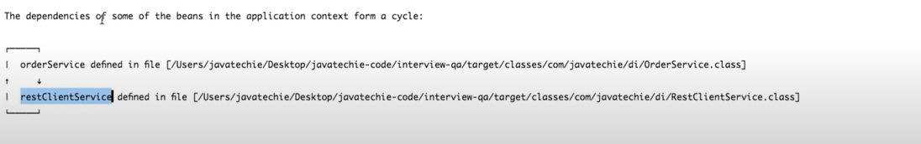

**Let’s use Setter DI to resolve Circular DP**

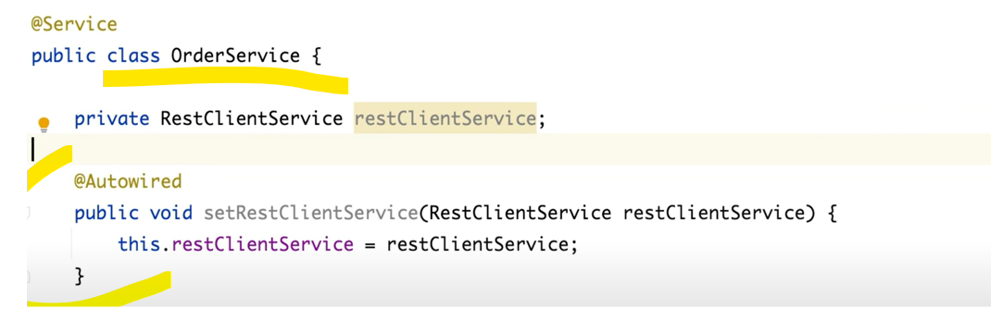

But if I will run still there may be a chance to get **Circular Dependency**. But since we are using the setter injection, I will also tell to spring hey until and unless I will not create the object don’t initiate it. So, for that we will use @**Lazy** on both the places.

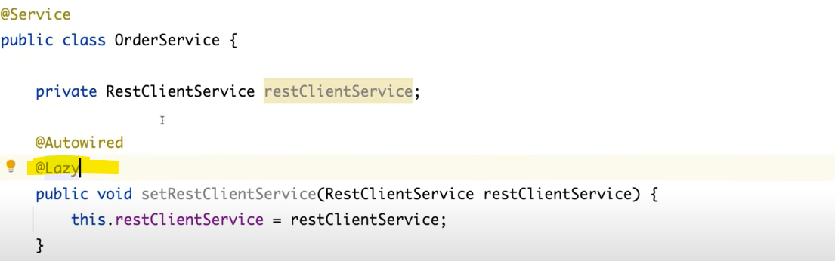

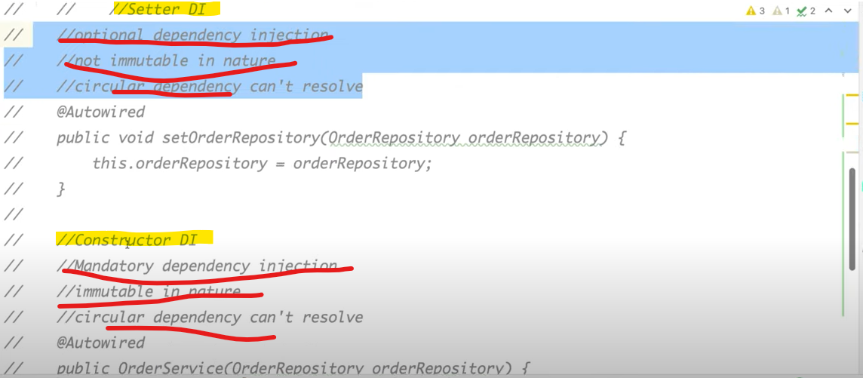

So as per your business need and how or in which way u want to inject your bean in your code u can choose accordingly.

@**PostConstruct** and **CommandLineRunner** both will be use which we are doing pre-processing logic. Like DB connection, **Kafka** configuration before communication, db connection pooling.

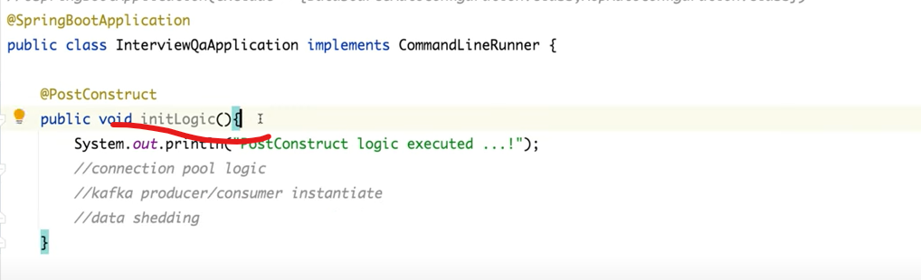

* We can load the value from properties dynamically using **@Value.**
* Even we can do using **Environment object** variable then u can use **getProperty** () with properties value key.

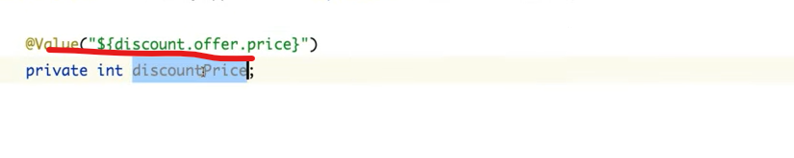

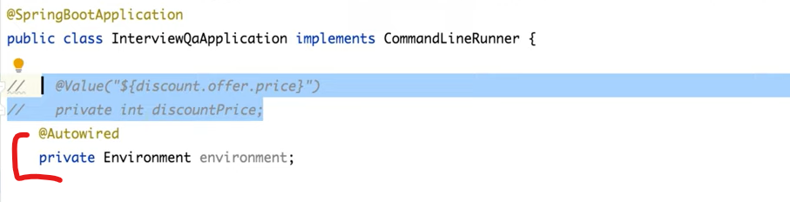

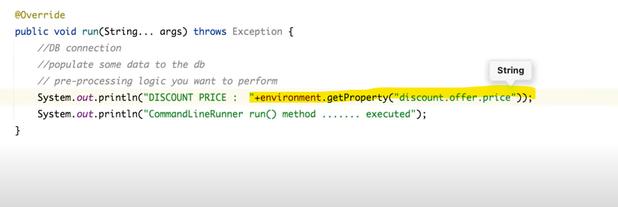

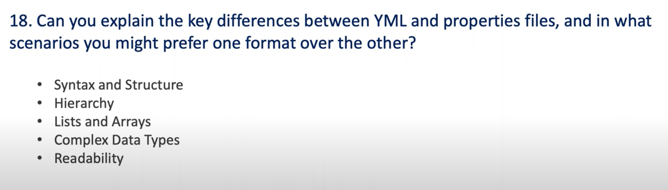

**In properties**

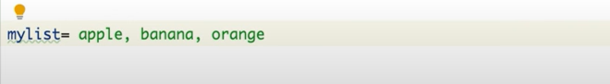

**In yaml**

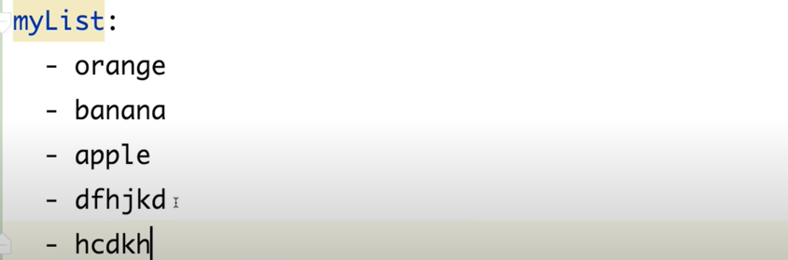

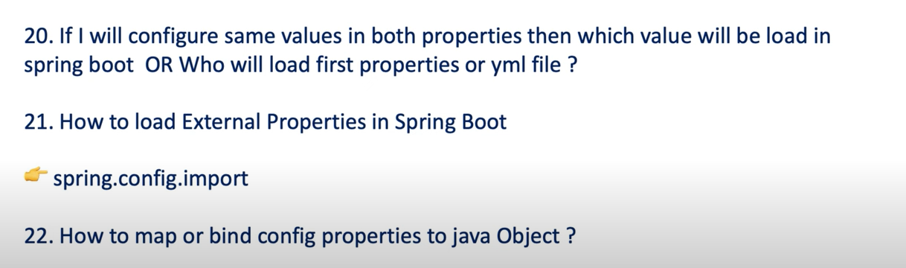

**First it will load values from properties.**



I don’t want to keep dynamic configuration instead I want to keep external to my application.

I have created **test. properties** and keep into desktop.

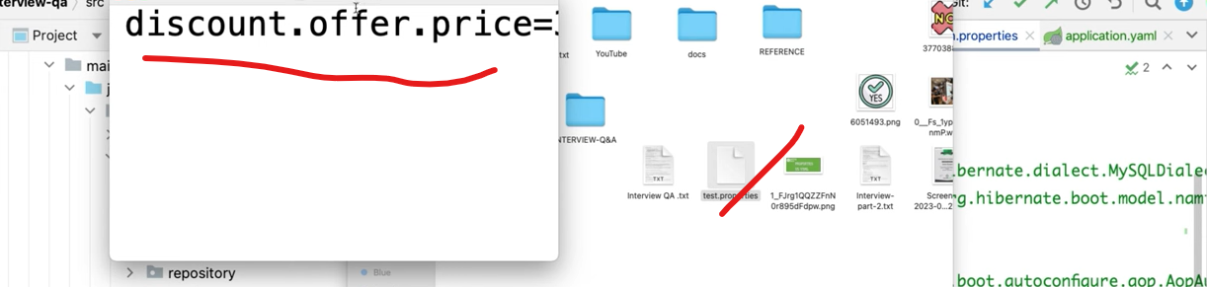

----------------------------------

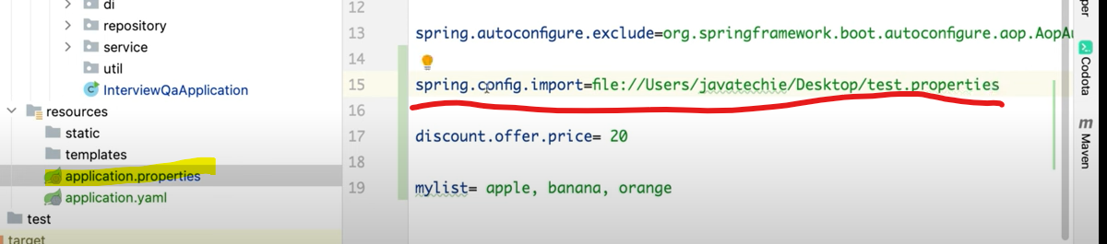

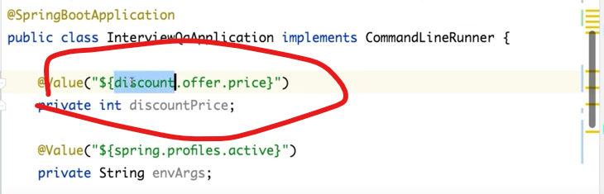



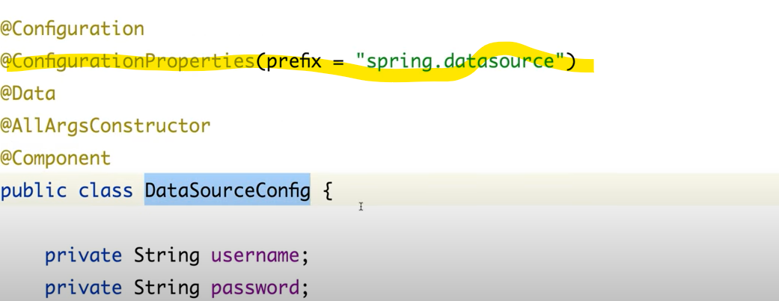

Use **@ConfigurationProperties.**

**Part -3**

**=========================**

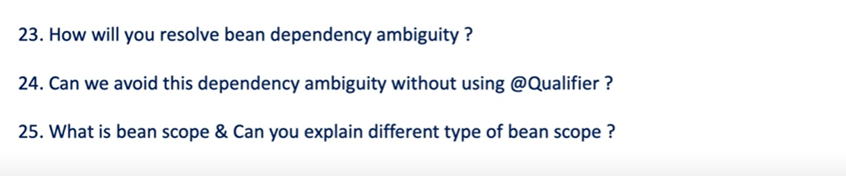

**If for one interface 2 or more implementation bean class then u can use @Qualifier.**

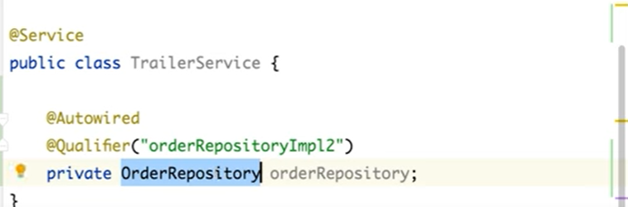



We can use @**Resource**.

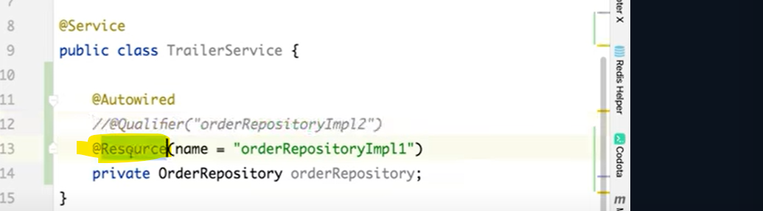

Difference between @**Qualifier** & @**Resource**.

* @**Qualifier** specific to spring framework but @**Resource** give to the java library itself.
* @**Qualifier** uses the **By Type** (by class type) but @**Resource** uses the by name.

------------------------------------------------



**\*\*\* Beans scope refer to the lifecycle and the visibility of a spring bean within IOC container means for how long Ur bean will be alive and when it will be destroyed.**

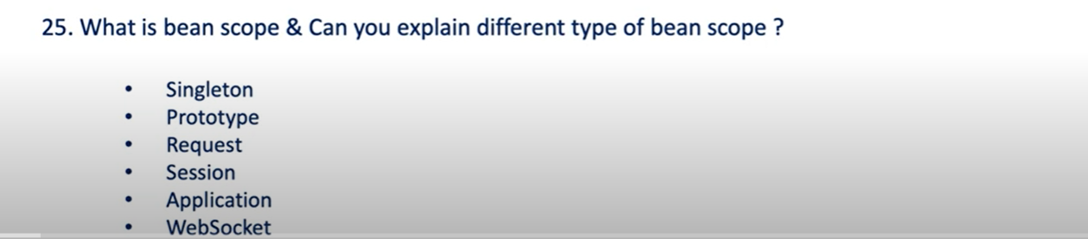

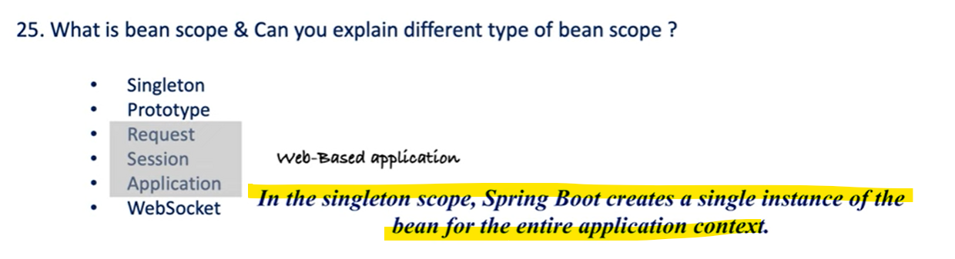

Default scope is **Singleton**.

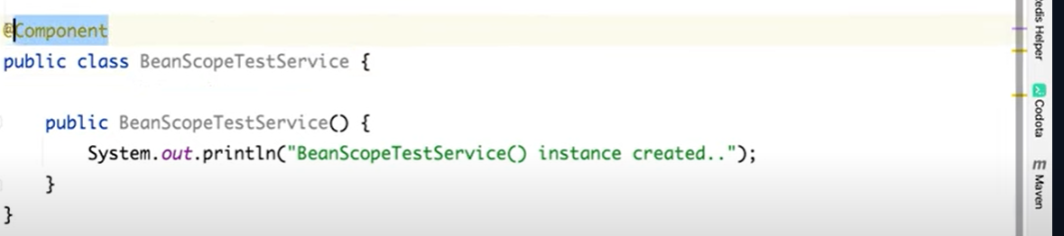

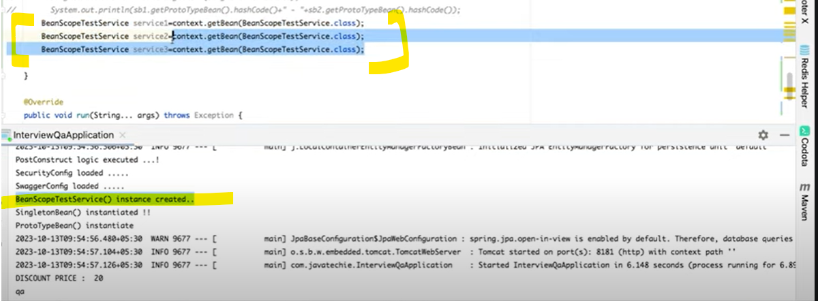

Since for Singleton scope I have created the bean for 3 times, but it is giving same only one object all the time. Means it creates a single bean for entire Spring IOC container.

**\*\*\* if u define bean scope as singleton. It will only create a single instance in your application context. Now going forward if you request for a particular instance the spring container will get that particular bean from in-memory rather than create a new one.**

If you define a scope as a **prototype**

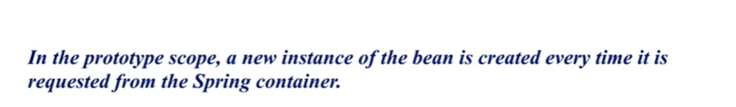

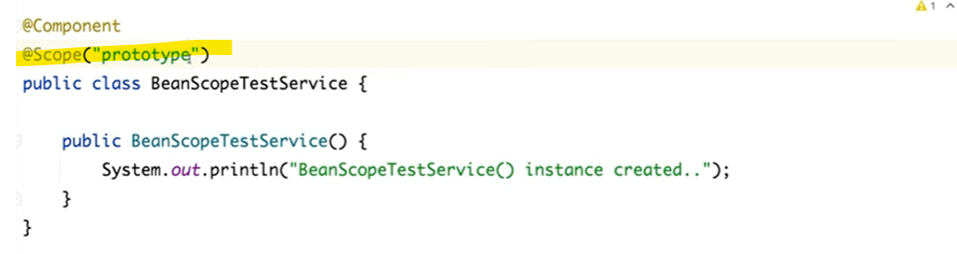

**\*\*\* If u define bean scope as a prototype as many times you will request for an object Spring will create a new Object for a that particular bean.**

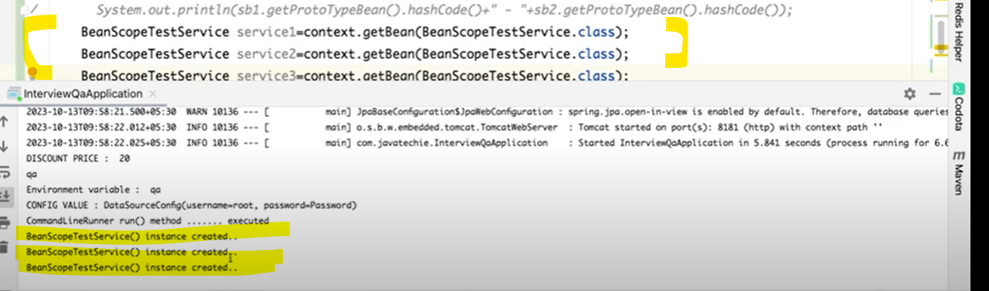

**Request scope---🡪**

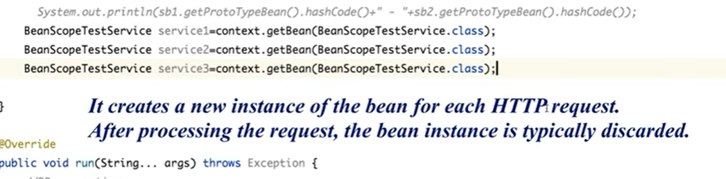

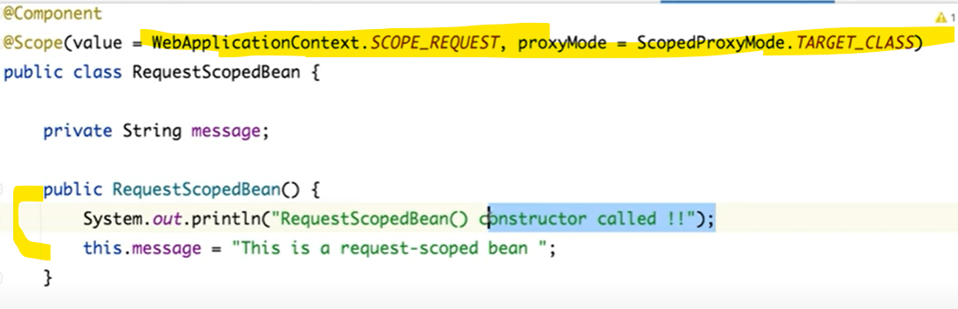

**Session scope-🡪**

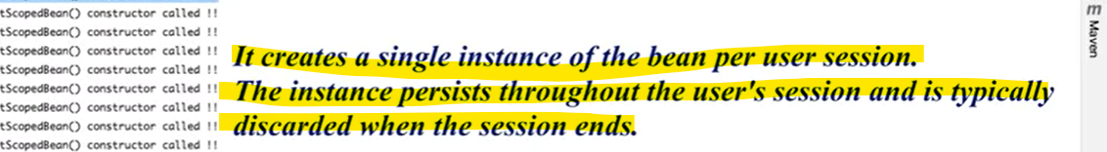

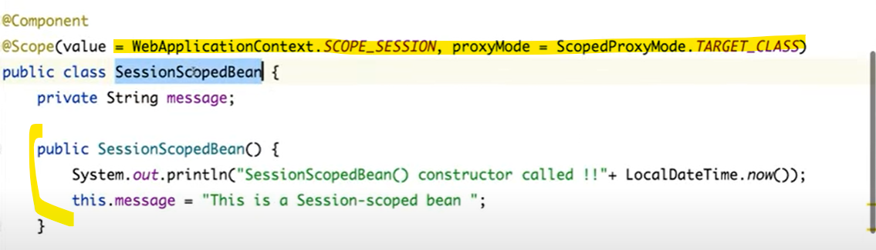

**Application scope->**

**It will create only one bean or object as per all requests and sessions.**

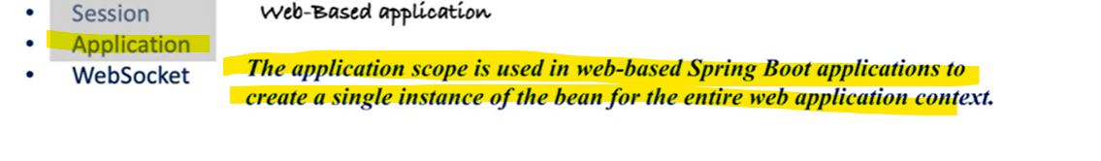

**=================================================================**

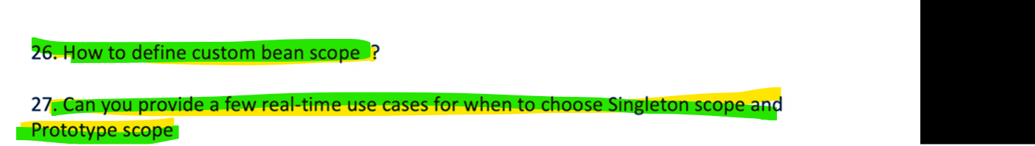

**Custom Bean scope**-> I want to create a different bean instance per thread.

You just need to play with the **Scope Interface**.

We can create using Thread Local.

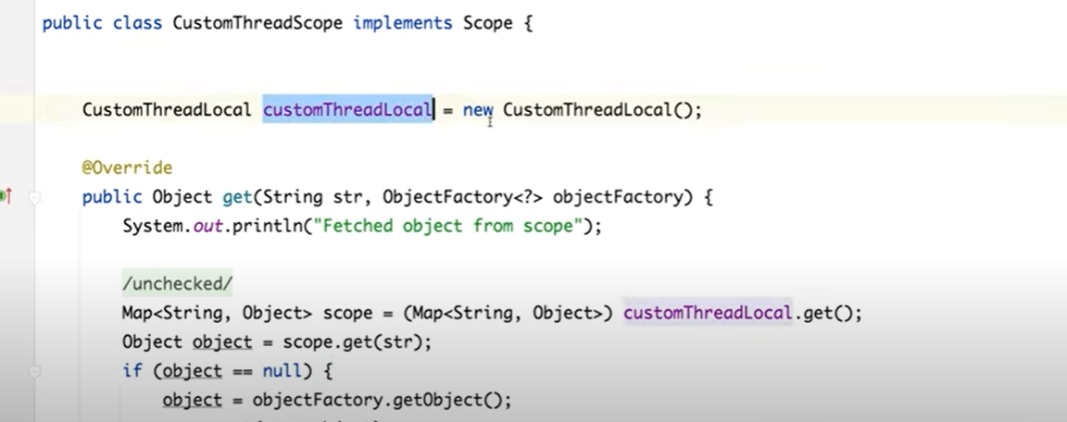

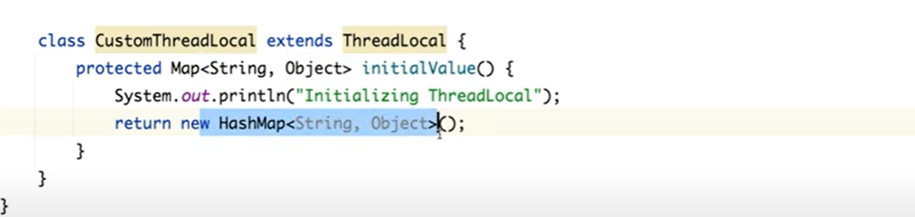

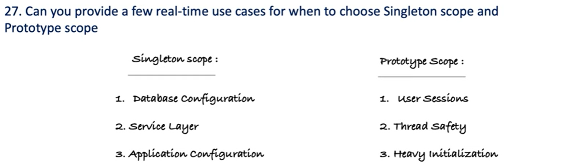

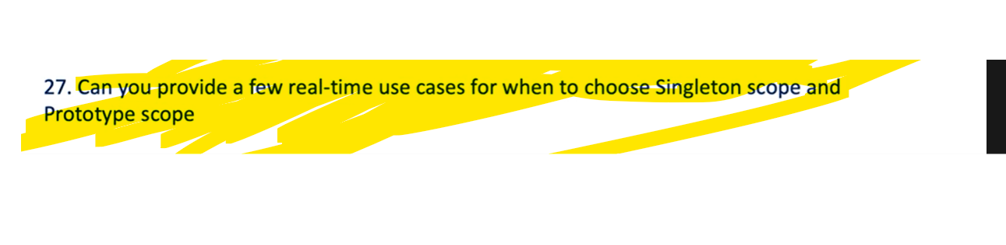

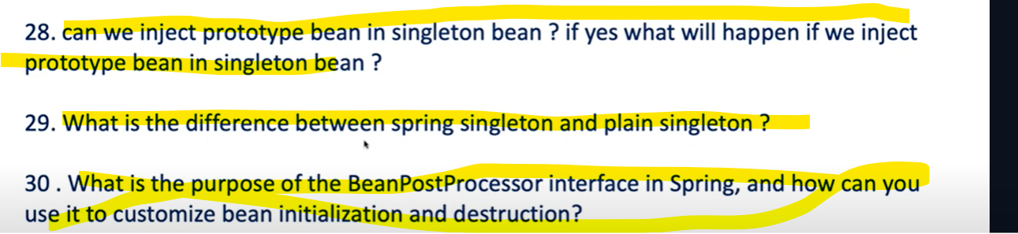

If u will add prototype bean in singleton bean, then it will also work like a singleton bean. How can we overcome this.

**\*\*\*\* To Resolve either you can use Application Context Object, Object Factory or @LookUp.**

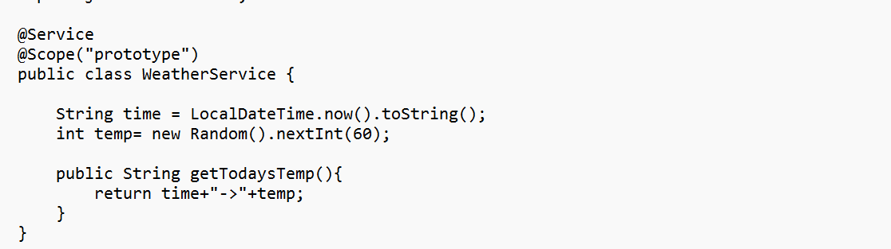

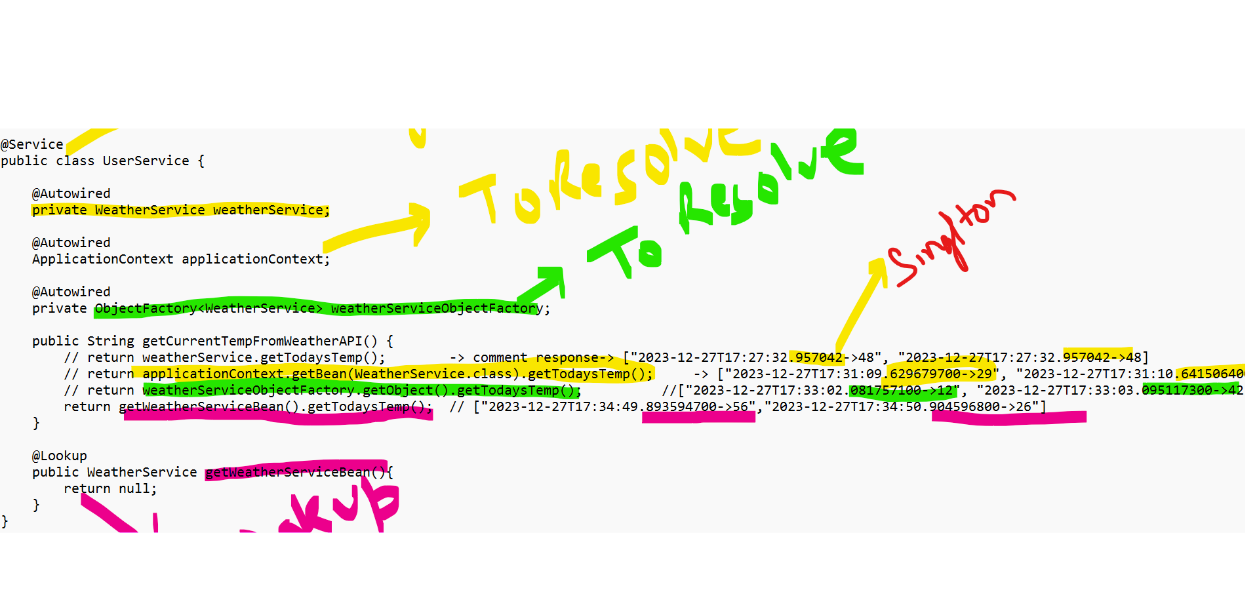

----------------------------------------------------------------------------



* In java Singleton DP to get only **a single instance per JVM**. Spring Singleton getting **a single instance per Application context**.
* Spring Singleton scope within the Application Context and plain Singleton scope within the JVM.
* In Spring if I will create 2 diff Application Context and from 2 diff application if I will try to get the singleton bean then it will give me 2 diff instance. But in java you will get 2 diff instance only if u run in 2 diff JVM.

-----------------------------------------------------------------------------------------------------

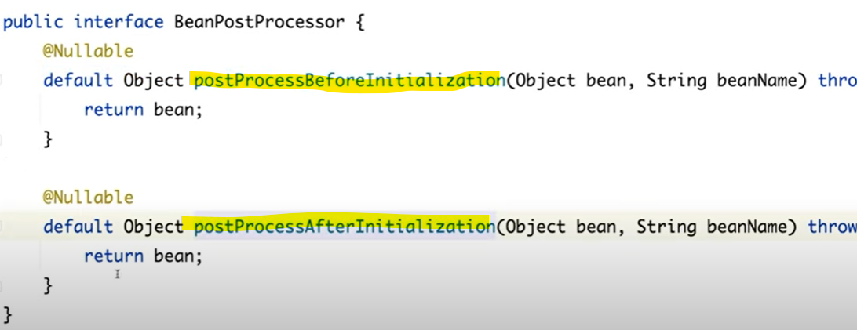

Alternatively, we can use @**Predestroy** - @**Postconstruct**

**BeanPostProcessor** is an Interface it provides action to perform pre-processing logic. It allow to perform custom action on bean before and after bean initialization.

I want to verify the user credential or user password before user bean initialized. How can we do that.

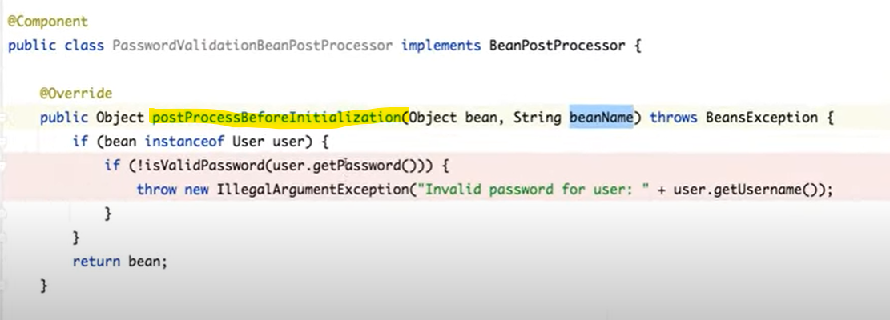

**Use case**- if u want to validate **Kafka Template** is it secured or not is it valid or not.

If u want to add property of bean before it created or after it created.

**Part – 4**

**==============================================**

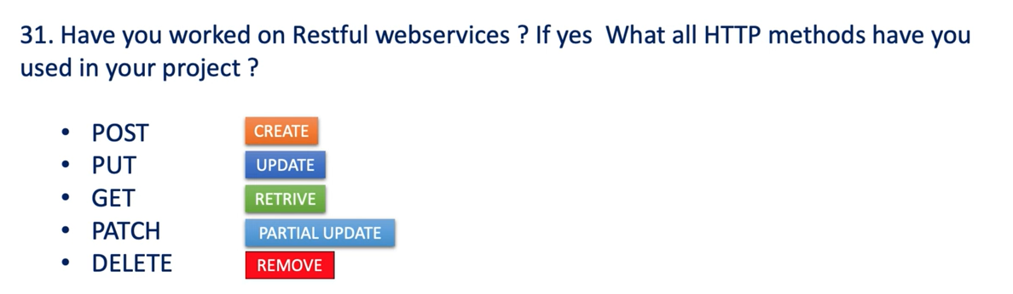

To Create a Resource on Server, To Update Resource on Server, To Access Resource from Server, To update Resource partially on server, to remove the Resource from Server.

Http Methods specific annotations.

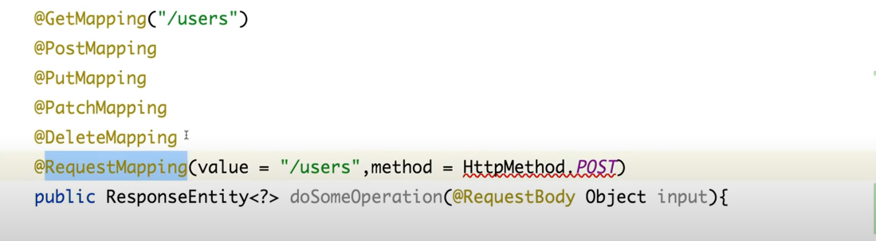

If you observe each and every Http Method extends from @**RequestMapping**.@**RequestMapping** is the Parent annotation for all the specific **HTTP** methods.

---------------------------------------------------------------------------------------------

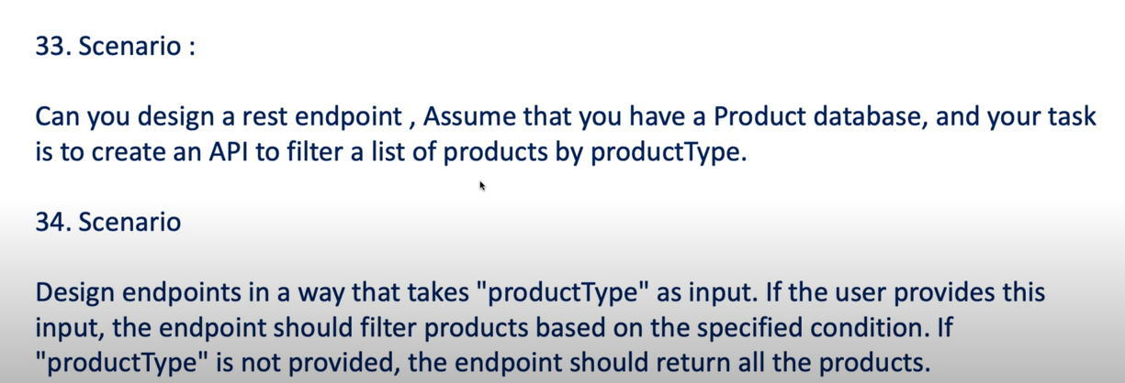

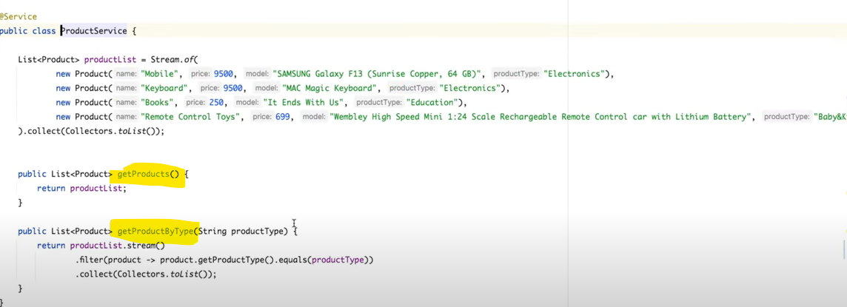

--------------------------------------------------------------------------------------------------------------------------------------

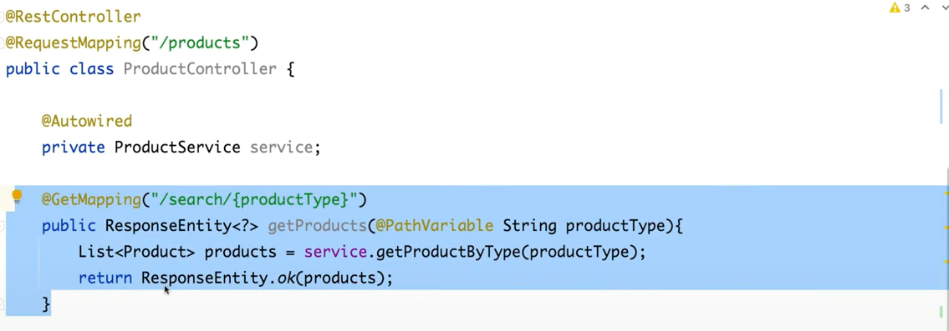

--------------------------------------------------------------------

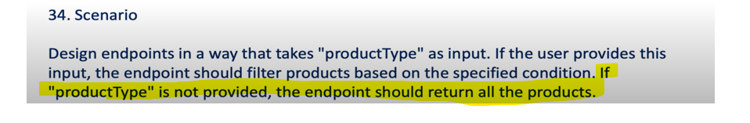

Here **productType** is optional if user give filter and send if user does not provide **productType** in that case return all products. So here product Type is optional.

So, In this case we can’t use @**PathVariable** we need to use **@RequestParam**

So, @**RequestParam** is having one field name **required so** if u want to make it mandatory then required will be true otherwise false.

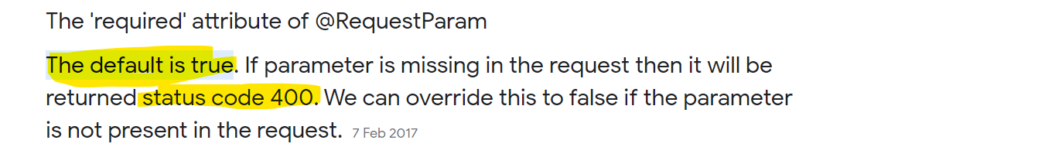

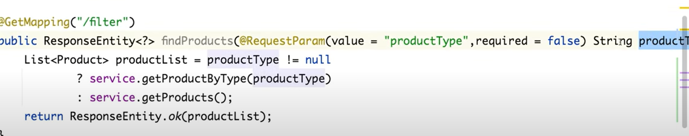

**--------------------------------------------------------------------------------------------------------------**

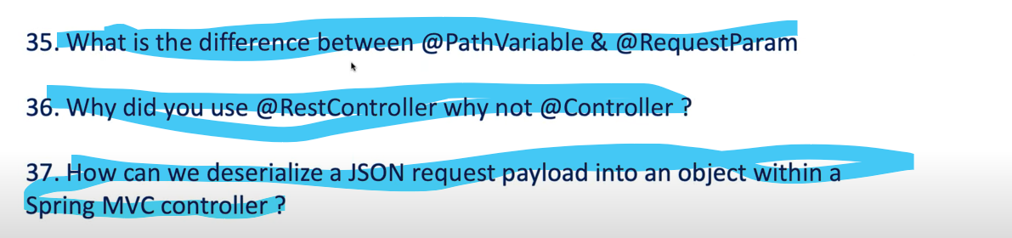

**@PathVariable** is mandatory if you do not pass the input, you will get **error 404**: not found or Resource not found on server. Server is unable to find the resource. But @**RrequestParam** is optional when you use required = false. It won’t give any error.



------------------------------------------------------------------------------------------------------

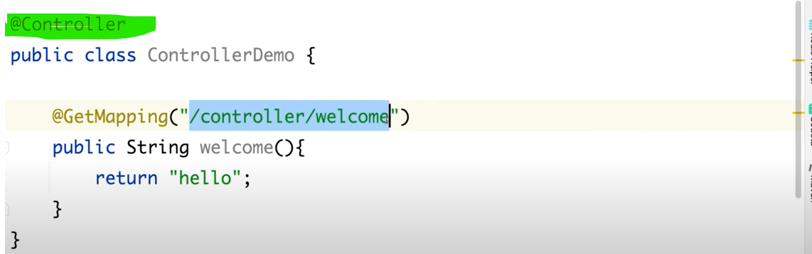

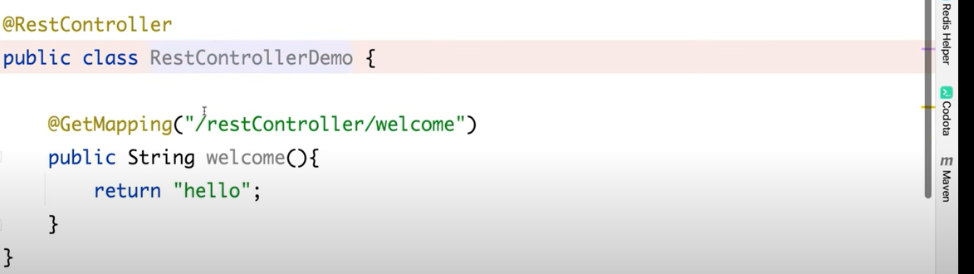

Let’s test and see----

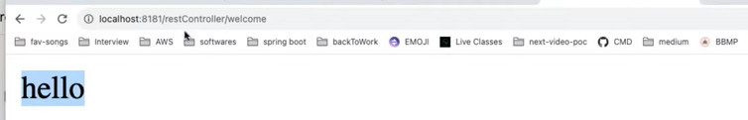

---------------------------------------------------------

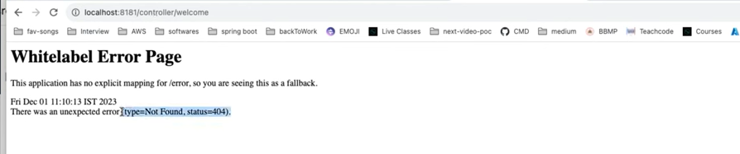

* Wherever I am using rest controller I can see the response but when using controller, I am not getting response rather than getting **404 resources not found**.
* @**Controller** always expect return type as a **ModelAndView.**
* So, the reason is if you define the @**Controller** and if u have define the endpoint then always Spring Framework will be looking for a html or view page for this particular hello like **hello.html** or **hello.jsp**.
* In case of Controller, it will always expect return type as a **ModelAndView** but we are returning string as a hello so spring will always search for a view page hello.jsp/html. If not found throw 404.
* In case of RestController you can return any Media Type.
* But we have option we can use **produces** and return any media type from @**Controller** so you just need to define **produces** and @**ResponseBody.**

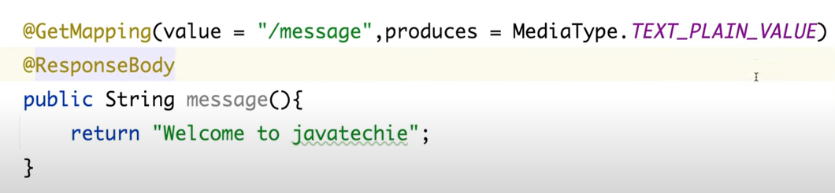

If you see the @RestController is a combination of a **@Controller** and **@ResponseBody**.

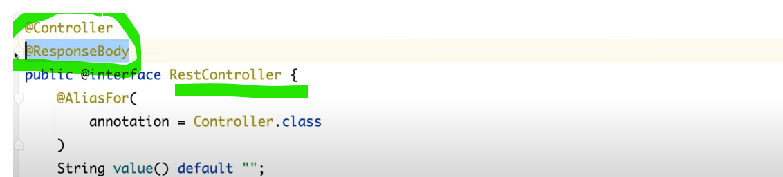



By using @**RequestBody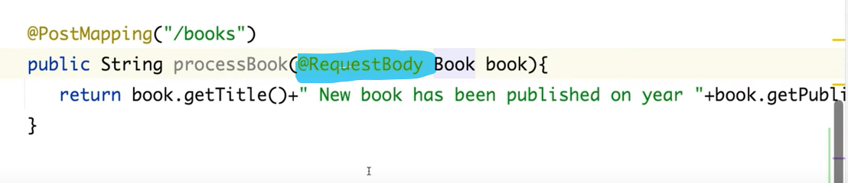------------------------------------------------------------------------------------------------------------------------------------------**

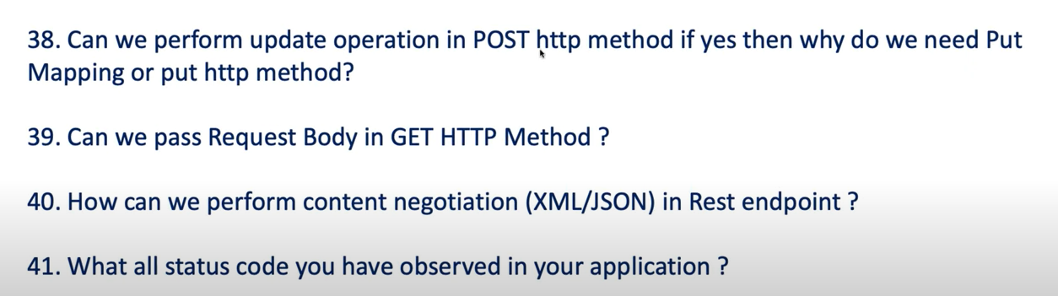

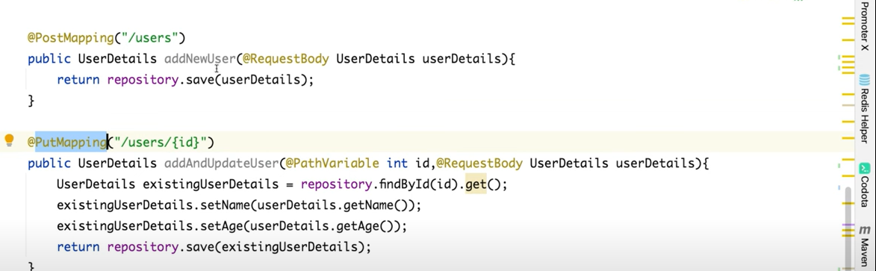

Yes, technically you can perform PUT operation using POST method but doing so we will violate the principal of RESTful design. In REST each HTTP method has a specific purpose. So POST is generally Create the Resource and PUT is for update the resource. The main issue while mixing up this two operation is **Idempotent** nature of HTTP methods. Let’s understand first.

*** The main issue while mixing up this two operation is **Idempotent** nature of HTTP methods.

Idempotency Principal of **RESTful** Services…

**On your subsequent actions If the Resource is getting modified then that is not consider as an Idempotent.**

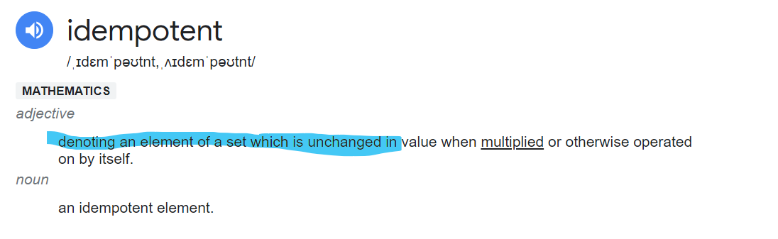

**Idempotent** – Subsequent access Resource not modified.

**POST**- **non idempotent** (On Subsequent req. it will modify the data and always create a new Resource).

**PUT** – **Idempotent** (On Subsequent req. it will not modify the data on server)

--------------------------------------------------------------------------------------------------



Technically u can do but it’s not recommended for GET to use @**RequestBody**.

---------------------------------------------------------------------------------------------------



How I can design my endpoint who can return different MediaType.

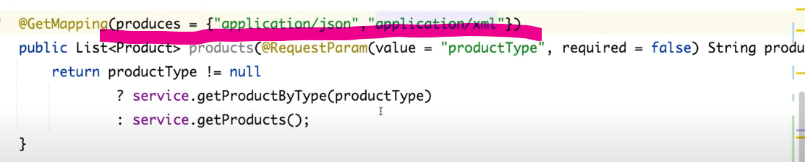

So, this particular rest end point will return Json and xml based on user input. Need to add dependency to support xml.

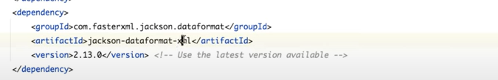

Add in properties file.

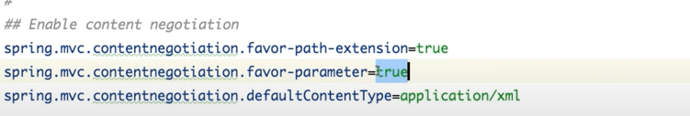

-----------------------------------------------------------------------------------------



Which represents the state of response.

**400** - **Bad Request** (If client expecting something and you are accessing from something)

**404** - **Resource not fount**/ Resource Not Available.

**401** - **Unauthorized** or Not Authenticated if giving wrong credentials

**403** - **FORBIDDEN** (authenticated but not a valid user to access that resources)

**405** - **Method Not Allowed Error.**

**415** - **Unsupported MediaType** (client need Json but you are passing xml)

**500** - **Internal Server Error (**server encounter some unexpected condition**)**

**200 - OK**

**201 - Created**

---------------------------------------------------------------

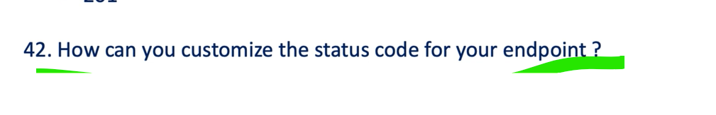

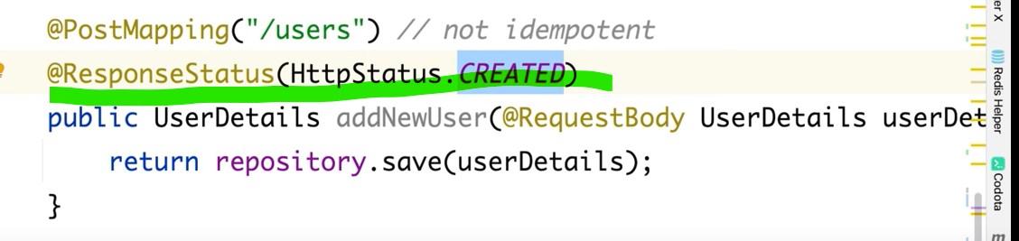

By default, it returning 200 OK, but I want to show 201

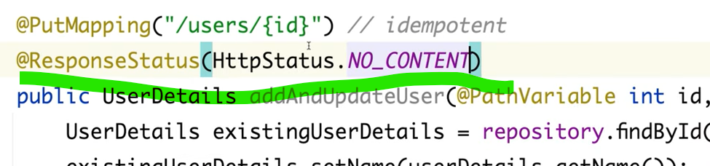

-------------------------------------------------------------------------------------------------------------------------

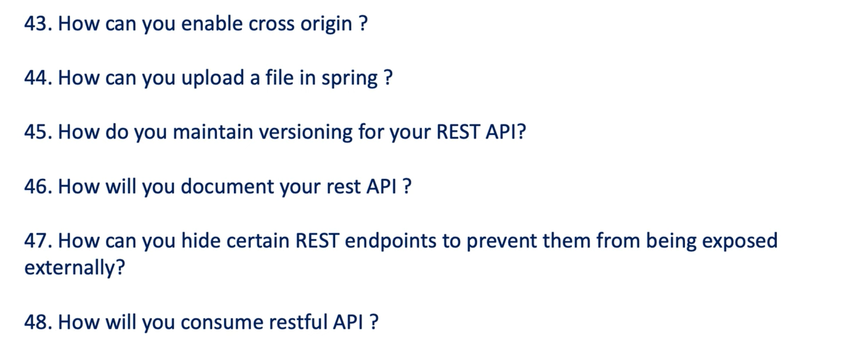

**Cross Origin or Resource sharing is a security feature implemented by web browser to control web page request made from one domain to another.**

**You can restrict what all domain or host can access your application using cross origin**

Allow only from Angular.

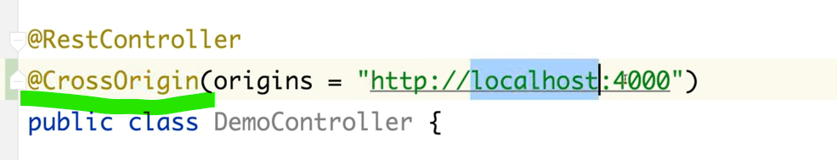

---------------------------------------------------------------------------------------------



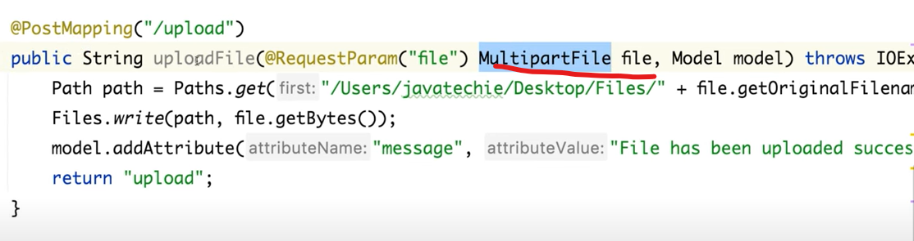



By just defining the Request uri

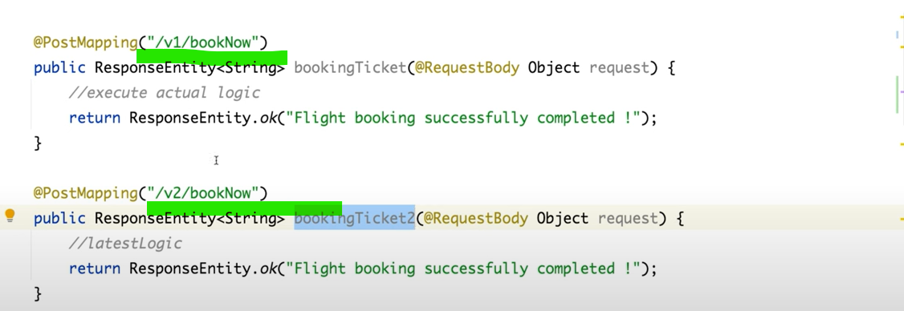

Otherwise, we can use @**RequestParam,** and we can pass version as 1,2 3… and make some condition.

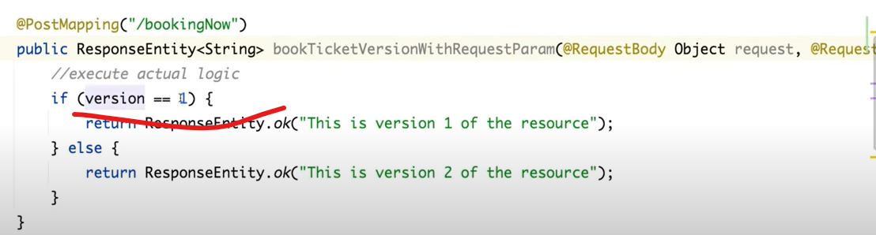

Otherwise, we can use Header Versioning.

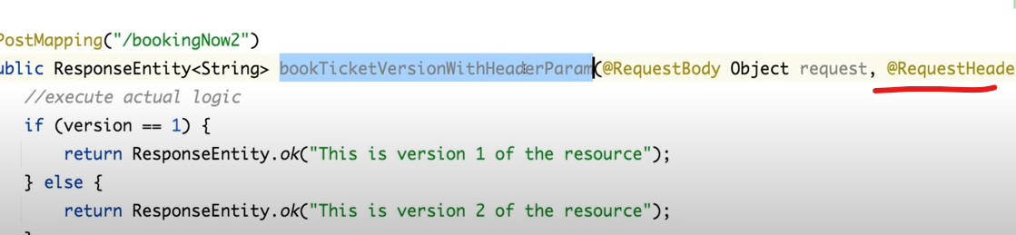

------------------------------------------------------------------------------------------



Spring uses **Open API Specification 3.0**

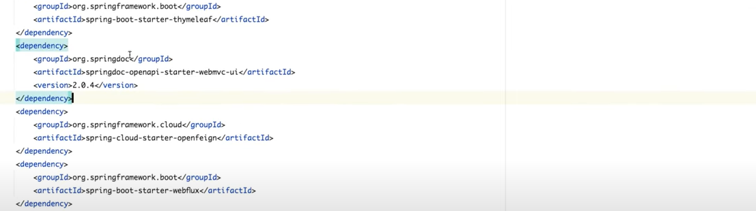

Then everything done by spring boot itself.

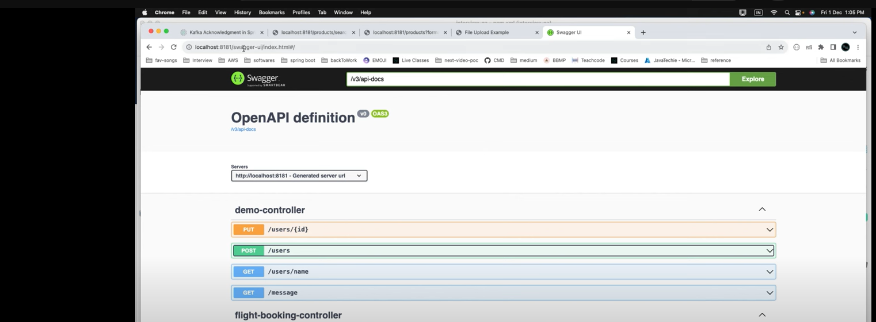

**If u want to generate api description and share to user**

**http://localhost:8080/v3/api-docs**

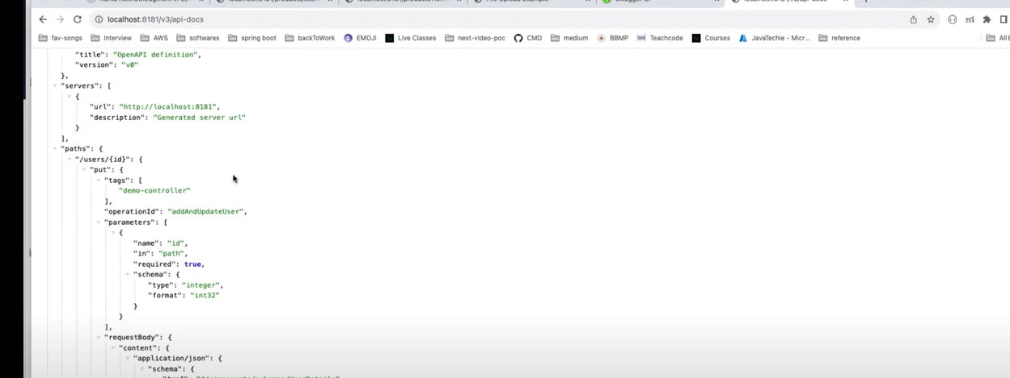

To download [**http://localhost:8080/v3/api-docs.yaml**](http://localhost:8080/v3/api-docs.yaml)

**--------------------------------------------------------------------------------------------------------------**



**I don’t want to expose v1 and v2 in documents we can use @Hidden.**

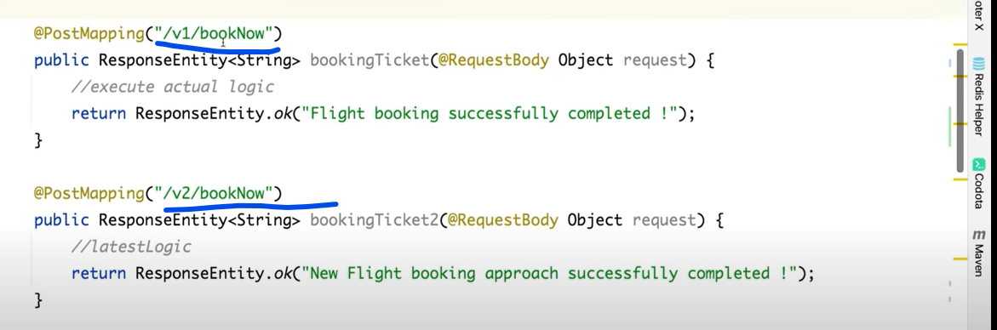

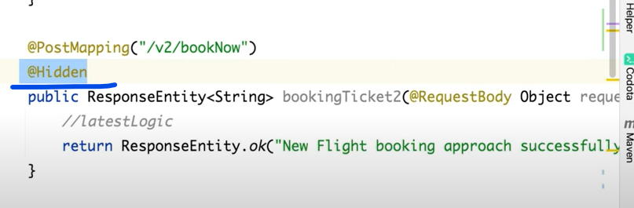

If I want to add some notes on end point what it’s doing in documentation…we can use @**Operation**(“----”)

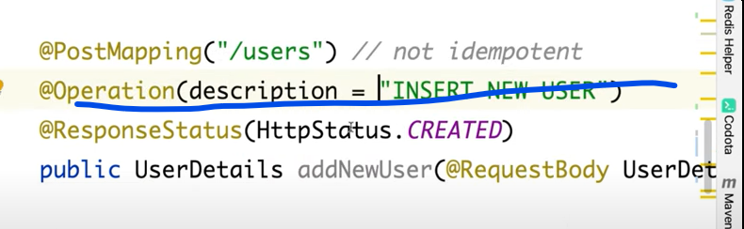





**Part – 5**

**==================================================**

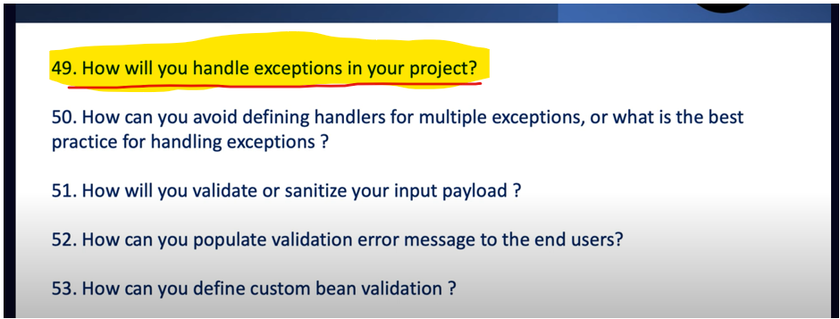

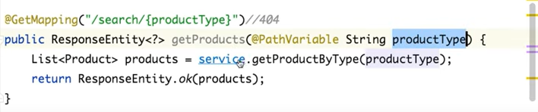

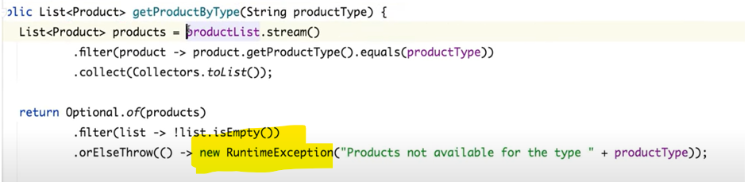

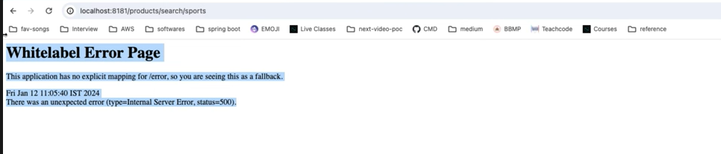

Let’s customize exception handling…

-----------------------------------------------

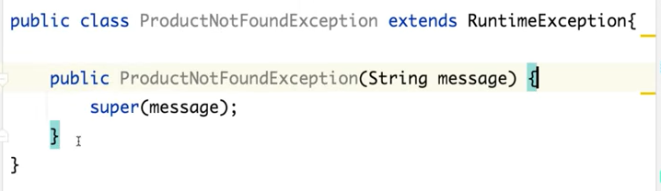

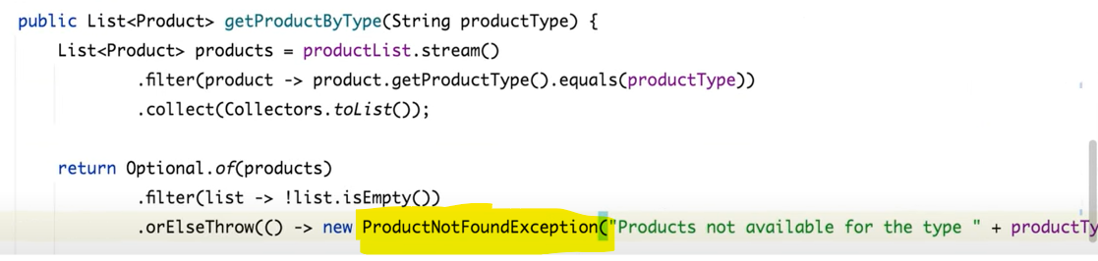

Note- I can see the actual error only in our console but in browser we are getting 505 – **Internal Server Error** that doesn’t make any sense. So, how can we send same error as a response. That’s the reason we have a @**RestControllerAdvice**.

So, you can tell to the spring boot if u are getting this particular kind of error then map it, extract the error message and set the additional field and send back to the user.

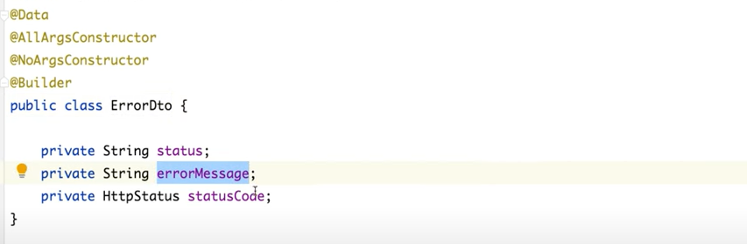

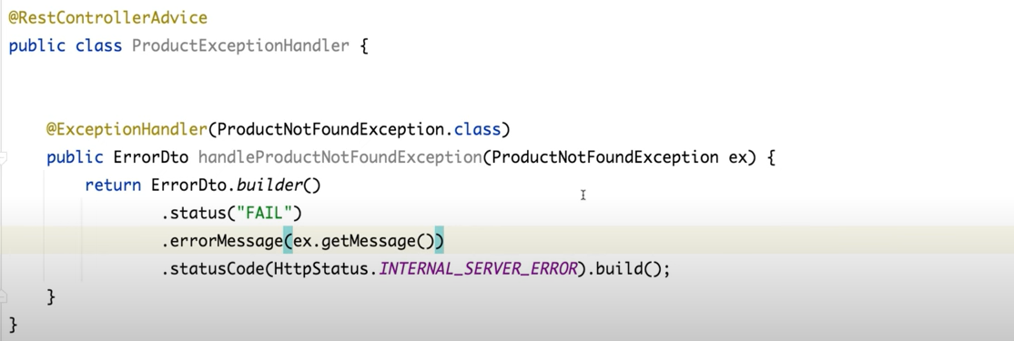

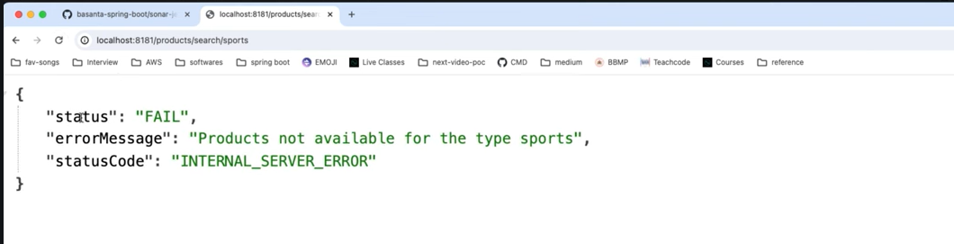

**Another scenario----**

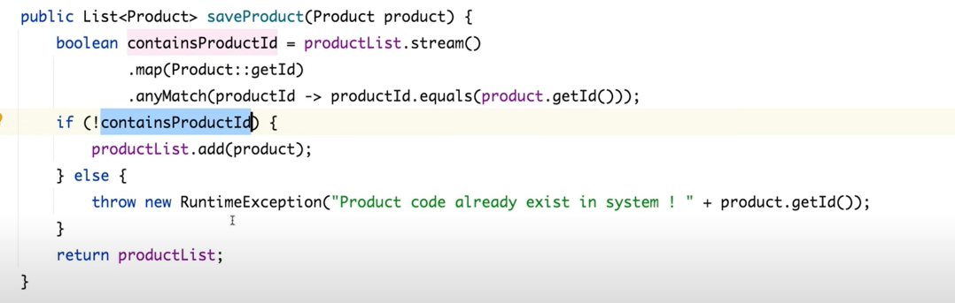

If 2nd time storing the same id and data is already present in db then we are getting exception **Internal Server Error.**

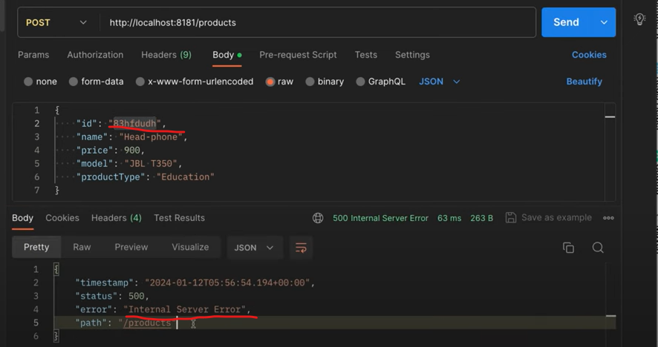

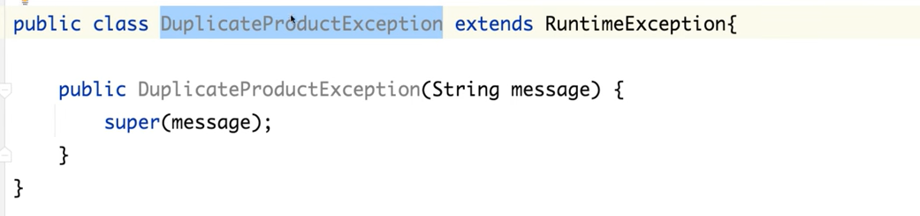

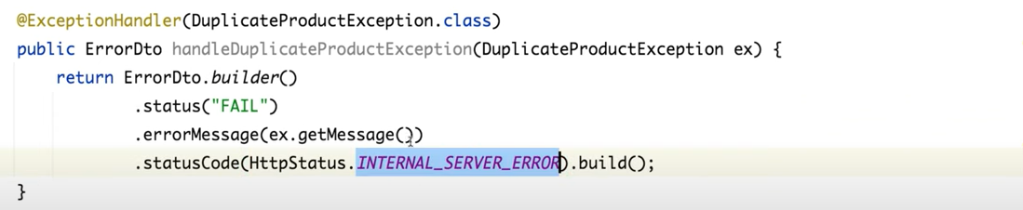

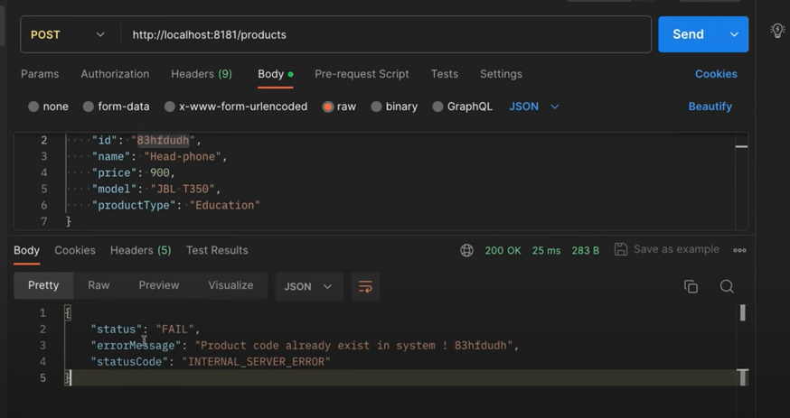

But If you are using Spring Boot version 3 and onwards then one good news no need to define a custom DTO class. No need to define your own class to map error message then there is a class define for **ProblemDetail.**

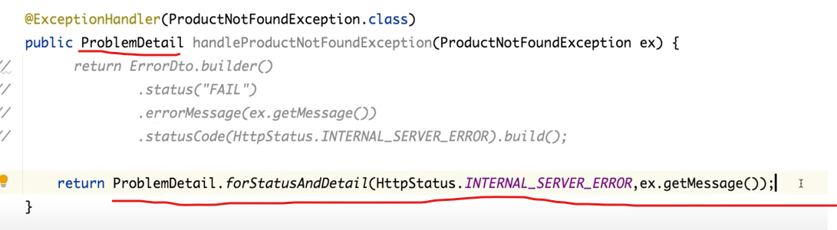

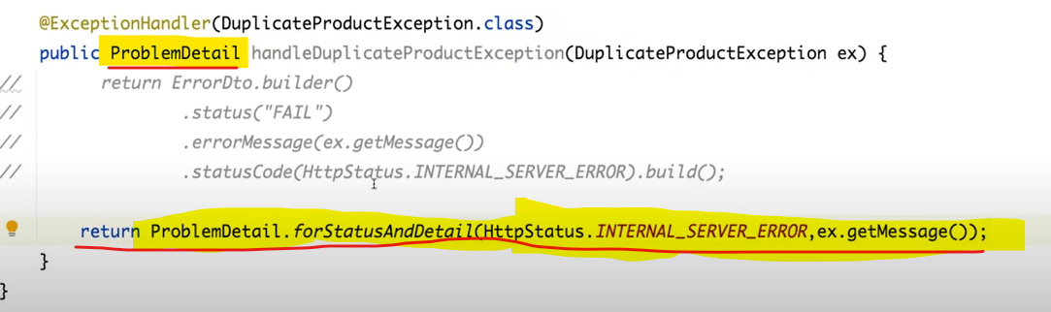

You can also customize the attributes of **ProblemDetail**

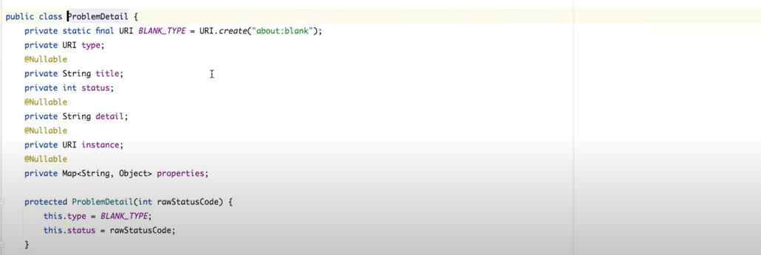

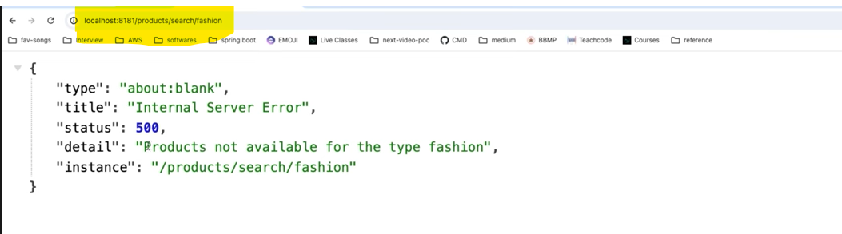

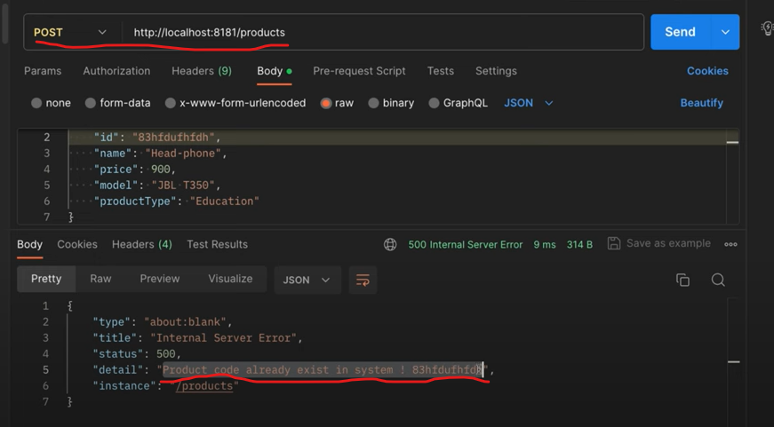

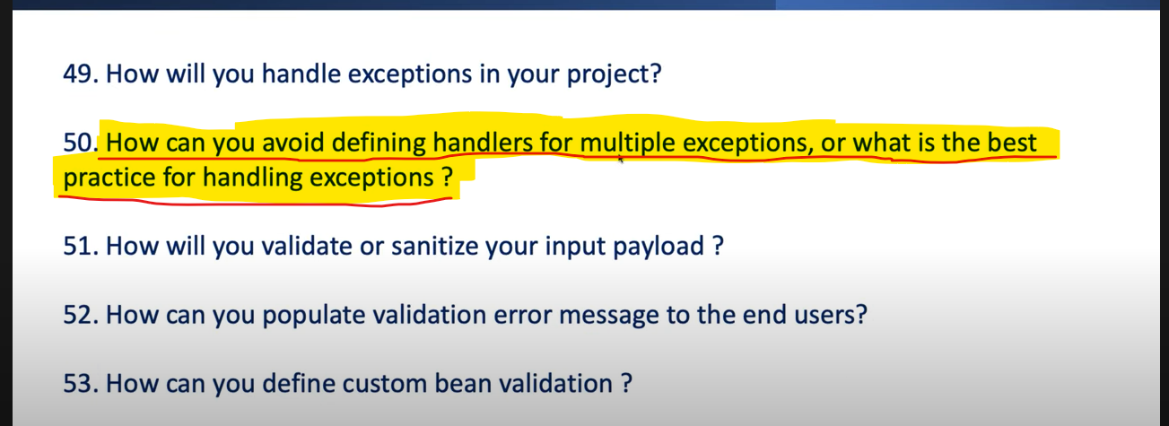

If in our project we are getting 10 diff exceptions so, do I need to create 10 different exception handlers. Let’s see how we can avoid defining multiple handlers to handle multiple exceptions. It’s not good practice to do that.

I have define one method call **fetchLocation()** and I have just define the flag for a toggle the call between db and rest api call or between **DataRetrievalFailureException** and **HttpClientErrorException**.

So, I just want to fetch the location of store by id. If the flag is **true,** then it will fetch from the db and if the flag is **false,** it will do the REST api call.

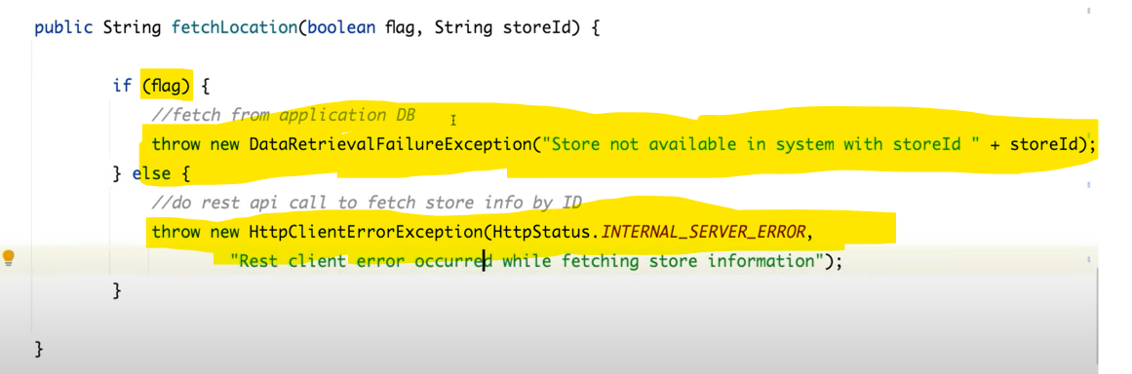

If any exception occurs from db side we are getting **DataRetrievalFailureException** and if any error occurs while doing api call we will get **HttpClientErrorException**.

If the flag is true, then **DataRetrievalFailureException** and if the flag is false then **HttpClientErrorException.**

As per earlier approach do we need to write the 2 different Exception Handler? Like we have defined for **ProductNotFoundException** and **DuplicateProductException**. The answer is No. not at all.

To avoid that what I will do, I need to suppress the 2 different types of exceptions with my custom exception. Let’s define a custom exception **ProductServiceException**. So, I need to suppress the any kind of exception with this custom exception ProductServiceException.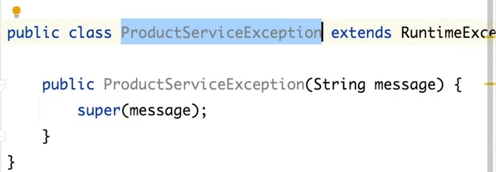

Imp-> Now I need to suppress any kind of exception to a custom exception. So just keep your actual business logic to try and catch block. In catch just handle any type of exception we are getting as an Exception class and then throw your own custom exception and get the message from an Exception.

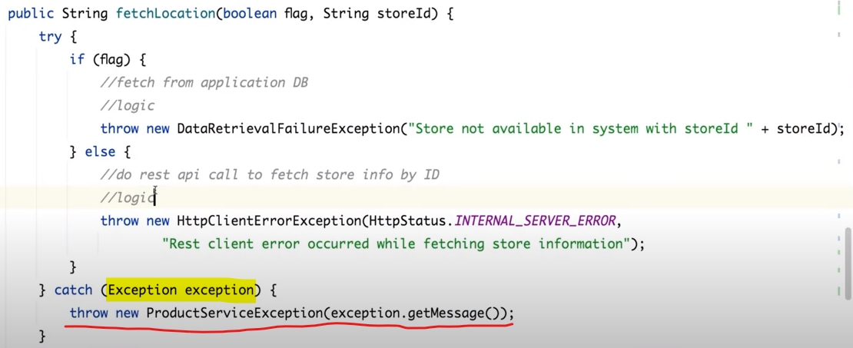

No need to care about what types of exception we are getting into business class. I just need to suppress that exception with catching it and then throwing our own custom exception. Now no need to handle diff handle we just need to handle this particular custom exceptio**n ProductServiceeException.**

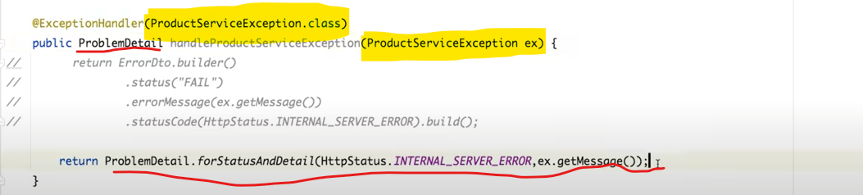

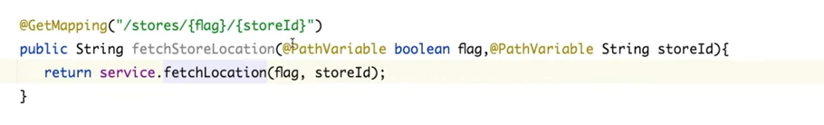

So below 2 we are getting for both the db and api exception.

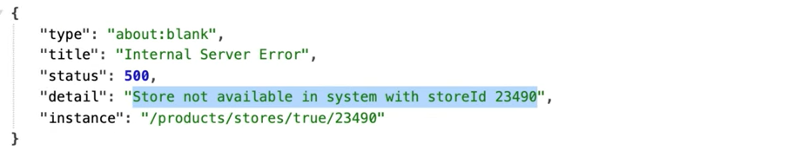

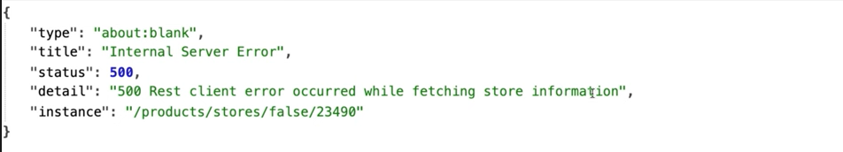

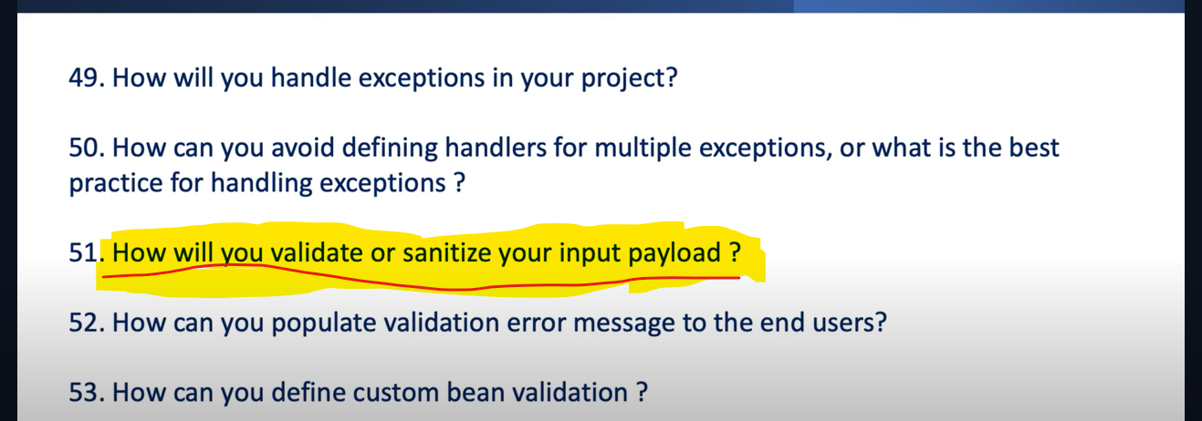

This below dependency is required to perform the Bean validation.

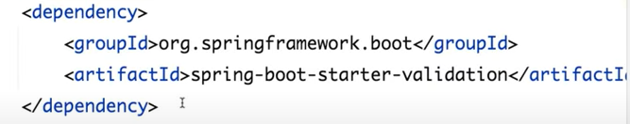

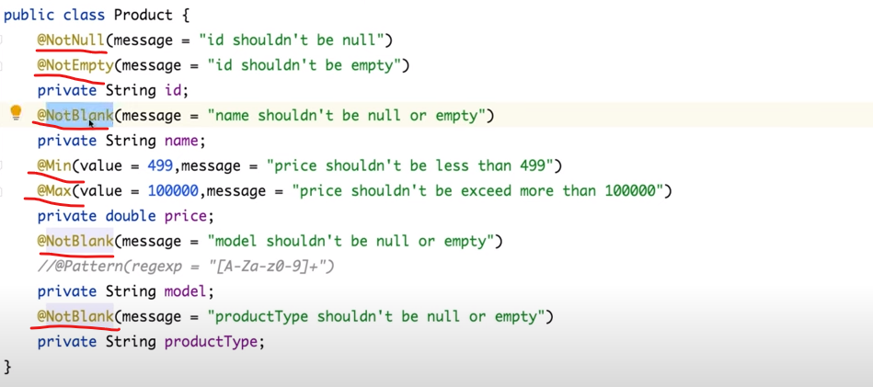

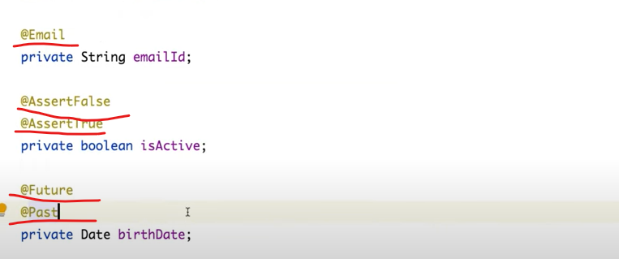

If we want our date should be a future date so always use @**Future** or if we want date should be a past date so, @**Past**. If we want isActive should always be a true so use @**AssertTrue** or if we want an isActive should be always false so **@AssertFalse**.

How we can tell spring boot to please validate the input using @**Valid**.

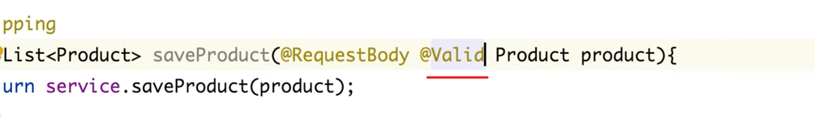

We are getting Bad Request and with multiple fields exception.

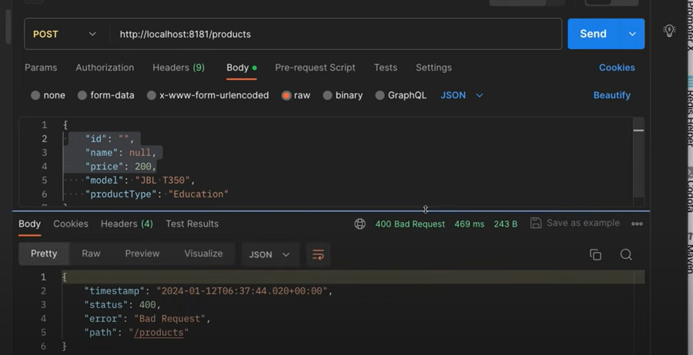









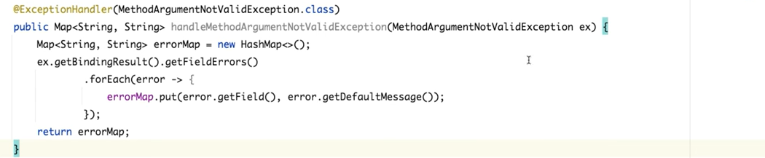

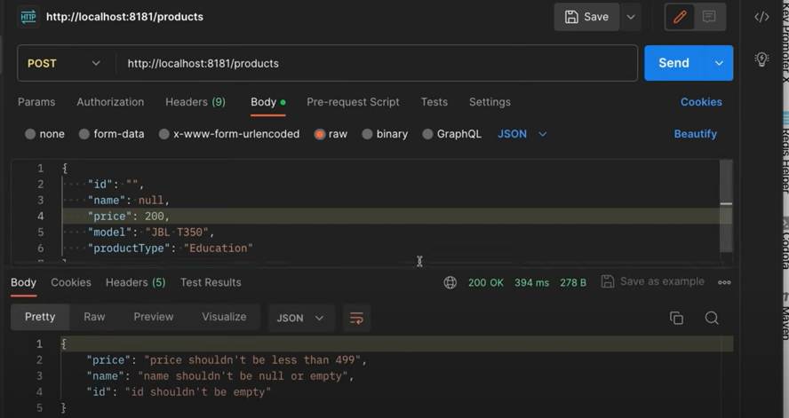

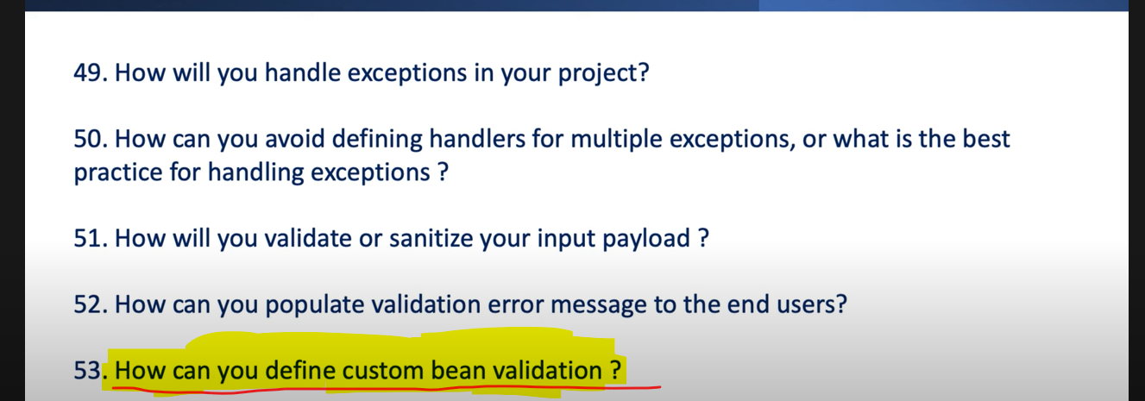

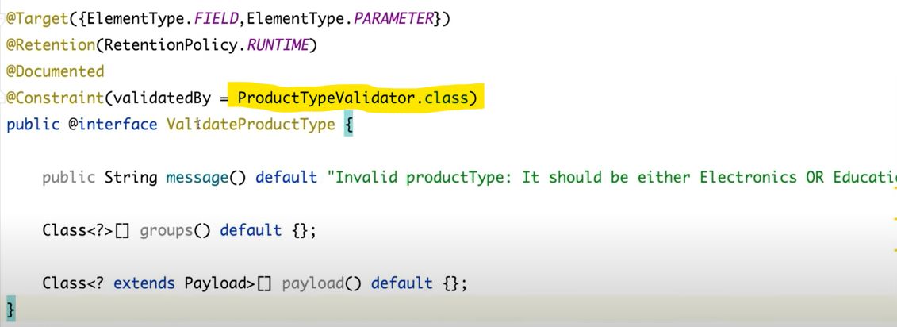

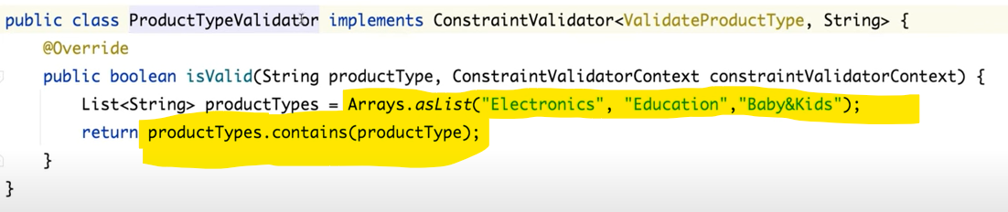

Just implement **ConstraintValidator** interface and override **isValid**() method and write your own logic.

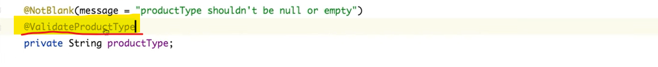

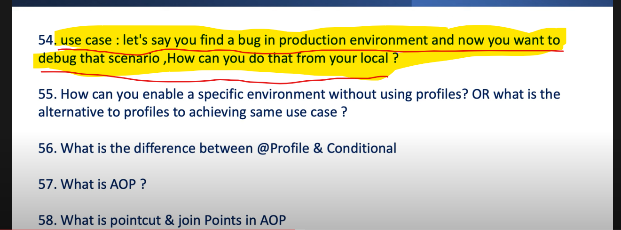

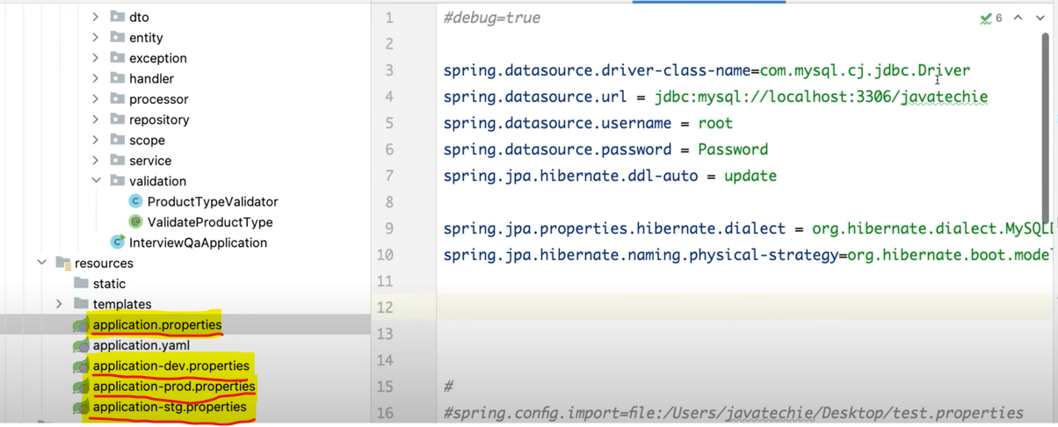

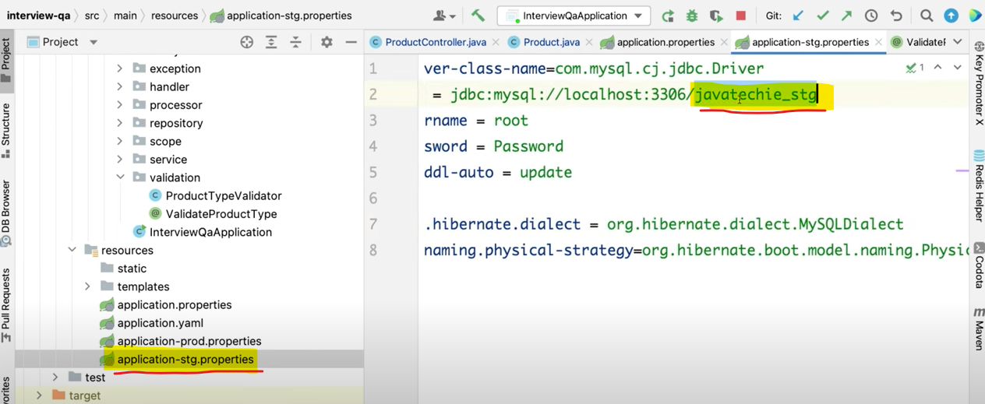

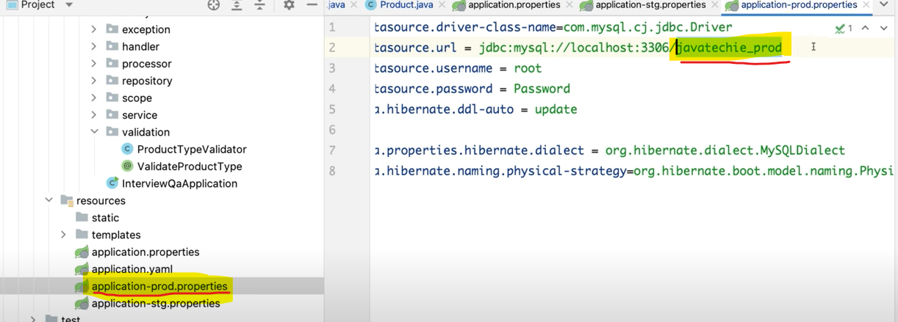

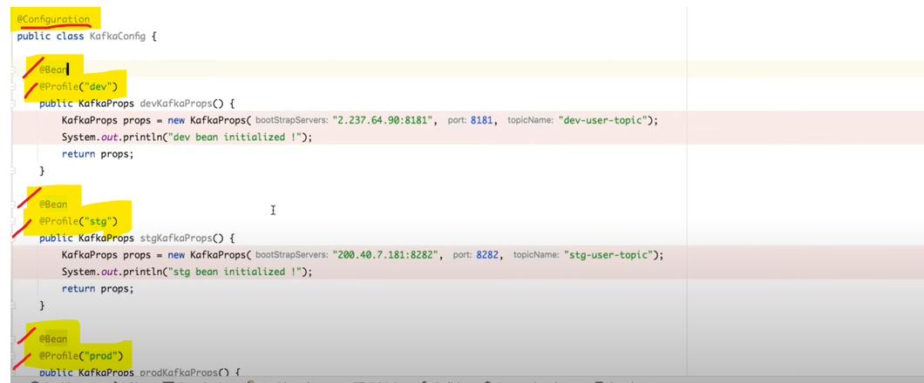

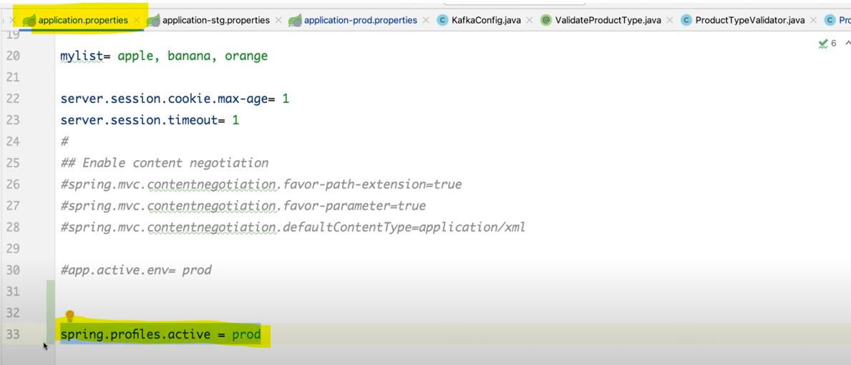

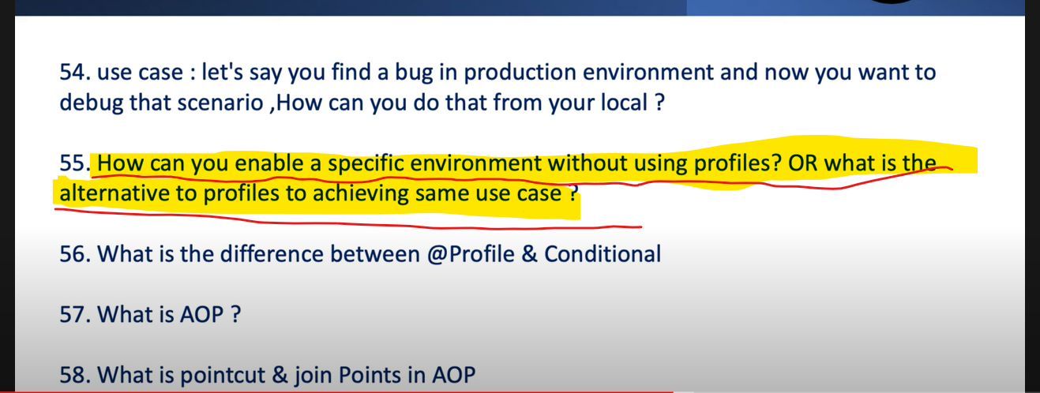

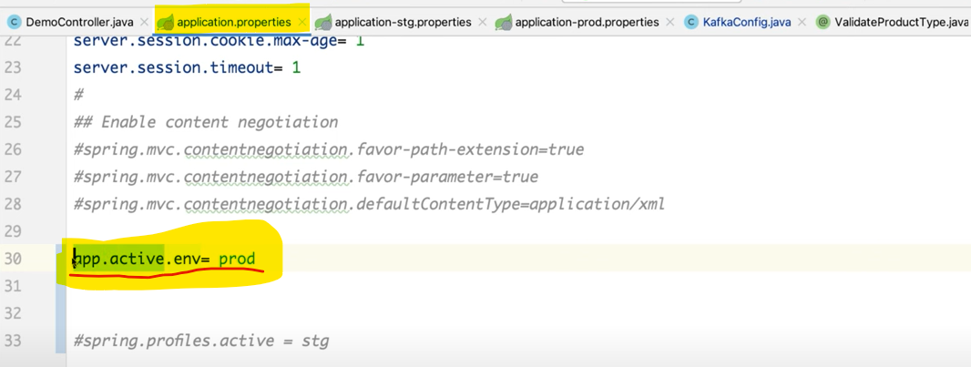

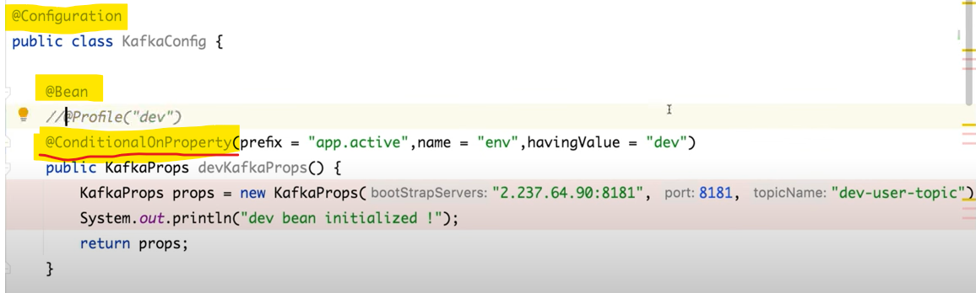

There are tons of @**Conditional** available like @**ConditionalOnMissingBean**, @**ConditionalOnProperty** which means if property available then it will make enable.

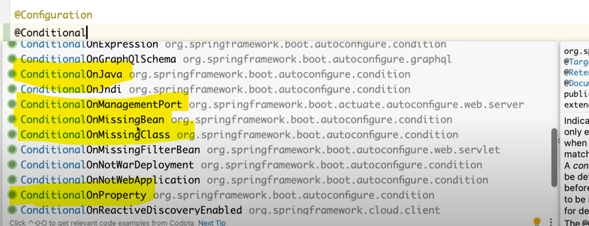

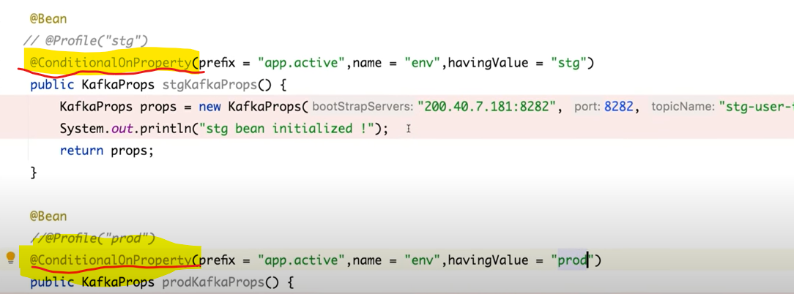

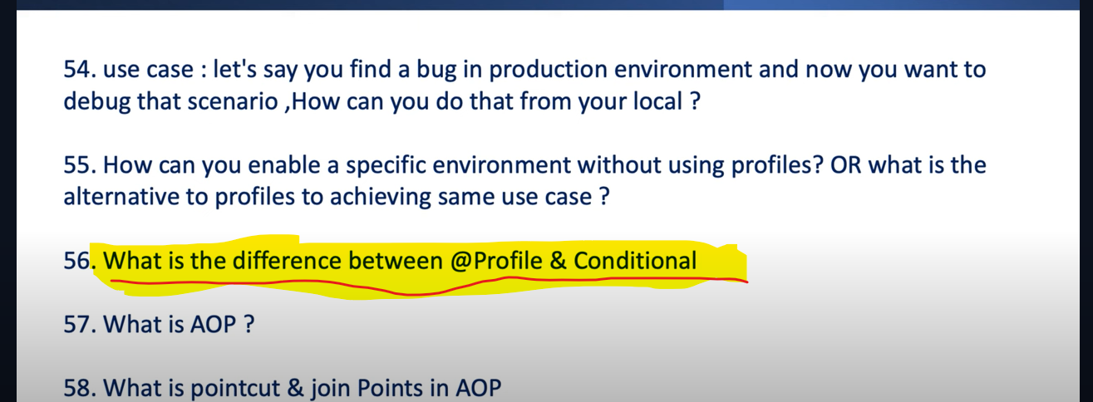

The key difference is **spring.profiles.active** = value which means profiles is specifically designed for activating component based on the active profile in the application.



So, if u go to the @**Configuration** based on the active profile and the value what you defined it will load that corresponding profile.

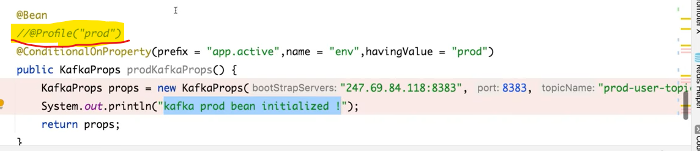

But In @**Conditional** which is a more general-purpose annotation that allow us to define condition for Bean creation or Configuration based on various criteria not limited to Profile. It means using conditional we can define multiple criteria like conditional on Bean, conditional on missing Bean, conditional on class, conditional on property.

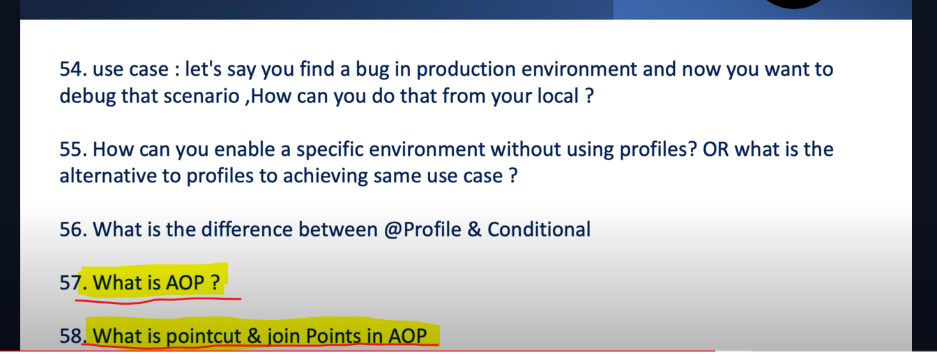

AOP stands for Aspect Oriented Program. AOP provide a way to separate cross cutting concern or secondary logic from the main business logic of our application. So, when I say secondary logic, it could be Transaction, Logging, Validation, Auditing or Notification related stuff. So those logics are secondary to my application.

Without them also my code can run why should I meshed up those cross-cutting concern and my business concern. So, how I can segregate using AOP.

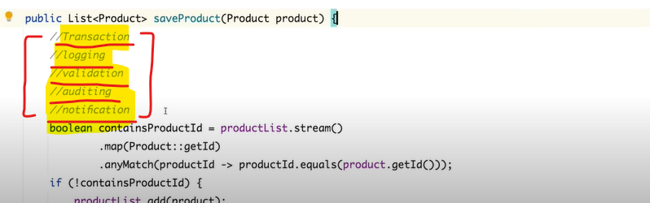

If we are writing the same secondary logic in each and every method so it would be the duplicate of code. These are the secondary logic without these also my business code will work. So instead of duplicating the secondary logic let’s segregate the secondary logic from the business logic using Spring AOP.

So, what we can do using aop each and every logic we can define as an Aspect. So, Aspect means the class which contains the secondary logic. Aspect is the class which contains this logging or validation related logic.

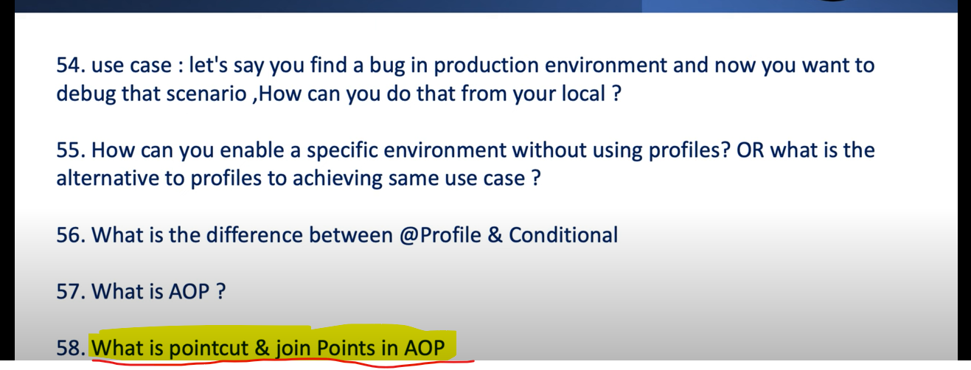

Pointcut and Join Point is 2 crucial terminologies in AOP. In save product method I just want to implement these 3 Aspects (logging, transaction, validate).

**Joinpoint** – so Joinpoint is nothing means Joinpoint is the target where we want to implement this particular Aspect.

For example, let’s say I just want to implement the aspect logging or transaction in getProductByType. So that means the Joinpoint is getProductByType. That is my target where I want to implement this aspect.

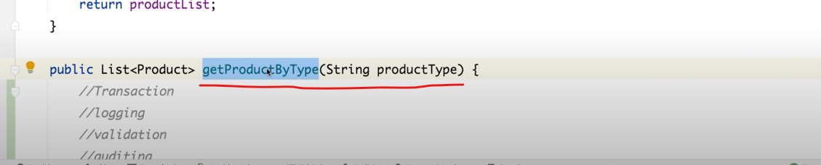

**Pointcut** – so Pointcut is nothing the expression to tell to the AOP that who is your Joinpoint. For example, saveProduct() is my Joinpoint where I want to implement this logging and transaction aspect. How we can tell to the AOP by just defining the Pointcut.

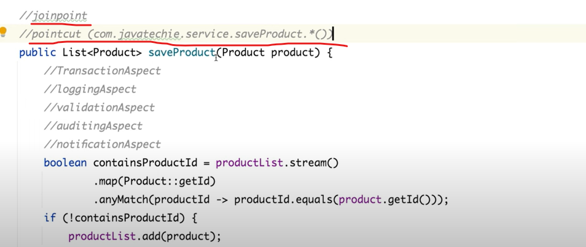

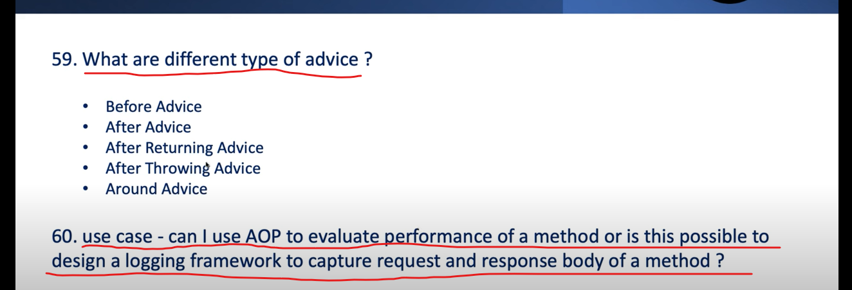

**Before Advice** – If you want to implement some logic which you want to execute before this particular method call then you can go for Before Advice. If you want to perform pre-processing logic.

**After Advice** – If you want to perform any post-processing logic or if you want to perform any logic just after the Joinpoint or after this method got execute.

**After Returning Advice** – why there are 2 advices to perform post processing logic. If u want to execute something after this method execution so just go for After Advice. If you are using after advice, it does not care about the Exception. Let’s say u execute something in this method and you got some exception but still you post processing logic will be get executed bcz u have used the After Advice.

But if you want if there is any error occur and you don’t want to process your post processing logic then u can go for After returning Advice.

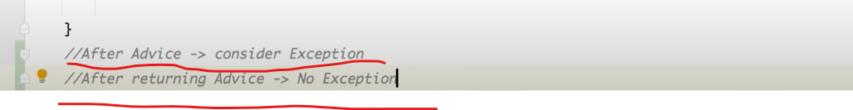

**After Throwing Advice** – If any exception occur then you want to execute an Advice then u can use the After Throwing Advice.

**Around Advice** – around advice is a combination of before and after returning advice. around advice is the key advice in AOP term. Using around advice you can design any custom aspects. If u want to execute something before this method execute and after this method execute then u can go for around advice. If u want to perform preprocessing and postprocessing at a time then u can go for around advice.

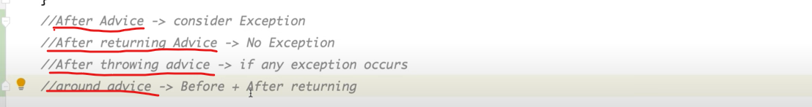

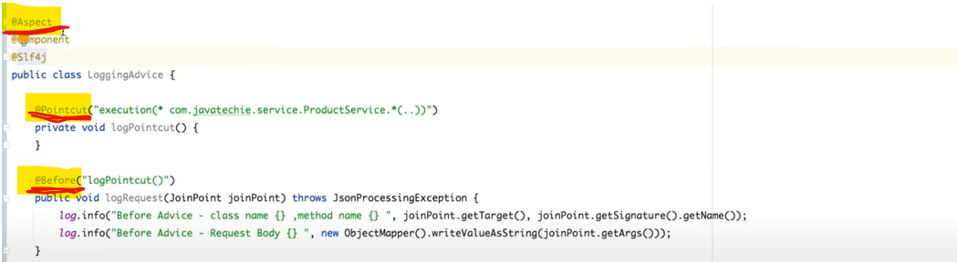

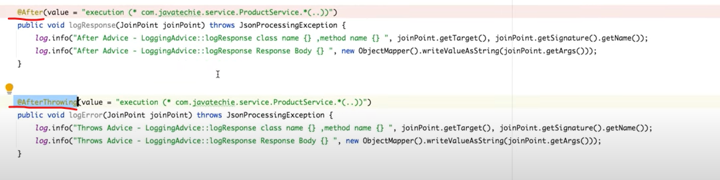

**Part -6**

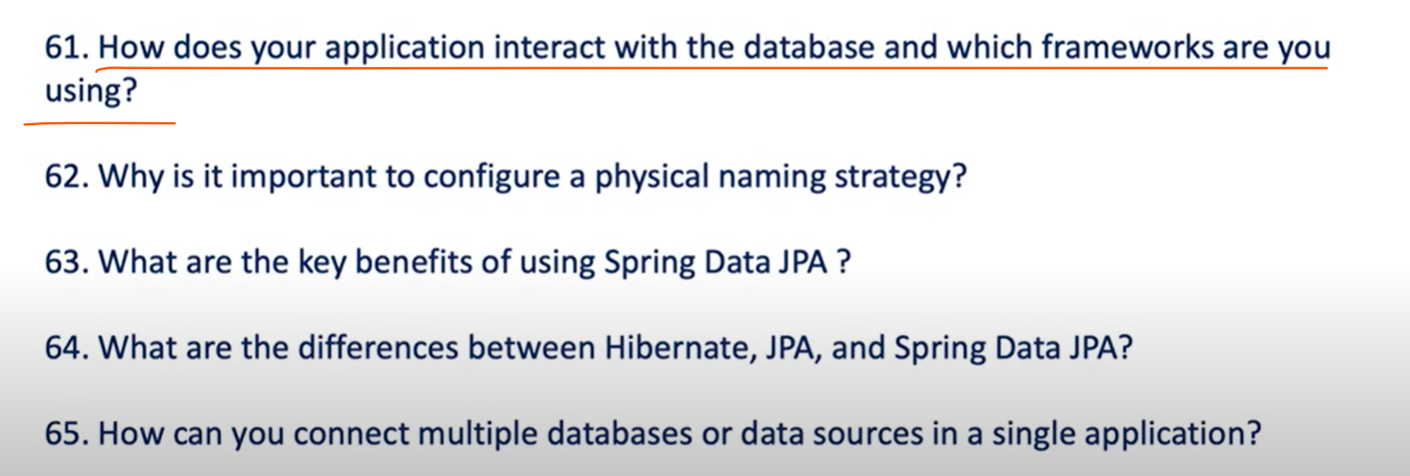

There are many frameworks to make the connection from db to our application like Hibernate,

JPA, JDBC and Spring Data JPA. Since we are using Spring Boot Framework so we are using Spring data JPA.

What all steps to follow to communicate with db and our application-

**1. You have to create an Entity class**

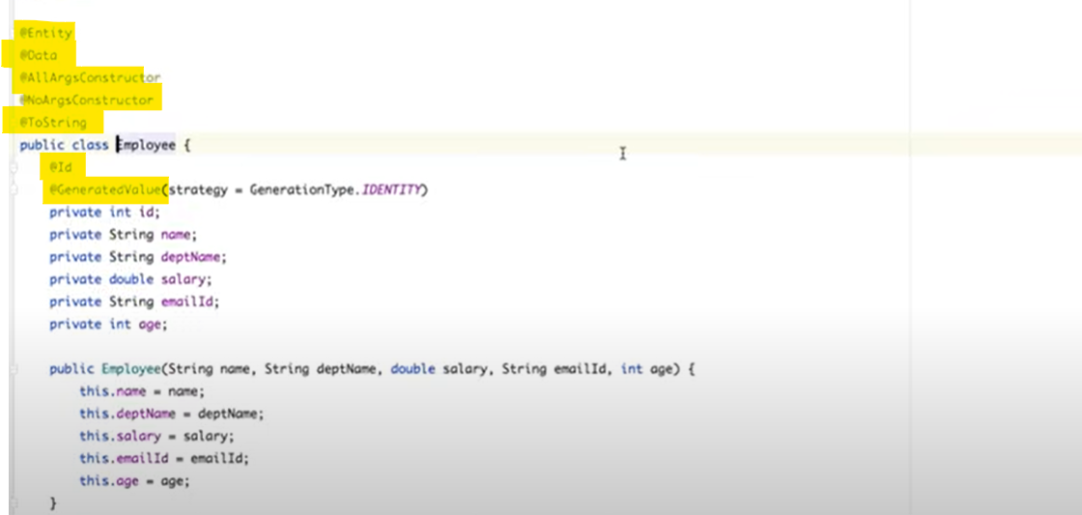

**@Entity –** If you want to define any Pojo as an Entity which you want to store into a db make sure

To annotate this pojo with @Entity.

**@Table –** If you want to create a Table with the defined name or if you want to customize table name. If you do not define then hibernate or JPA will create a table with the class name.

If you are defining any Entity then you define first attribute as a primary key then you must define or annotate with **@Id**, which will be always unique. If you want id to be auto generated then must annotate with **@GeneratedValue.**

**GenerationType.IDENTITY –** auto incremented

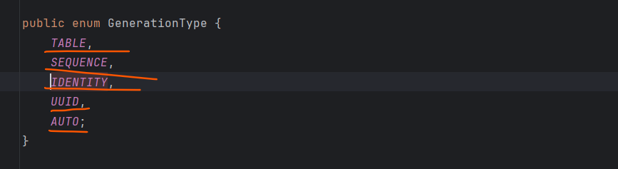

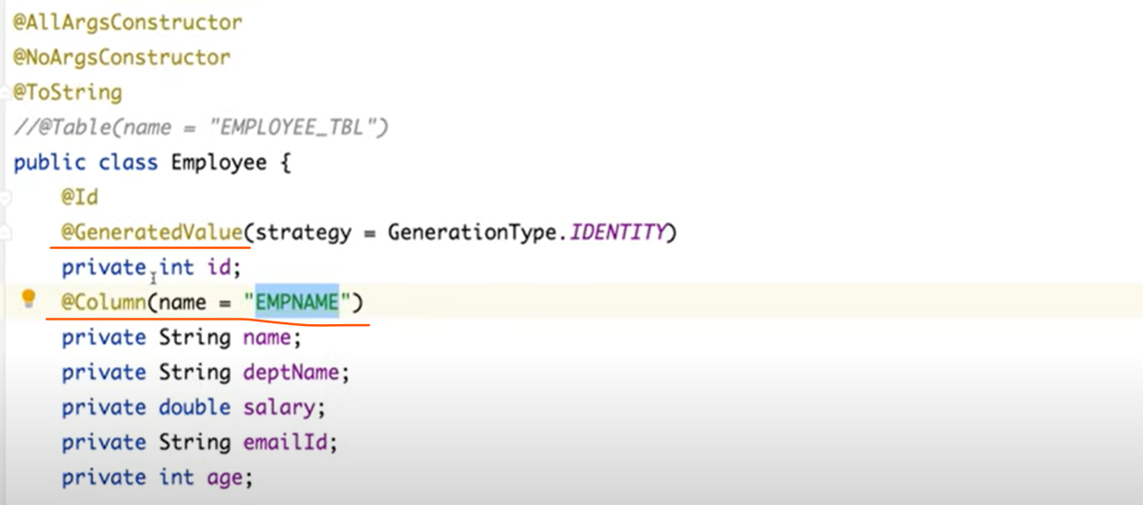

Create a Repository interface and extends with a JpaRepository and jpa repository type would be first would be type of your entity and second parameter will be the data type of your entity primary key id.

**2. you need to define the properties for data source and jpa specific properties**

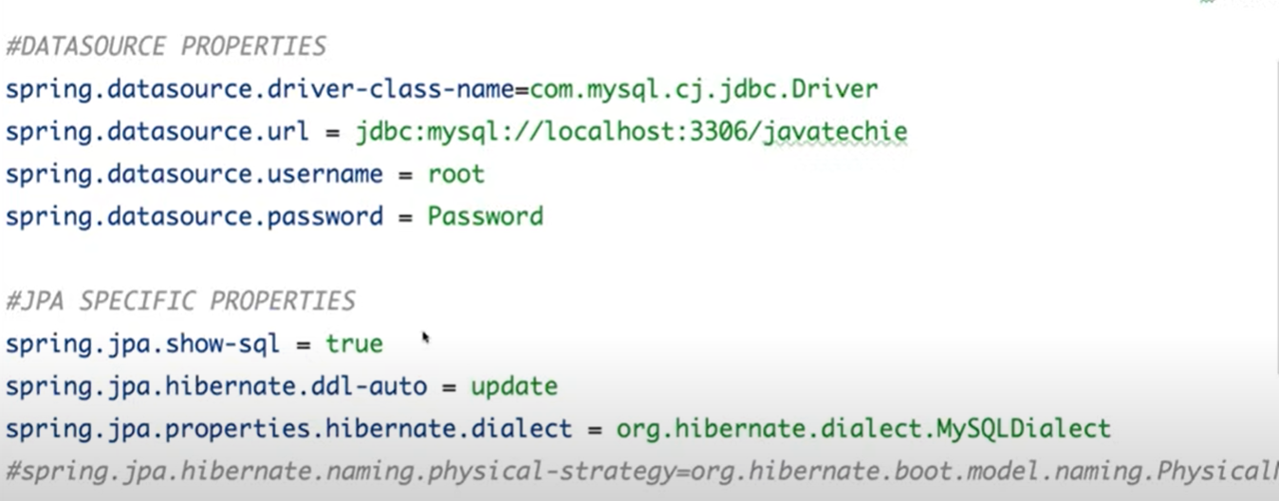

**show-sql** – what all the queries jpa will generate for us we can see in a console.

**hibernate.ddl-auto –** by defaulthibernate will create a table for us.

**hibernate.ddl-auto = update,** so by default **hibernate.ddl-auto=create** so it will always create a new table every time instead we want to update the table if any changes occurred.

**properties.hibernate.dialect** = MySQLDialect, every database have their own dialect to fine tune your query or this particular dialect will help jpa to generate a queries behalf of you. So this dialect will fine tune your queries based on what implementation you are using.

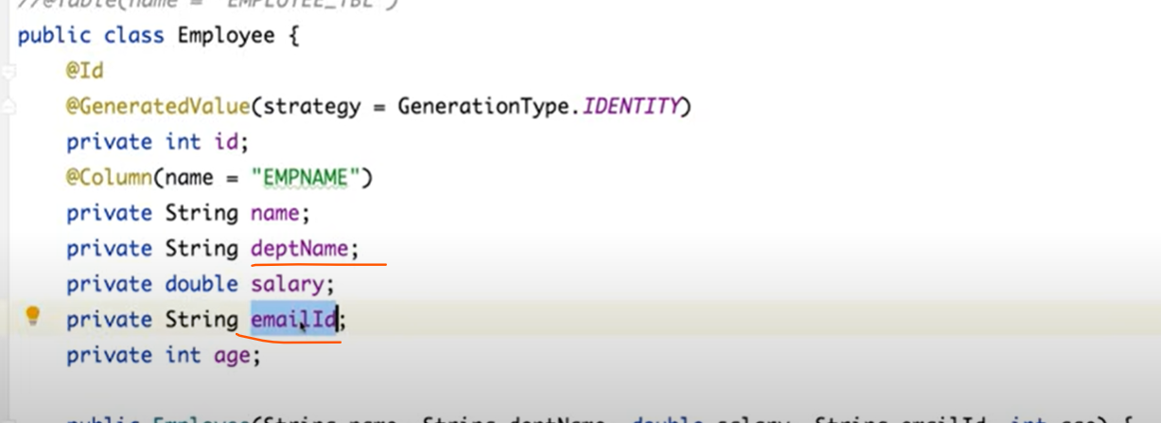

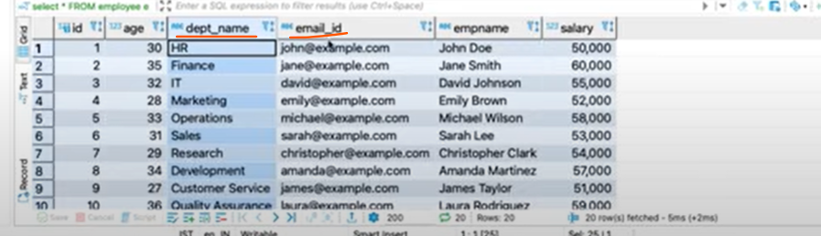

If you can observed column name is diff from our entity they have create with _ like empName is equivalent to emp_name.

So if you want a proper naming convention like our entity filed just declare in properties file

**spring.jpa.hibernate.naming.physical-strategy=org.hibernate.boot.model.naming.PhysicalNamingStrategyStandardImpl**

If you define this in your properties file then you can see changes as a below in db column.

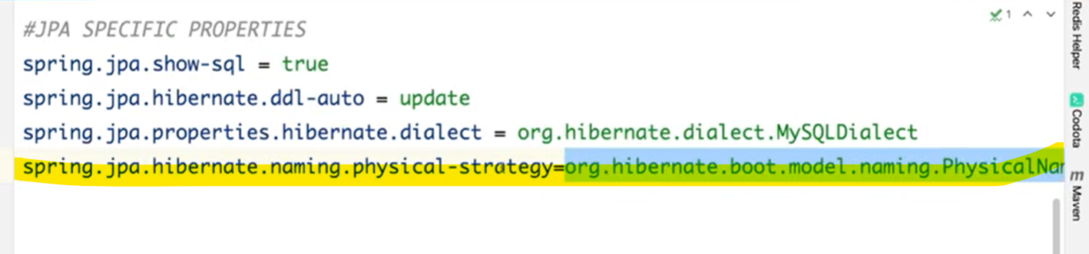

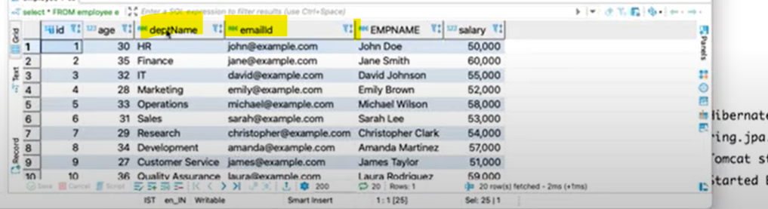

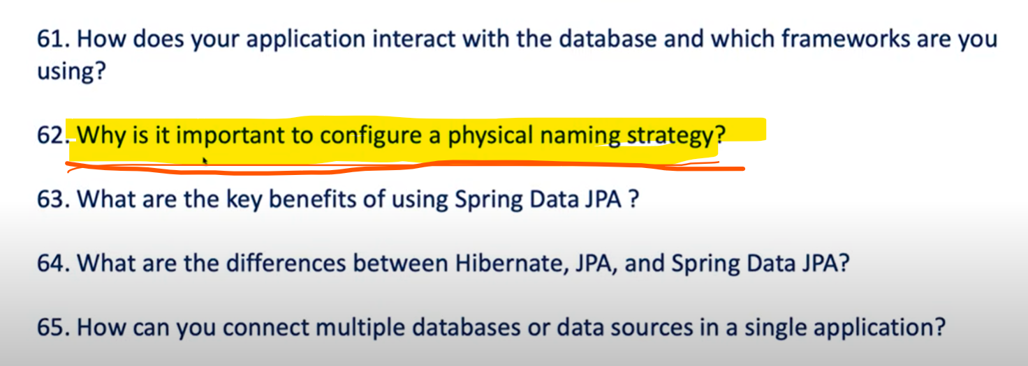





If you can observed column name is diff from our entity they have create with _ like empName is equivalent to emp_name.

So if you want a proper naming convention like our entity filed just declare in properties file

**spring.jpa.hibernate.naming.physical-strategy=org.hibernate.boot.model.naming.PhysicalNamingStrategyStandardImpl**

If you define this in your properties file then you can see changes as a below in db column.





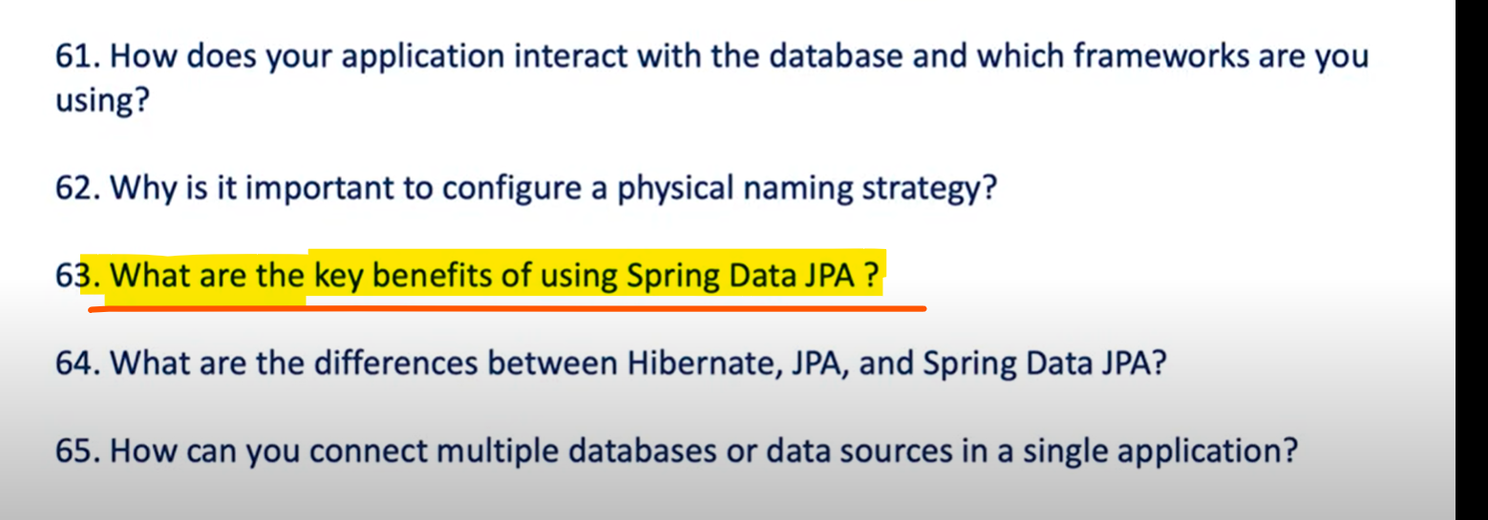

Since we have lots of persistence frameworks why Spring data JPA.

It removes the boiler plate codes.

It also supports Query method generation from Method name which Reduce the need to Write Custom Queries.

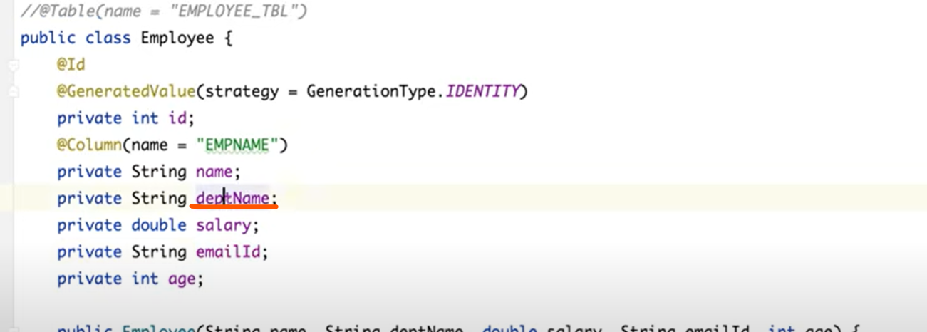

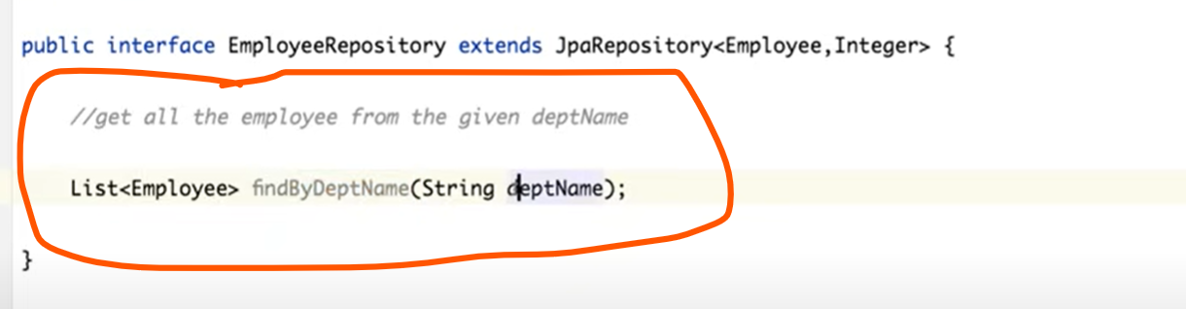

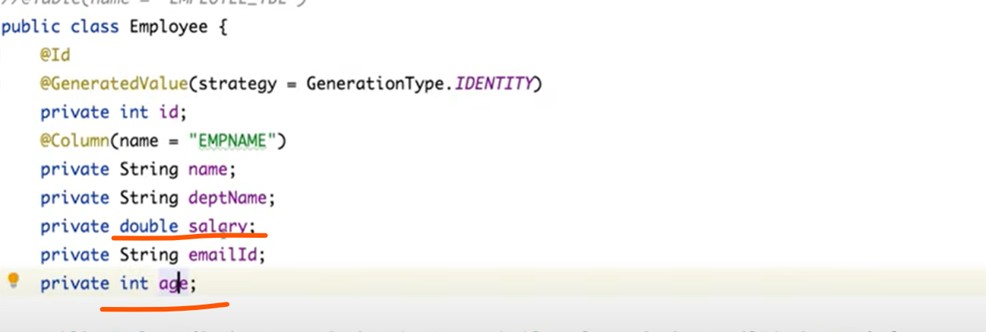

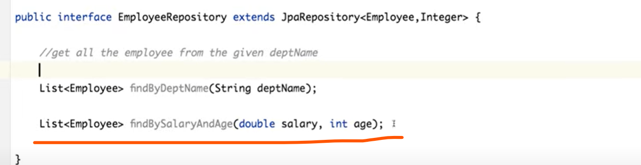

Hibernate and JPA offers the same thing then Why did you choose Spring data JPA over JPA?

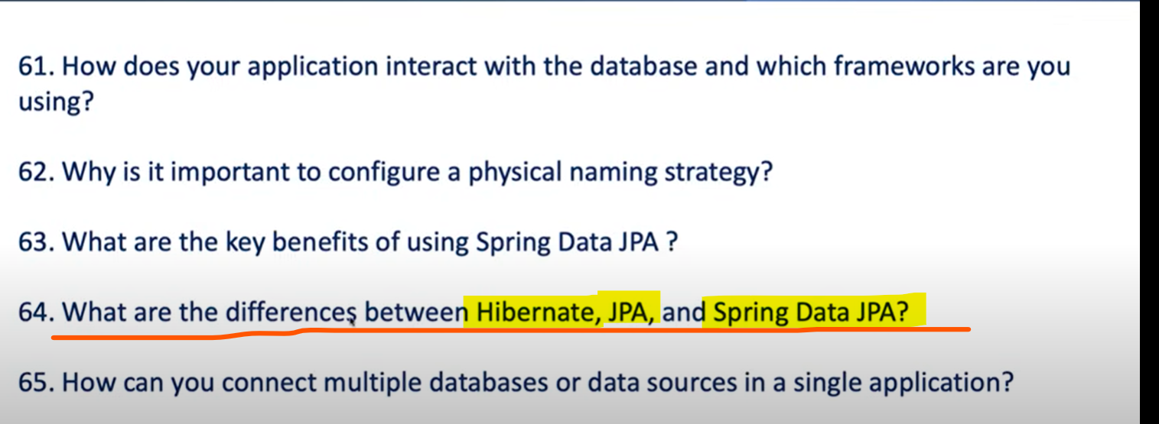

**Hibernate** is an ORM Tool, Object Relational Mapping for Java.

**Hibernate** helps you to do the directly mapping from your table to the Java Object.

**Hibernate** also offers Caching and Transaction.

**JPA** is an Interface and specifications and Hibernate is one of its Implementation.

**JPA** is a Specification who offers couples of API and methods which is Implemented by Hibernate ORM tool. That’s the reason whatever methods available in JPA you will be able to find them in Hibernate.

**Spring Data JPA** is just an Another Layer of Abstraction on top of JPA Framework who again offers couple of utilities methods using that you can able to perform CRUD which is inbuild operation and you will be performing few more additional things like defining the method in the form of Queries.

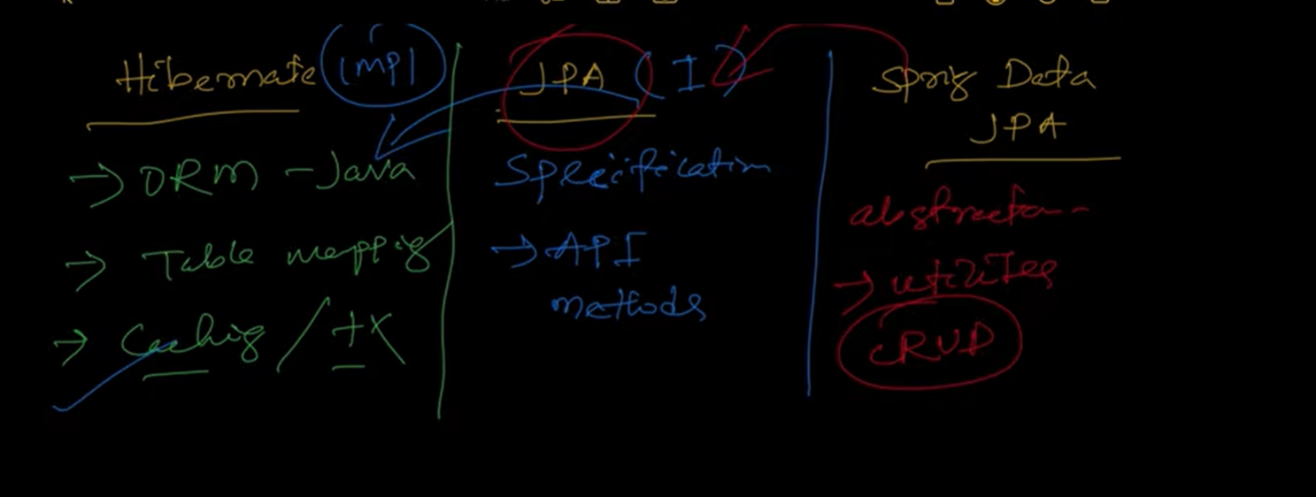

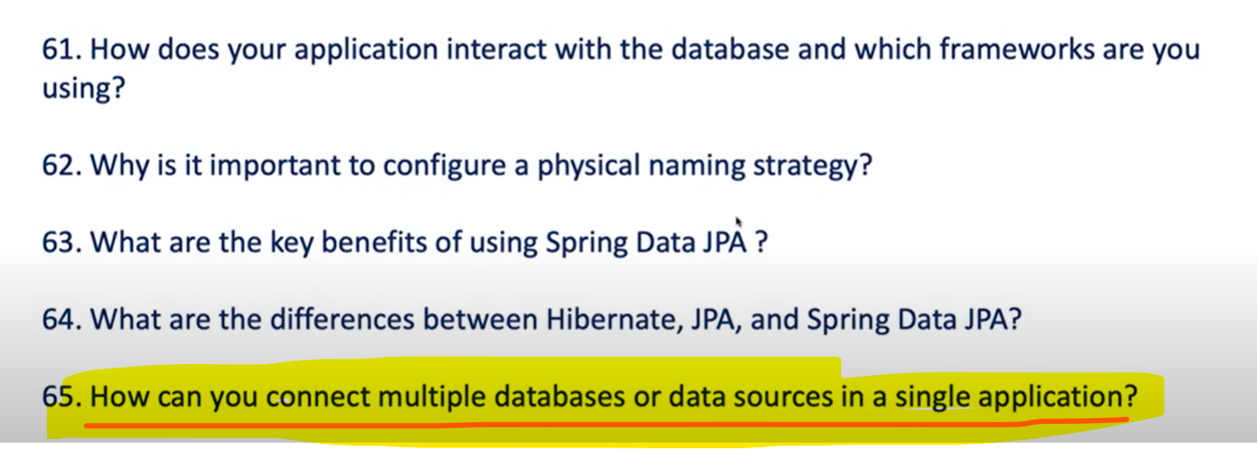

Suppose I have 2 tables **Order** and **Payment.**

I want to store all the order information’s in MySQL DB and all the payments information in Oracle DB and we want to Segregate 2 different data source in a same application to store some different different data, then how can you do it using Spring data JPA.

When we were trying to connect to Spring data JPA We first create an Entity then we create the Repository once we create the repository then we specify the data source and that will Interact to our Database.

Behind the scene since this is abstraction for us what it does this Spring Data JPA at the end using the JPA specification it is just an abstraction.

It create an **EntityManager.** It provide **data source** to an Entity manager then also It create a **TransactionManager** .

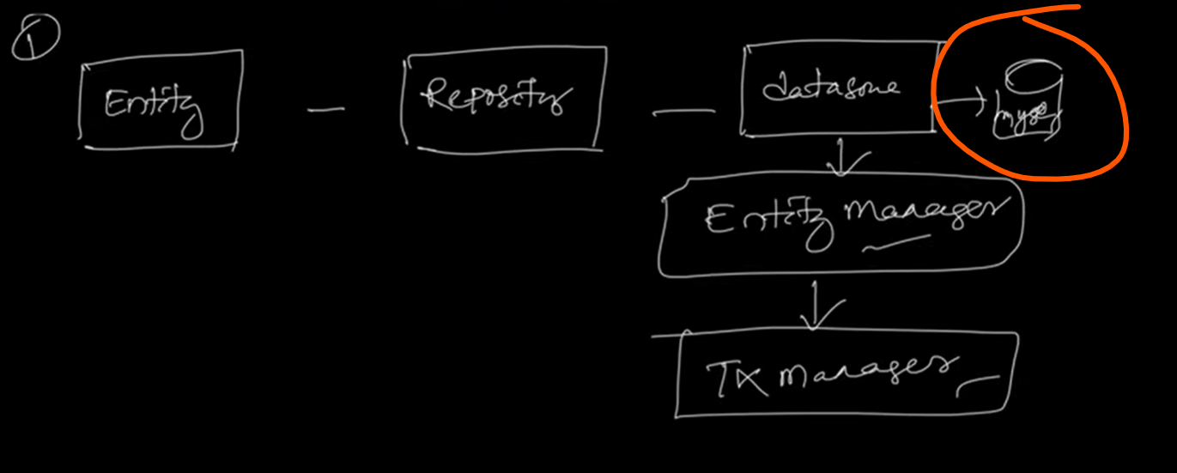

Now If you want to create an another Entity and If you want to store it in a different db suppose this is MYSQL suppose you want to perform the same thing for a different database. So you also need to create an Entity, Repository then again you need to create a data source and then you want to connect to oracle db and then behind the scene it create an **EntityManager** and **TransactionManager**.

Since we want to keep 2 different data source oracle datasourec and mysql datasource in a single application so you need to define 2 Different data Source

**STEP 1** you need to define 2 different data source.

Once you have define 2 different data source then

**STEP 2 Entity** and **Repository** you have to define for each and every entity

**STEP 3 Need to define Entity Manager**, since you have different data source you have a different **Entity Manager** and **Transaction Manager** for each entity you need to customize them. You need to define 2 different Entity Manager 1 for MYSQL and one for Oracle

**STEP 4 Need to define Transaction Manager**

So for each and every configuration you need to define explicitly because you are playing with 2 different databases in a single application.

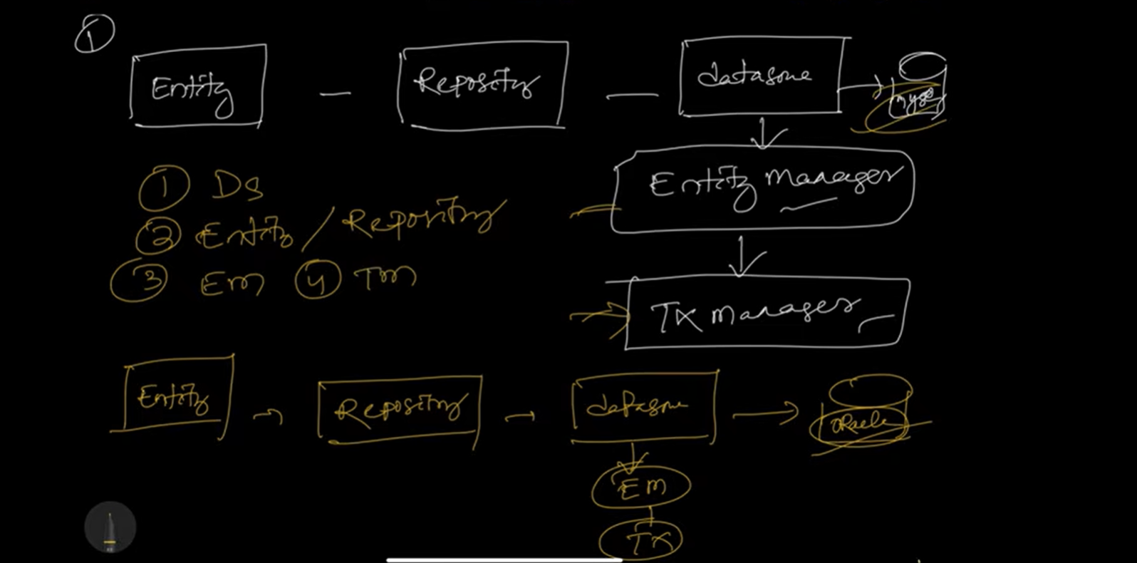

Behind the scene JPA does for us but since if u want to customize you have to override entity manager and transaction manager.

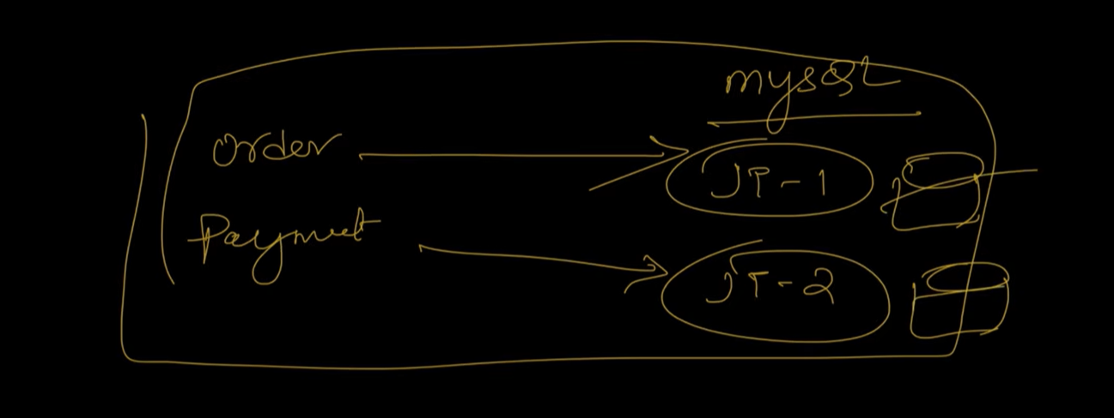

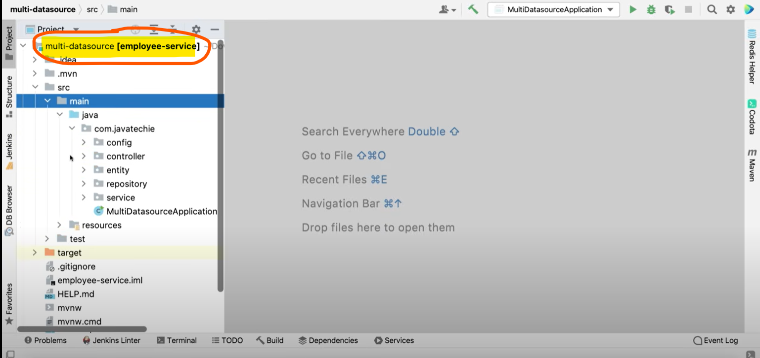

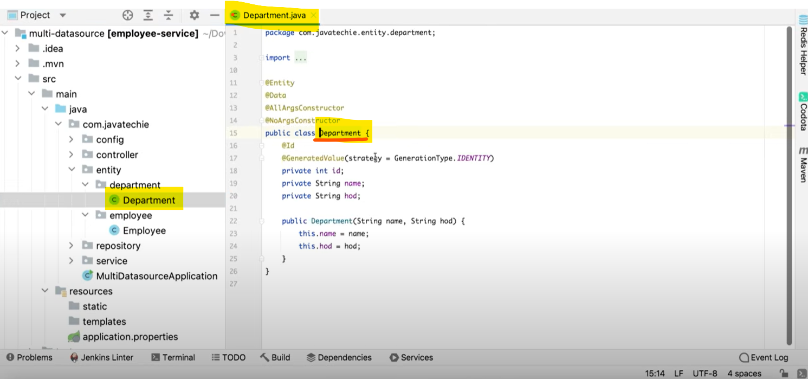

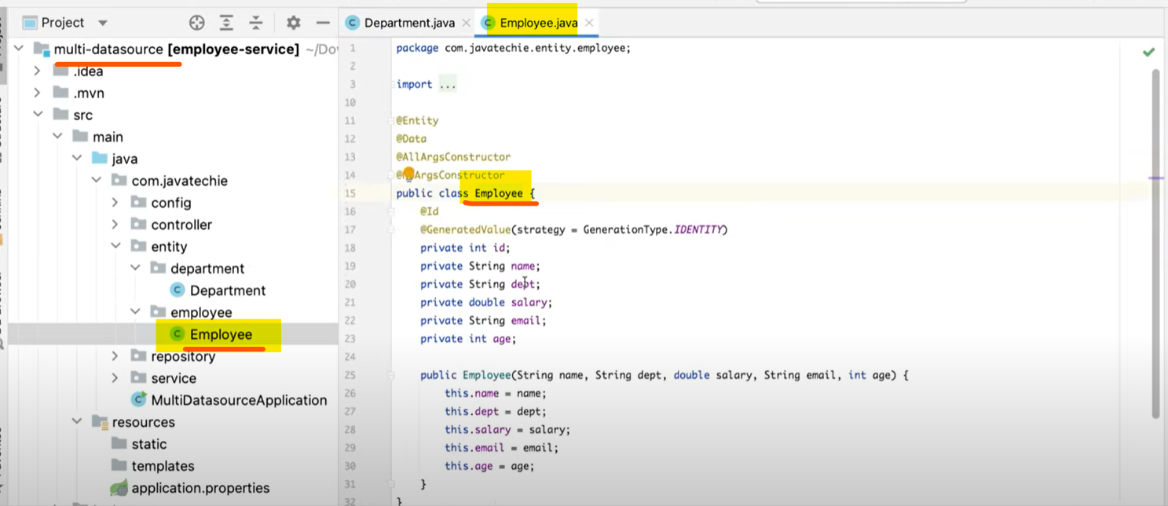

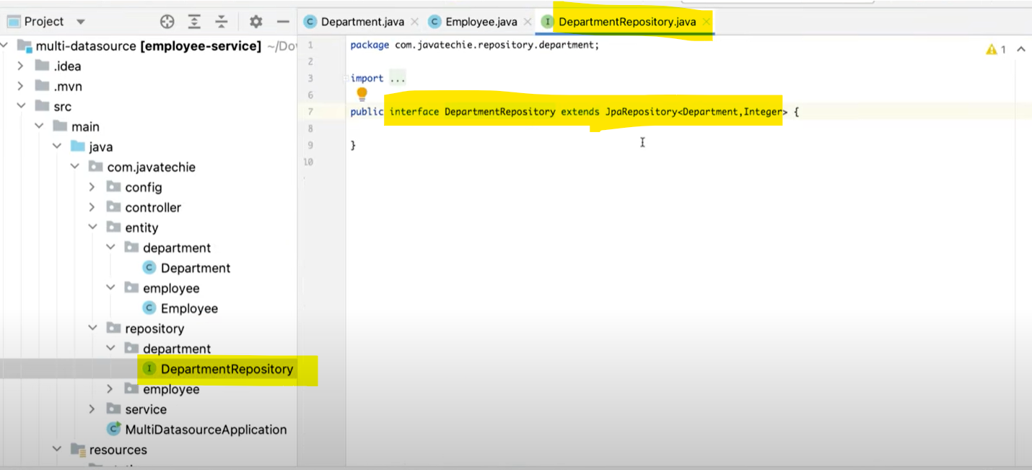

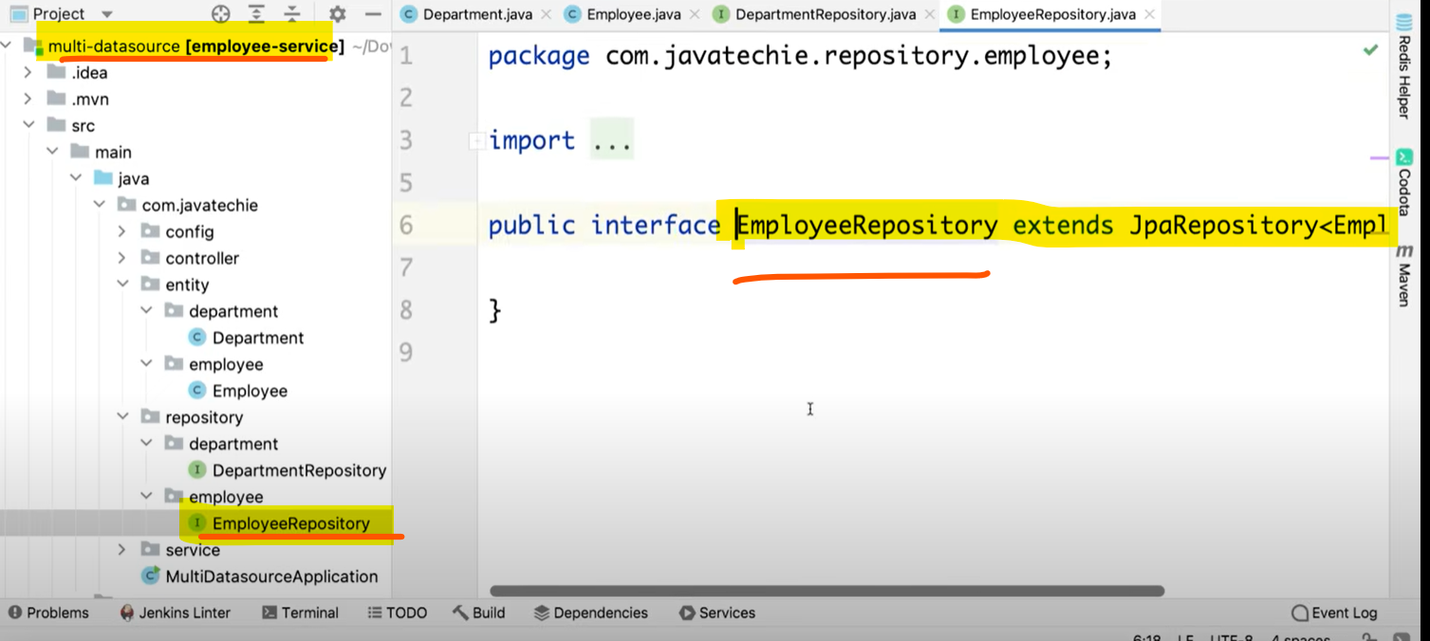

**2 different data sources**

We have added prefixes to show 2 different data sources for **employee** and **department**

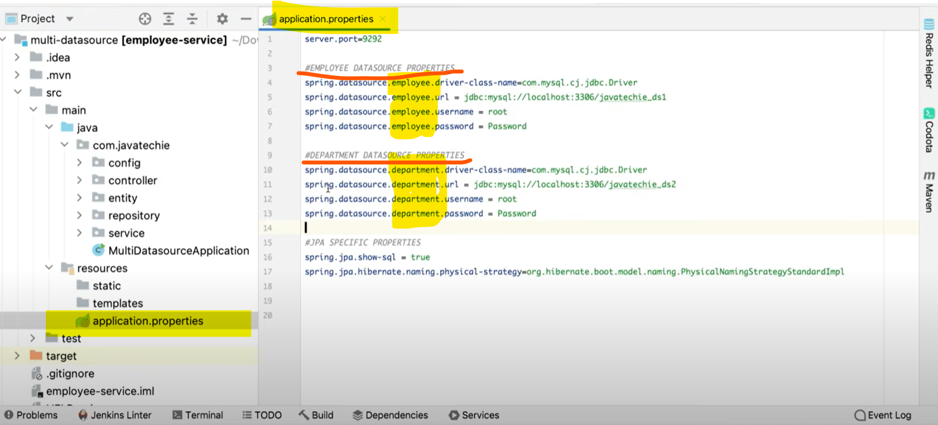

If you can observe employee data is saving in database ds1 and department data is saving in database ds2. employee data is saving in schema ds1 and department data is saving in schema ds2.

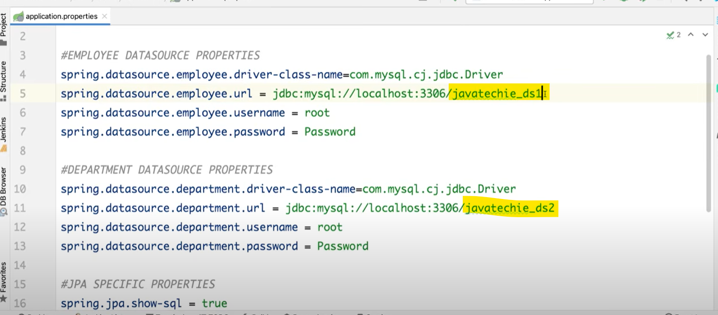

So, we need to create a diff entity, repository and we need to segregate the diff data source properties.

Now this data source properties we need to give it to Entity Manager then Entity Manger need to give it to Transaction Manager.

Now How can I tell Entity Manager for Employee related operation take this data source and for Department related operation take this data source so, you need to define the configuration.

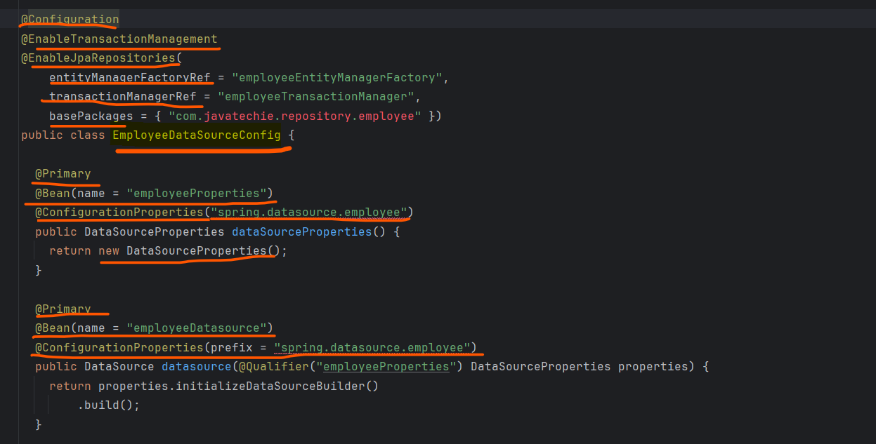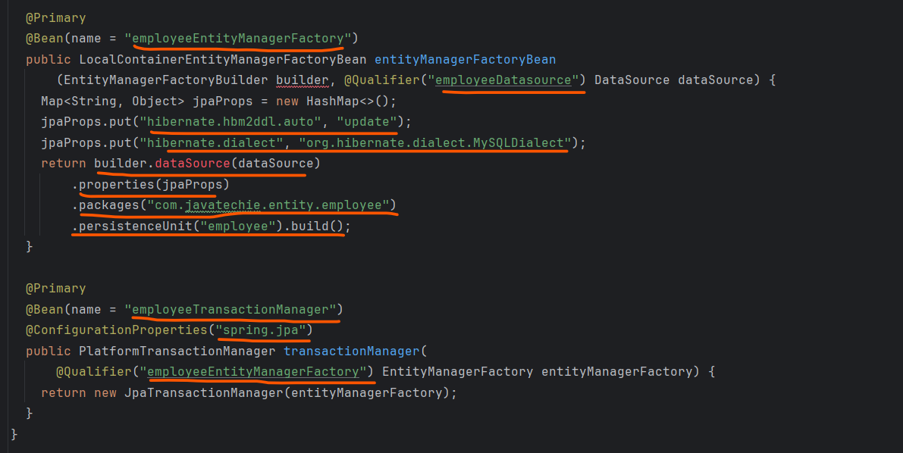

**You can define multiple Entity inside a single Data Source.**

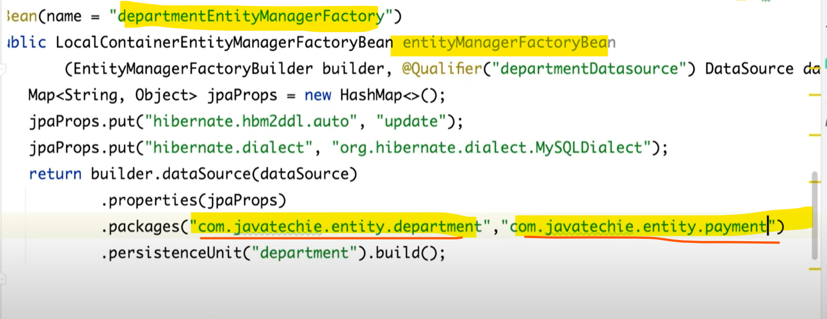

**So, if we do have multiple data sources Then How we can find which one is the default one or how we can give priority to one of our data sources. So, we can use @Primary while we are defining the annotation “Bean.**

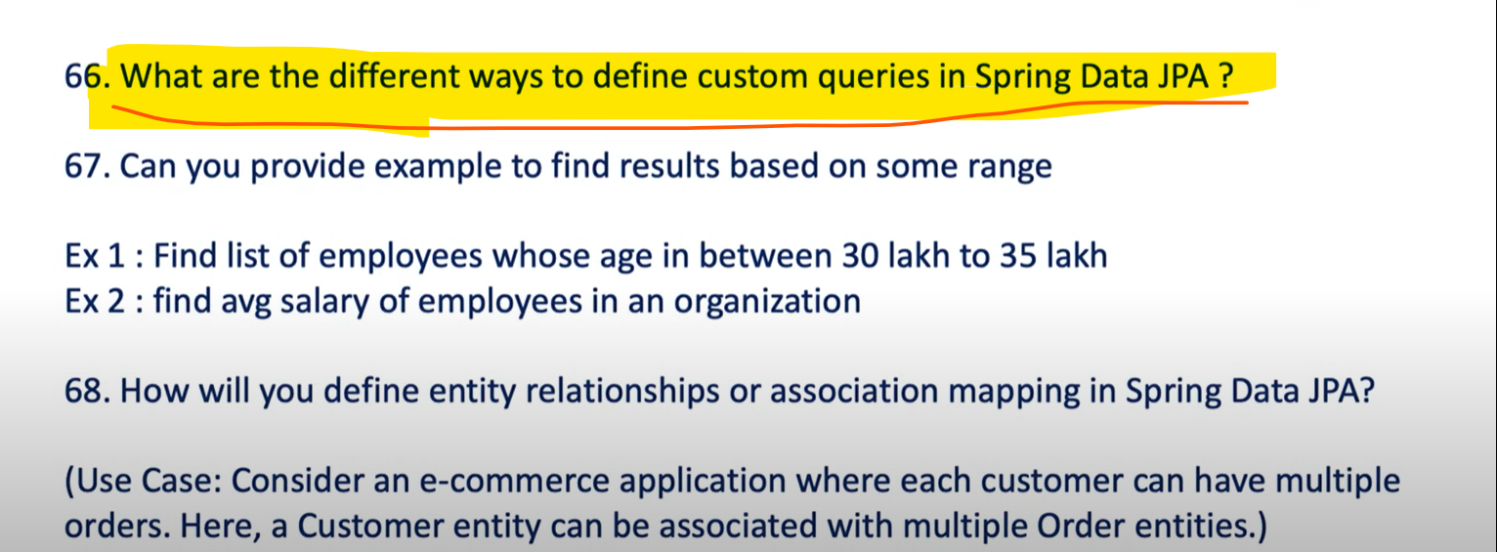

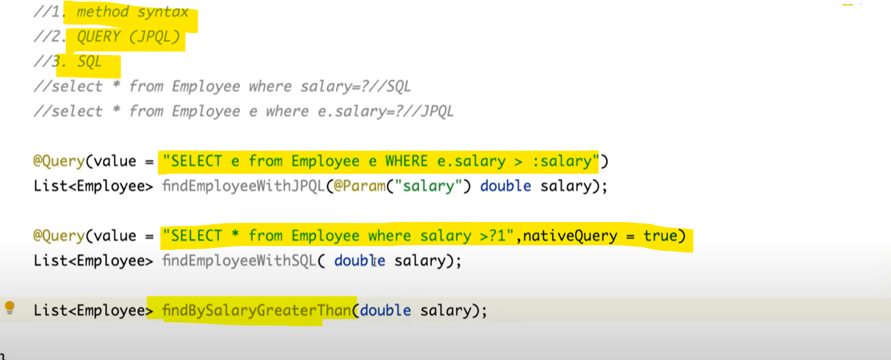

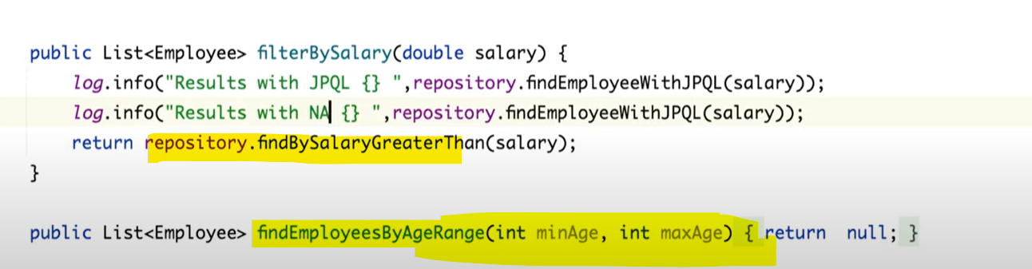

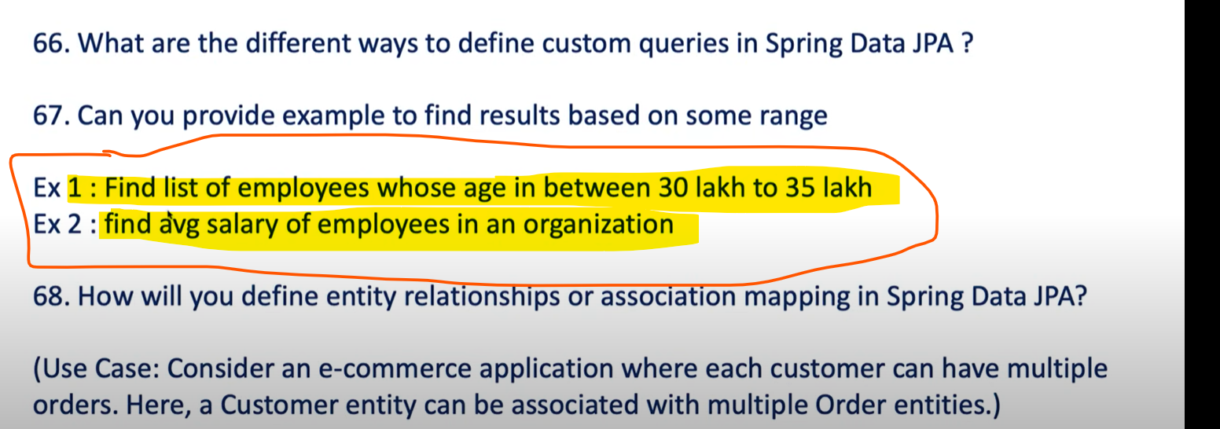

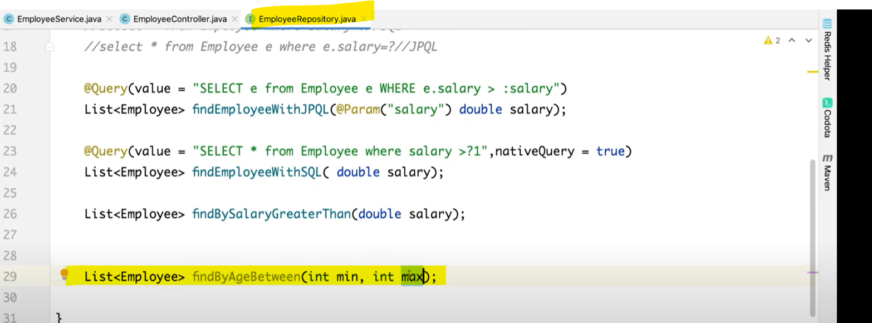

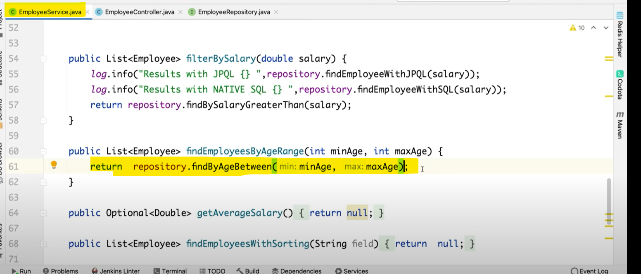

**Aggregate function will not be directly supported by spring data jpa.**

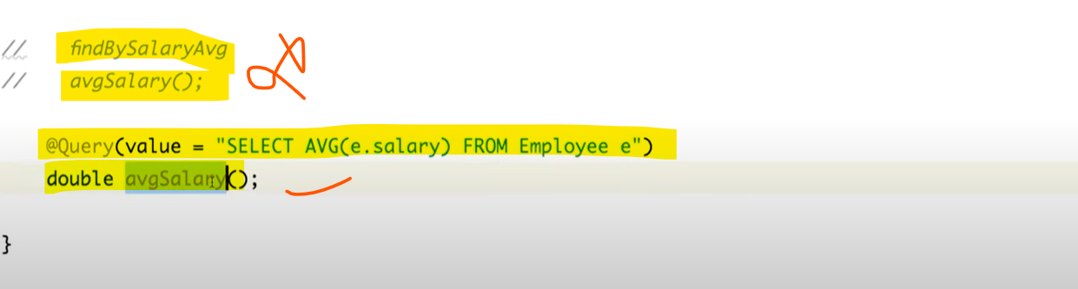

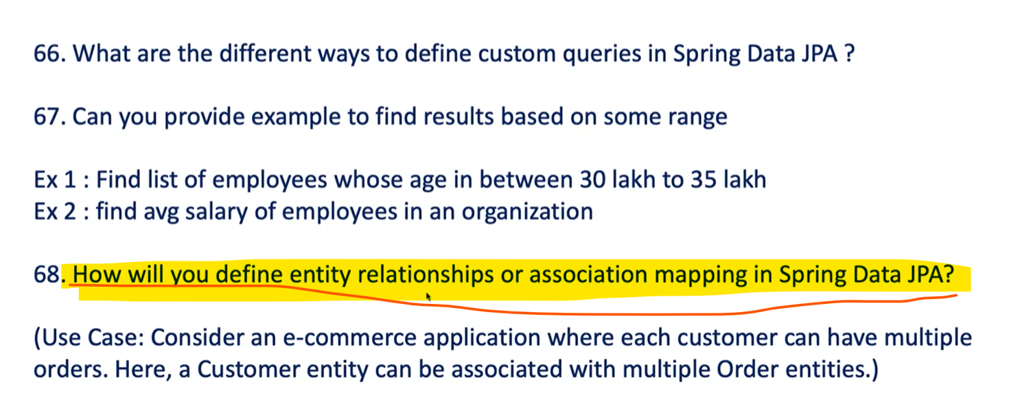

**This approach is not recommended if you are using microservice architecture. In microservice we do have a design pattern called database-per-service each service pointing to their own database. So, it’s not good practice to keep an association mapping or entity mapping in microservice architecture.**

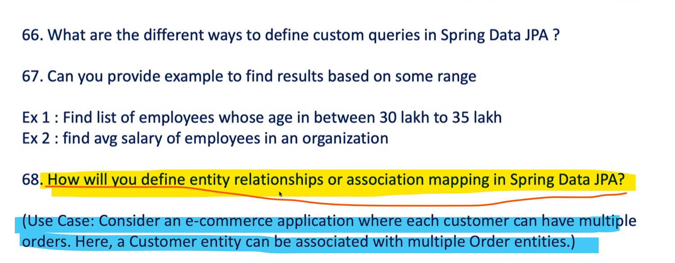

**One customer can purchase multiple products vice versa all products can be purchased by a single customer.**



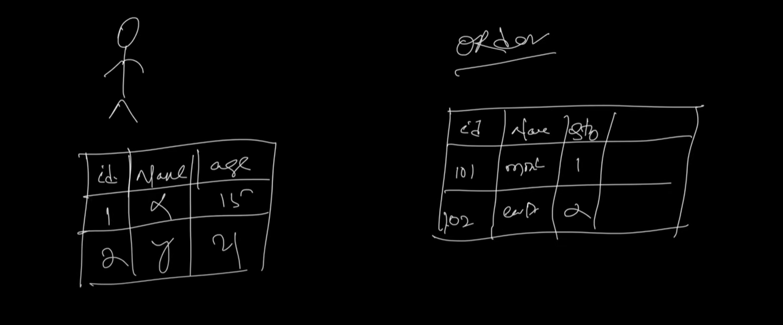

**How will you find this particular product is purchased by whom.**

**You have to map primary id column from a customer table to the foreign key in order table. So this primary key of a customer who is owner of this mapping that must need to map here. So, in order table customer_id column work like a forign_key.**

**Let’s assume that product 101 is purchased by customer 1 and product 102 is purchased by customer 5.**

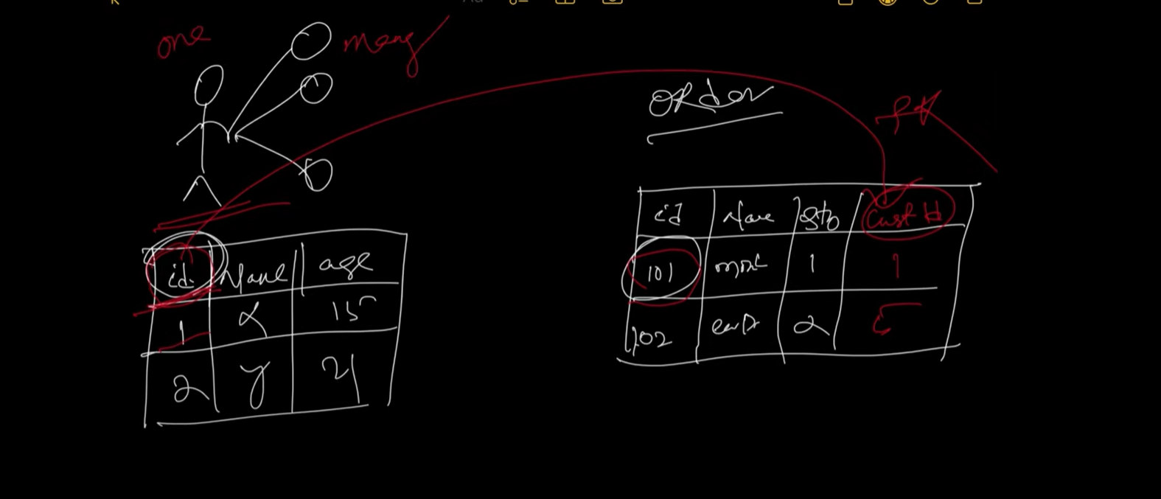

**So, one – to – many products. So, always it’s good to maintain the bi-directional.**

**So, one customer can purchase multiple products and in reverse order multiple products can be purchased by a single customer, so here many orders can be purchased by a single customer.**

**So, it’s always good to maintain a bi-directional. So, it’s one to many but from child side if you observe it’s many to one.**

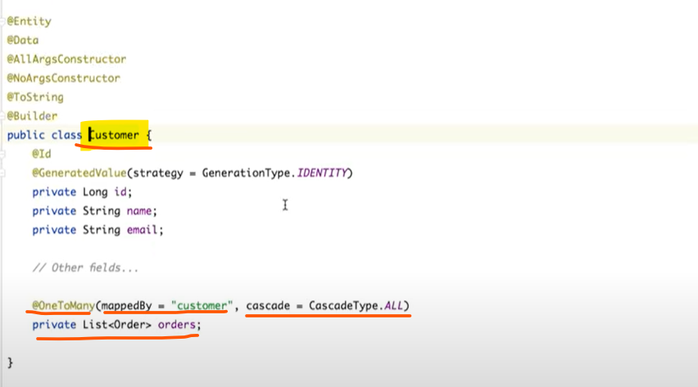

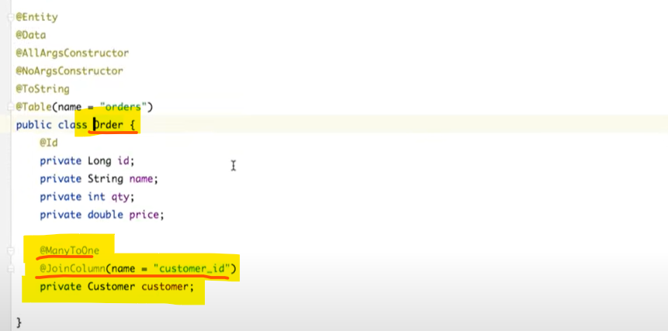

Since one single customer can purchase multiple orders that’s the reason, we kept List<Order> orders even we can kept set of orders.

Since one single customer can purchase multiple orders that’s the reason we annotate **@OneToMany** then we define **mappedBy** customer so in this relationship customer and order who is the owner **customer** is the owner so **mappedBy** indicate the field in the child entity that who owns the relationship. So, one customer can purchase multiple orders so who is owner here who is doing action customer, so I have defined customer as a **mappedBy** to this order entity.

I have also defined **CascadeType.ALL** means when I am doing any operation along with the parent please play with my child as well. So, this is one way of mapping from customer to order.

Now, If I will go to the Order in Order also, I have field id, name, quantity and price and if you see **@ManyToOne** many orders can be purchased by a one customer, and we are defining a **@JoinColumn** as a **customer_id** which will be there in the Order table.

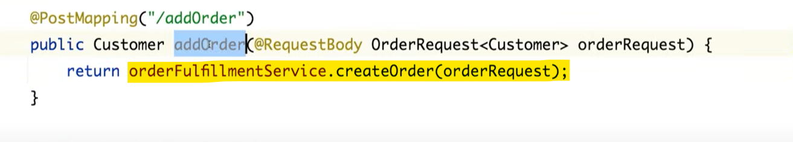

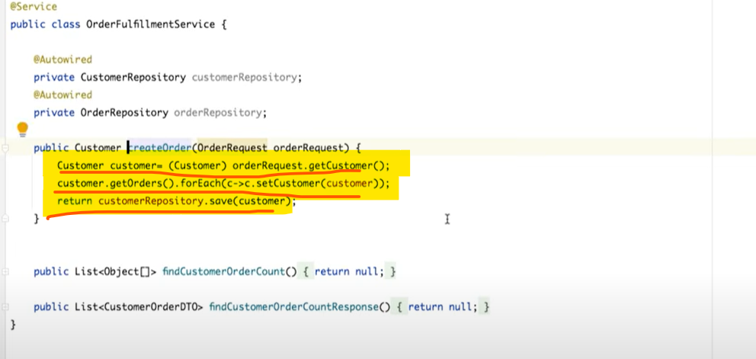

I am going to save a customer with a list of orders. We are setting the customer who purchased the orders.

This below line is for many to one.

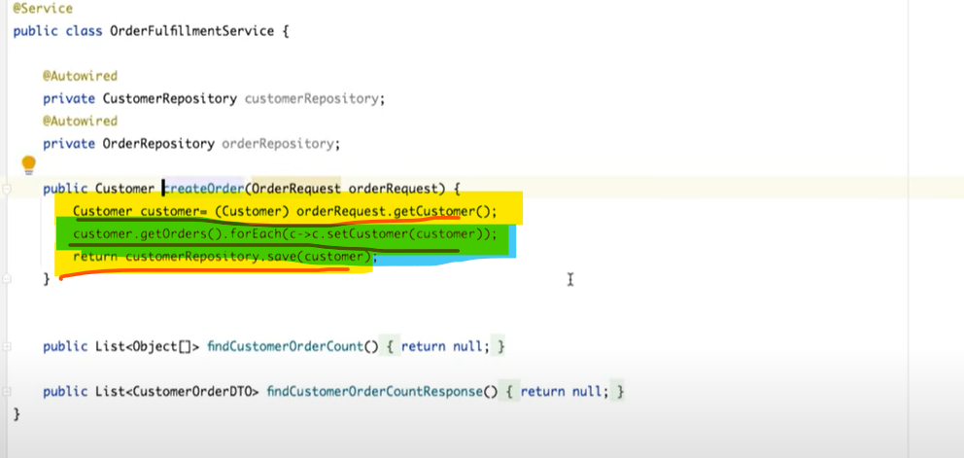

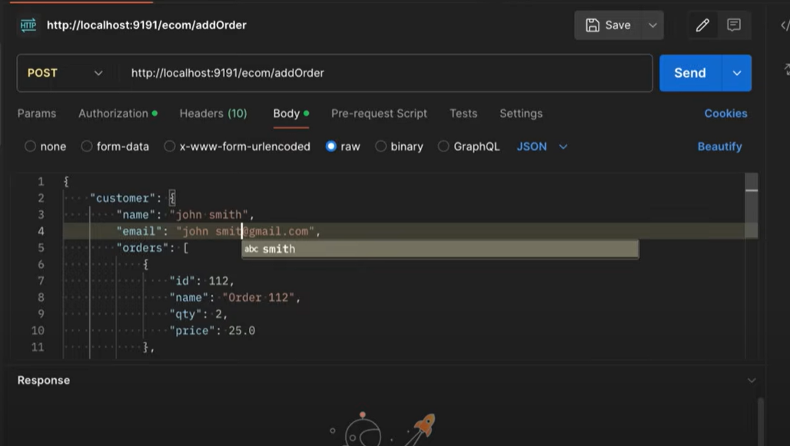

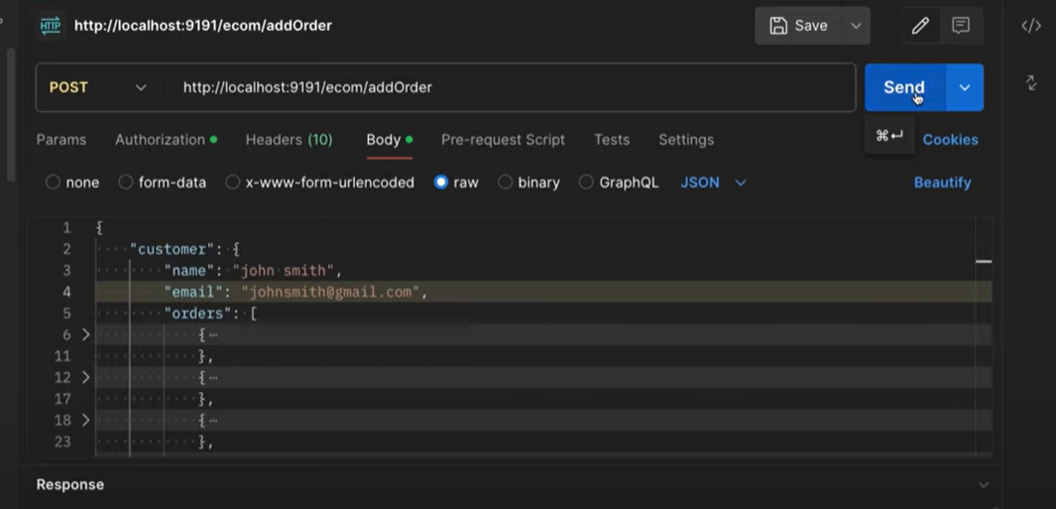

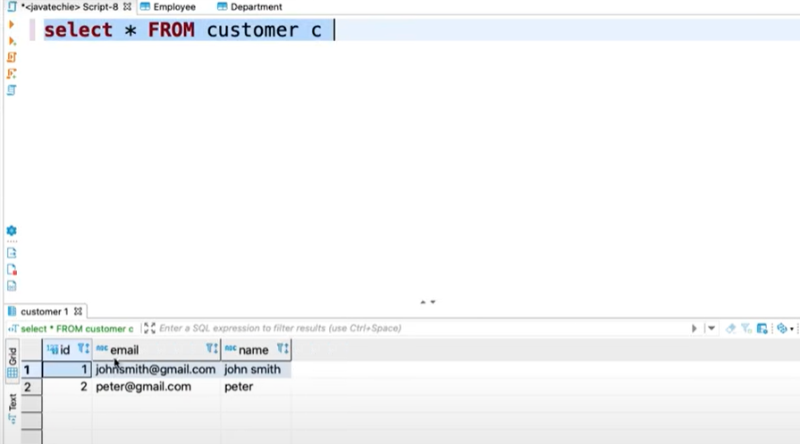

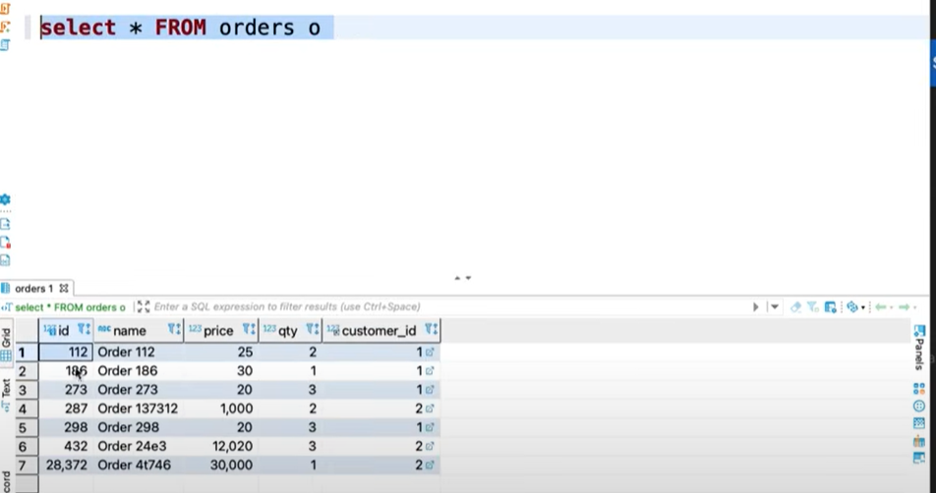

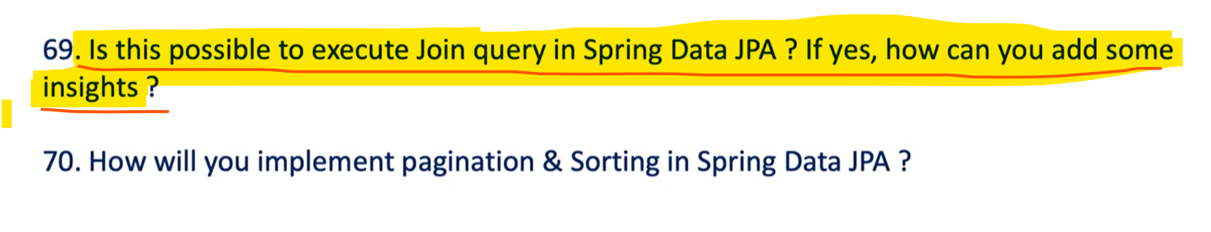

If you are working on microservices it’s not good practice to do mapping between the entities. So, you do not need any JOIN query if you are working on microservices in some scenarios if it’s needed how will you perform JOIN query in Spring Data JPA.

Suppose I want to find the customer’s name and the total number of products he purchased.

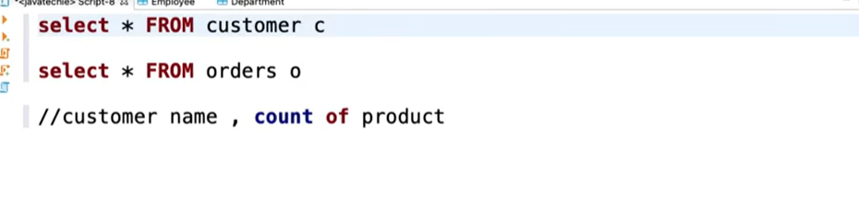

So, from the customer table I want to find the customer name and the total number of products purchased by the customer from the order table.

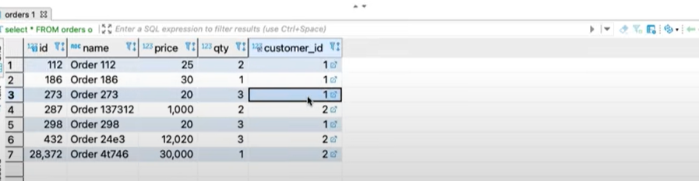

So, we have the customer id so we can count no. of customer id present in order table and we can fetch the customer’s name from the customer’s table just using the JOIN statement. You have to write a custom query because there is no in-build method defined by join query.

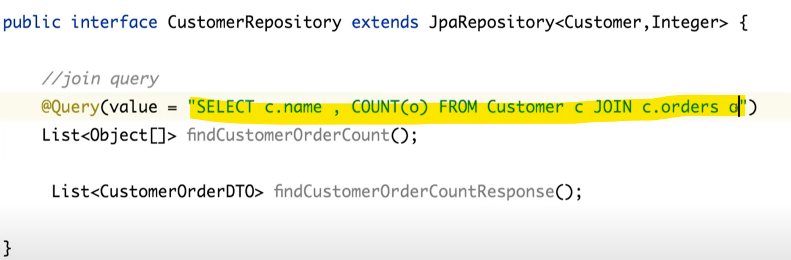

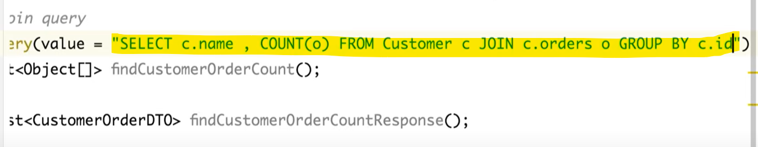

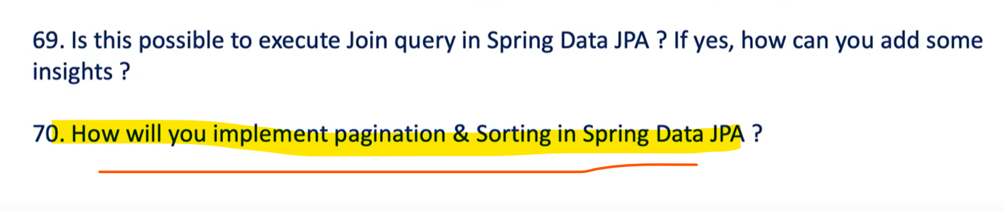

Suppose I am getting thousands or millions of responses then How can I display them in our front end.

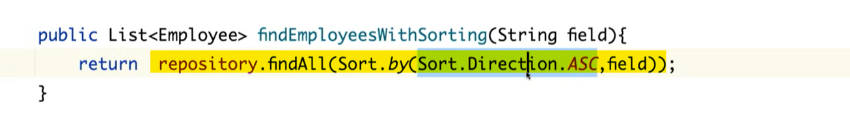

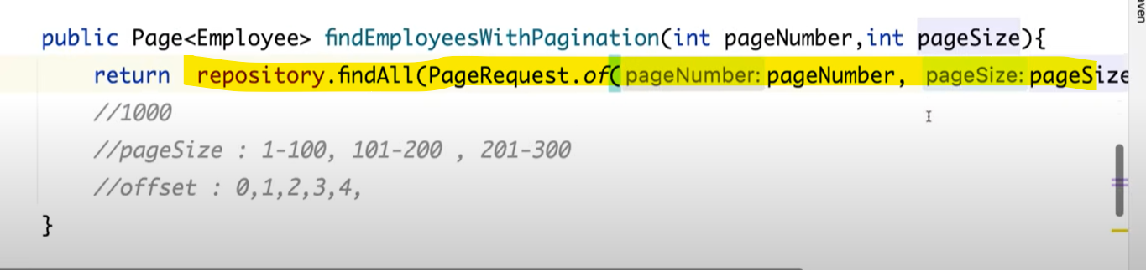

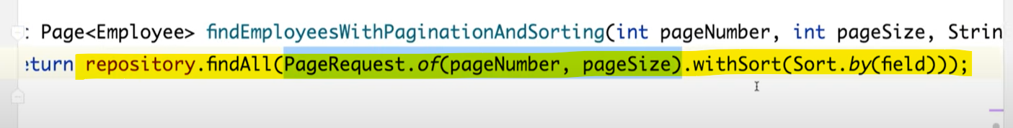

**Part - 7**

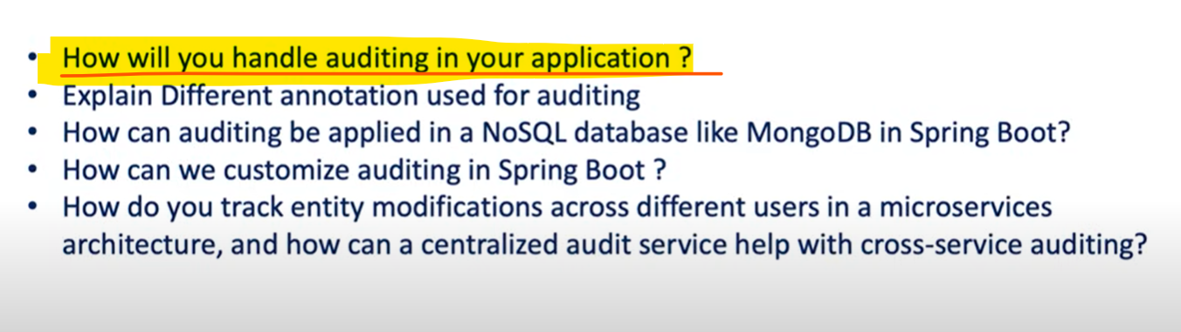

Why do we need Auditing??

Suppose I have one Item Entity which is Inventory_Items table and suppose we have 4 API methods get, post, put and delete and I have added 1 item in inventory some other people has updated the no. of items for a specific product id but how will you figure out who did it why he did it and when he did it.

So, If someone did the change, he should have the valid Reason why he did the changes so, in real time we are using so many entities, and we need to keep track of those entity changes otherwise it’s difficult to figure out who did and when he did the changes. So, this is the reason why you need **auditing** in your project. So, we understand why auditing is a key aspect of an every applications.

Spring Framework has provided one **Template** to go with Auditing.

Very first step you need to enable the auditing for your Entity class by annotating or using **@EntityListeners** and this class offered by the Spring data JPA class.

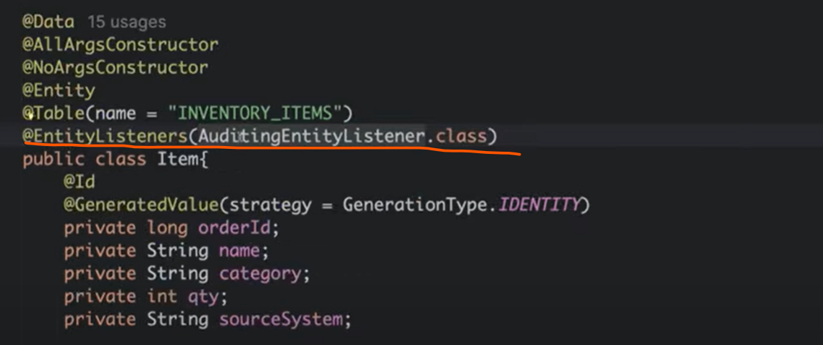

Once you have done that then you have to keep track on Entity changes right like who created, when created and who updated and when last time get updated.

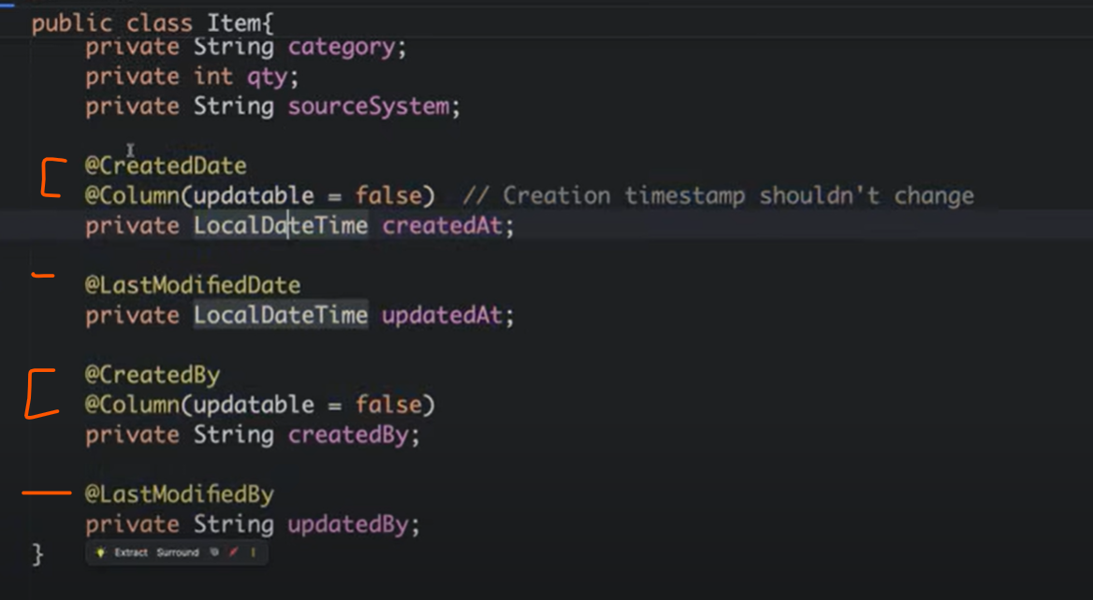

These annotations came from **spring framework.data**

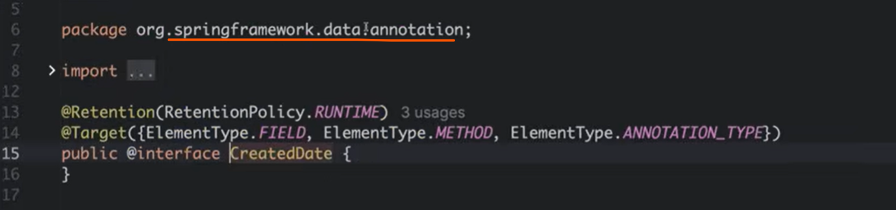

So, if you want you can change field name but annotation name you can’t change. Apart from it you also need to create a **AuditingConfig** configuration class or you can use @**EnableJpaAuditing** annotation in a main class.

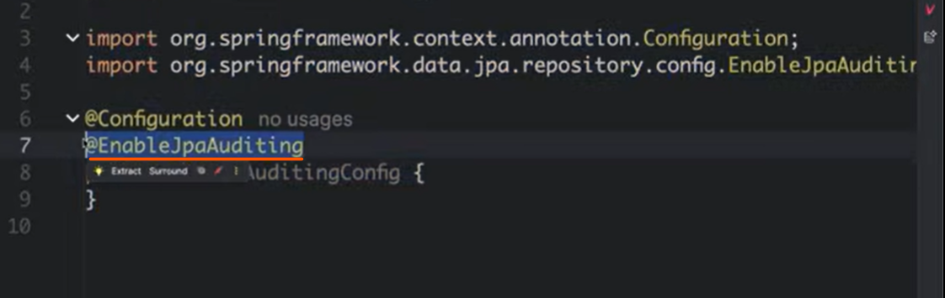

Who created and who has updated how spring will found that kind of information for that who is the last logged in to your user application.

So, for that there is an implementation **AuditAwareImpl**  and it’s implemented from **AuditAware** Interface.

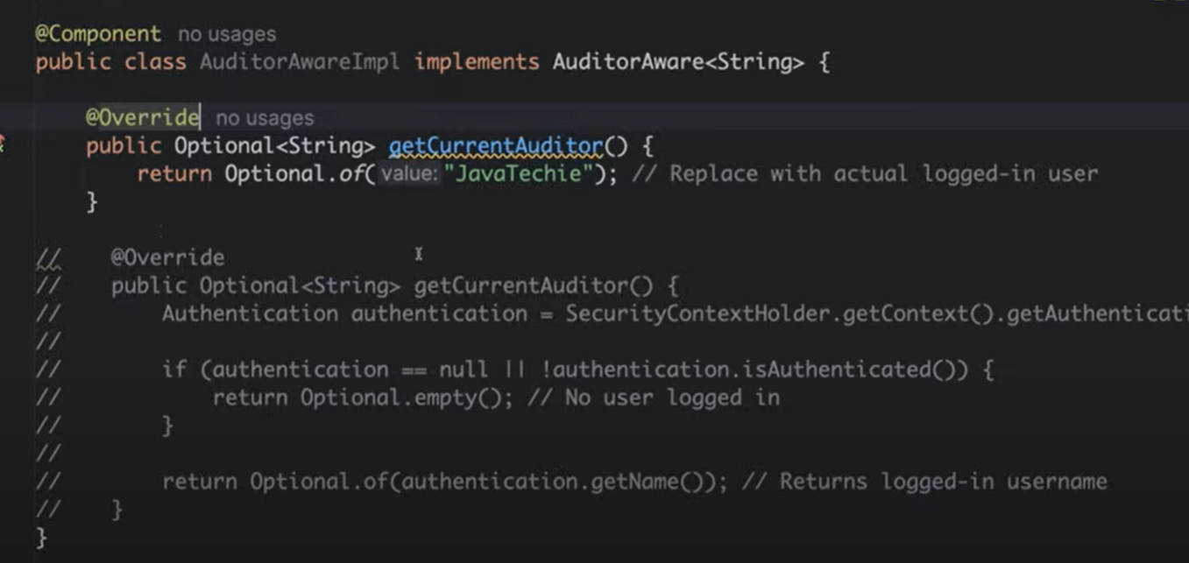

**For auditing there is 4 points:**

1. You need to enable the annotation **EntityListeners** in entity class.
2. Define the attribute to track the entity changes with annotations **@CreatedDate, @CreatedBy, @LastModifiedDate** and **@LastModifiedBy.**
3. Implement AuditAwareImpl to capture userId.
4. You need to enable auditing by annotation in main class **@EnableJpaAuditing.**

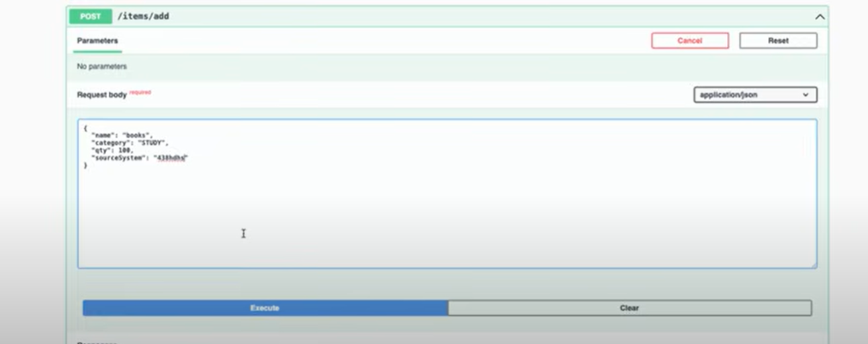

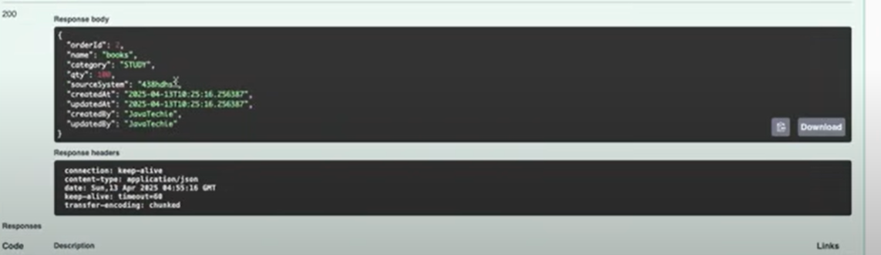

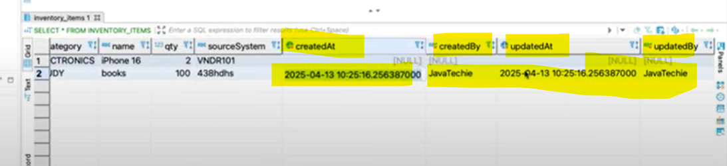

This is how you can do the auditing on your entity.

Currently we are hard coding the userid, let’s try to find out the logged in user id.

Let’s enable security

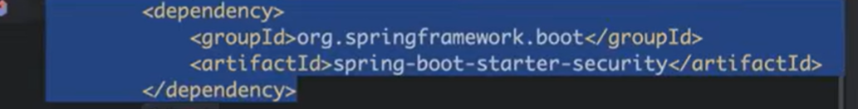

Now go to security config since there are so many controller but I want to enable security only for the Item create and update scenarios.

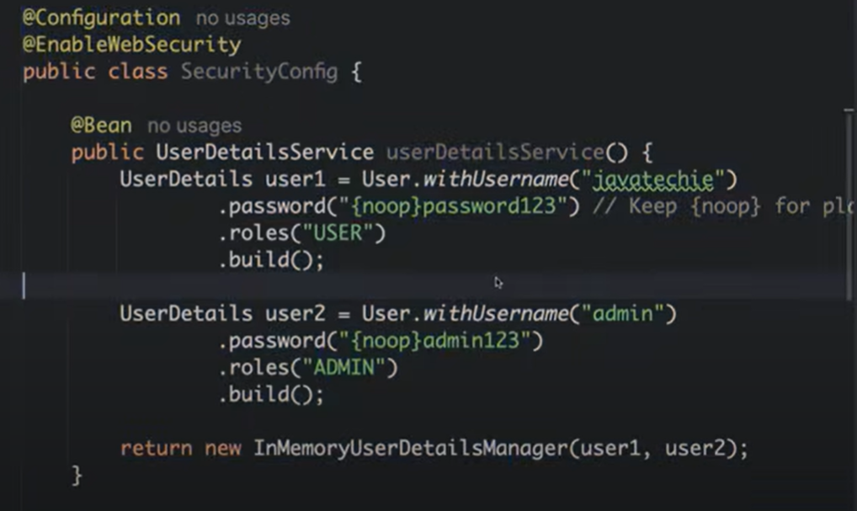

I have hardcoded 2 loggedin user I am not connected with db so using InMemory db credentials.

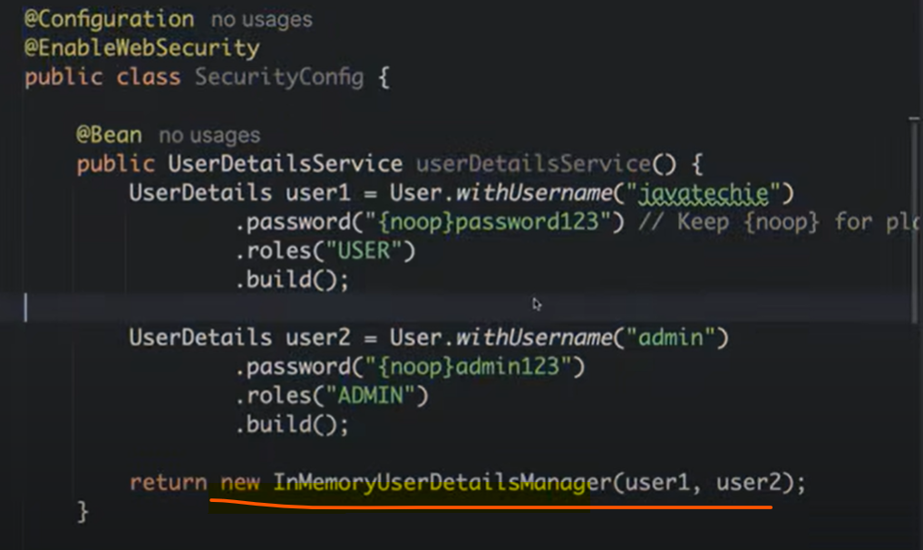

And we have added security filter chain. So, if any request coming with endpoint /add, /update and /delete then authenticate them otherwise allow them.

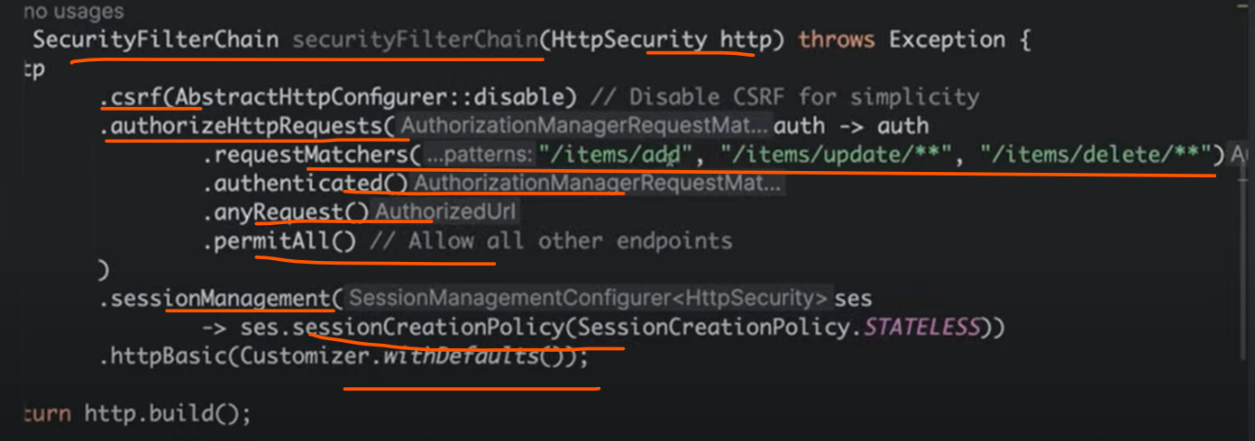

Now you want to get current auditor details for that get it from the Security Context.

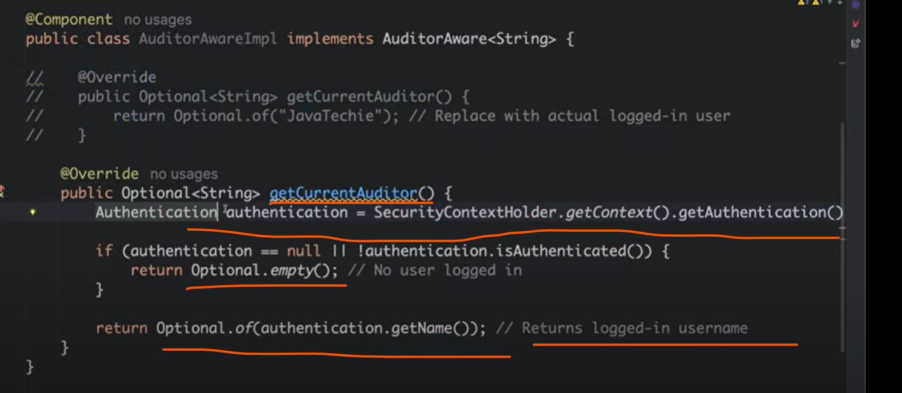

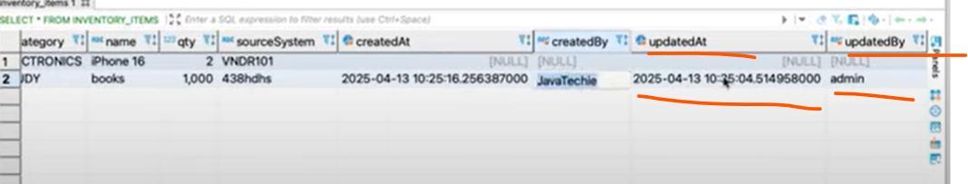

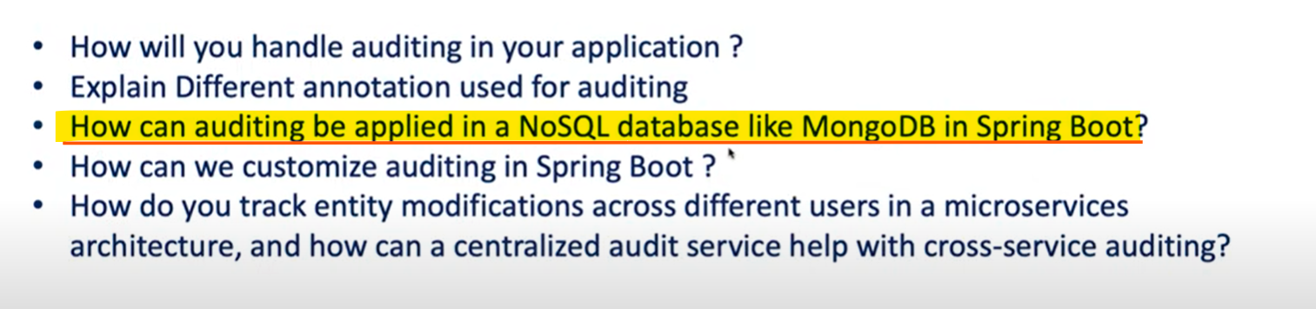

So, in a same way we can do it only changes need in an annotations and rest of all changes would be same.

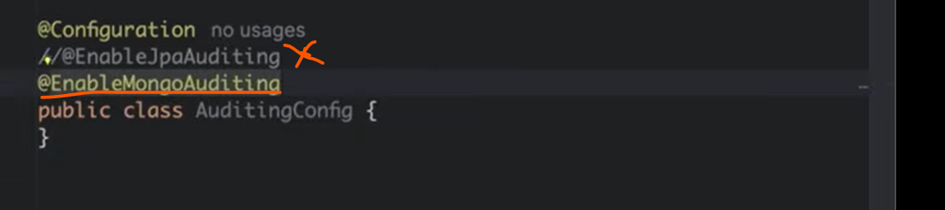

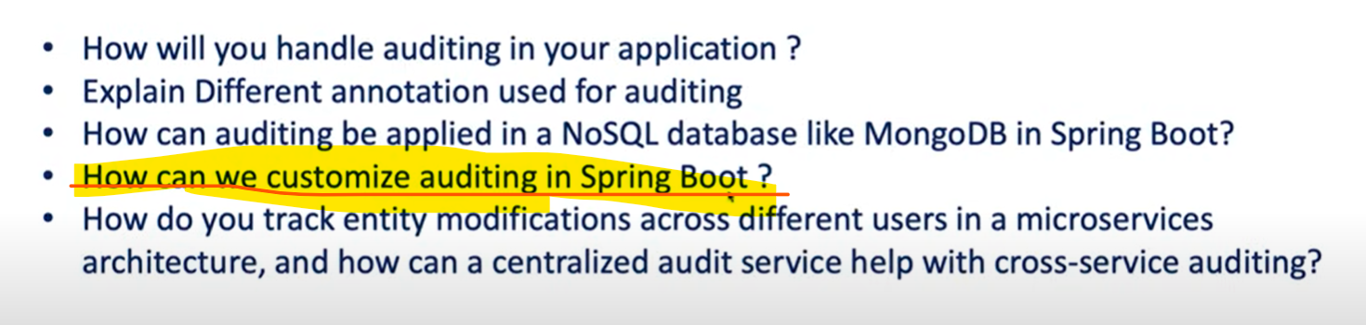

You can customize auditing by fetching actual logged in user. If your application has only 1 entity we can annotate this annotation and declared 4 attributes but what if you have 100 entities. Do I need to write all 4 attributes in all entities. No, for that you can create a BaseEntity and then let all your Entity to extends from them. So that all these 4 properties get inherited to all those entities.

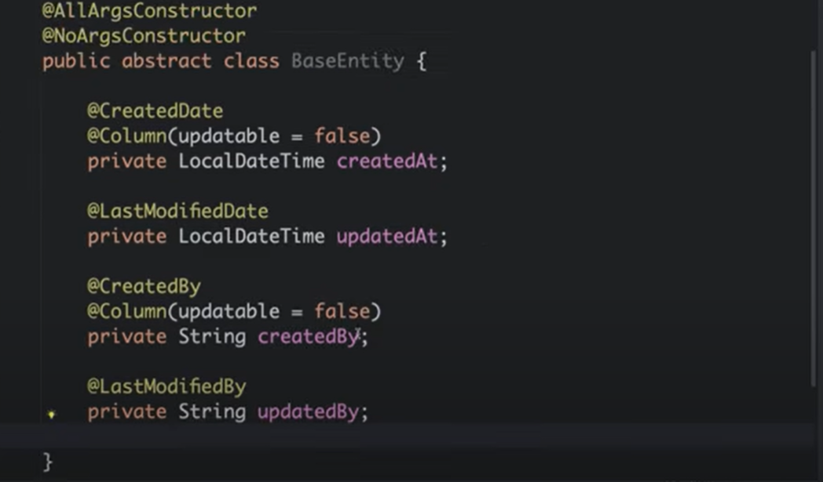

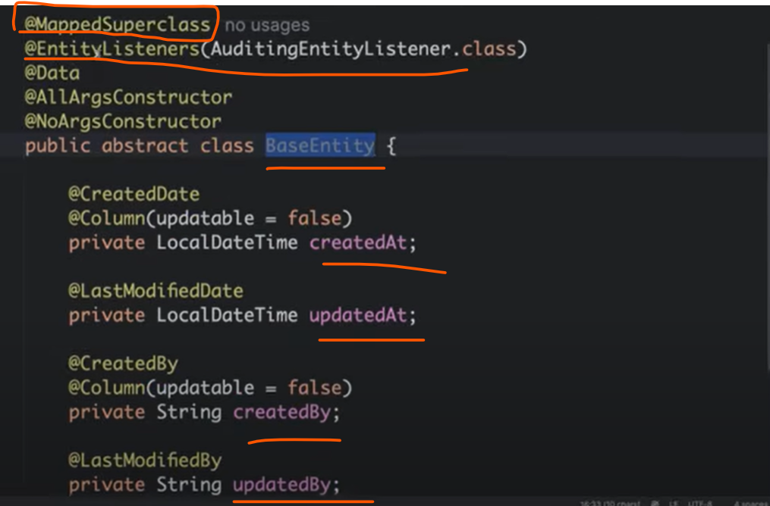

In **BaseEntity** I have used **@MappedSuperclass** the main purpose to use this annotation @**MappedSuperclass** I don’t want to create the table for Base Entity class rather I want all the properties of this particular class to be inherited to the child class who extends BaseEntity.

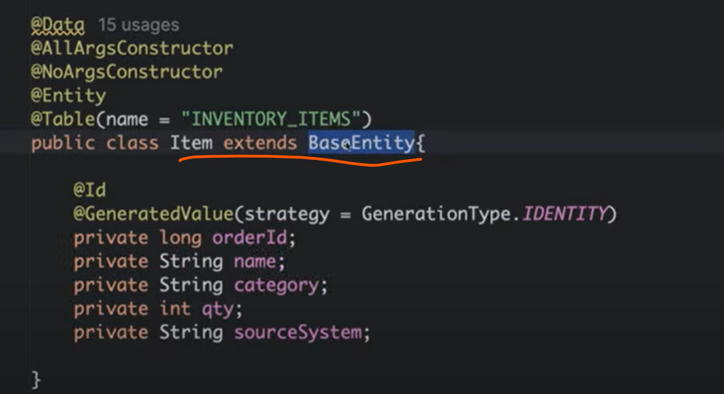

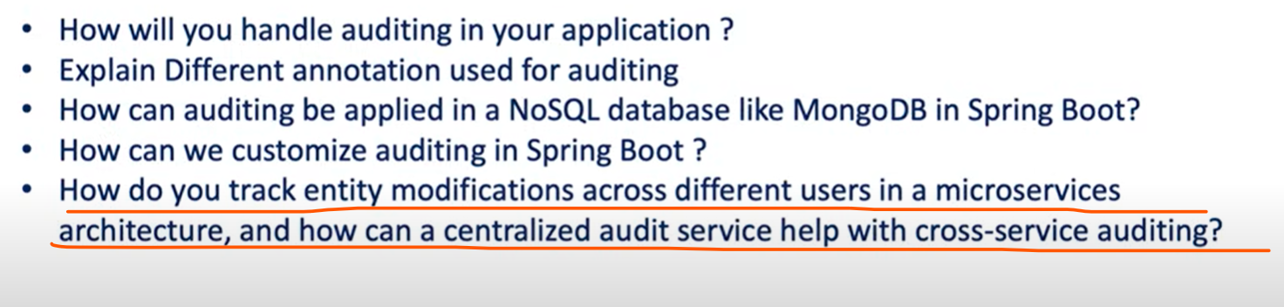

What auditing we have used you can’t implement for microservice architecture. Because microservices follow database-per-service pattern. Each microservices have their own database to use. Since all are isolated microservices so that you can go for distributed audit service mechanism or centralized audit service mechanism.

Imagine you have something called Order or name it Item and this Item can be modified by different system. It can be modified by order service, it can be modified by inventory service or dispatch service.

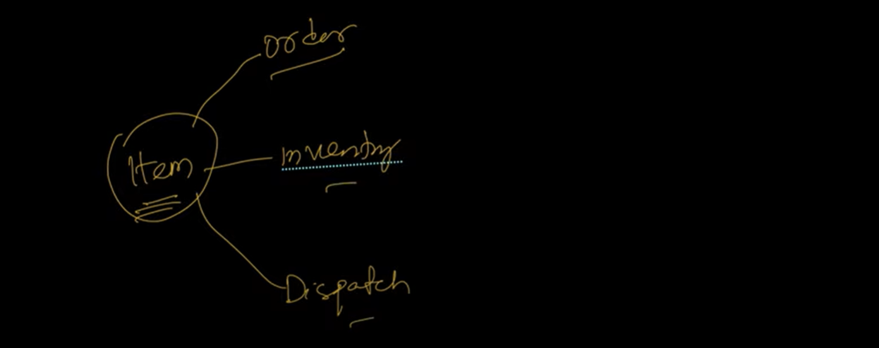

So can can you identified this Item changes is modified by which service and when it modified and what changes modified since each are individual microservices so, for that we will go for **centralized-audit-service.** This design pattern is very similar to the event-sourcing.

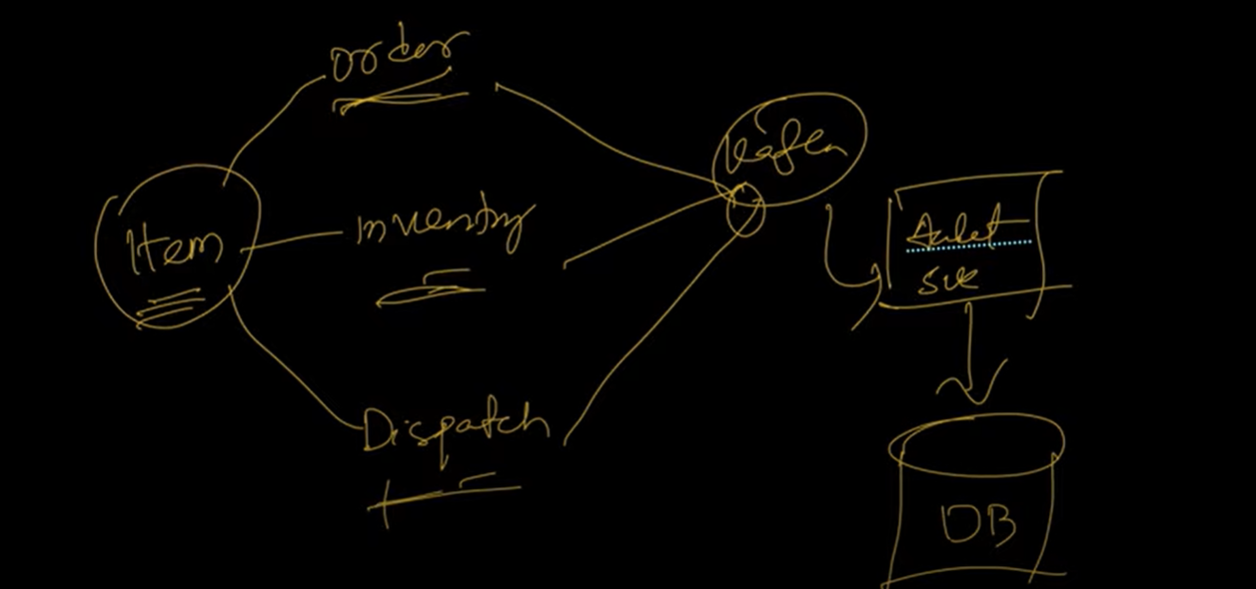

Let the order, inventory or dispatch do the changes and then simply they will published the message through Kafka now you will create one Audit Service which will listen to that event from Kafka then we will simply update the state of entity to the database.

So, this way you can track the state of your entity changes in microservice architecture.

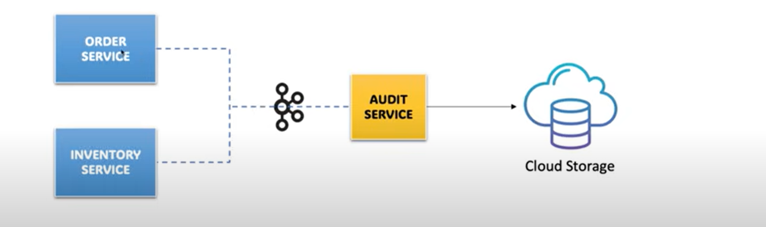

There is order or inventory service they will change the entity state event change to the kafka now we will create another service called audit service will listen to that kafka and update the data in cloud storage or database. So, the data will be looks like this.

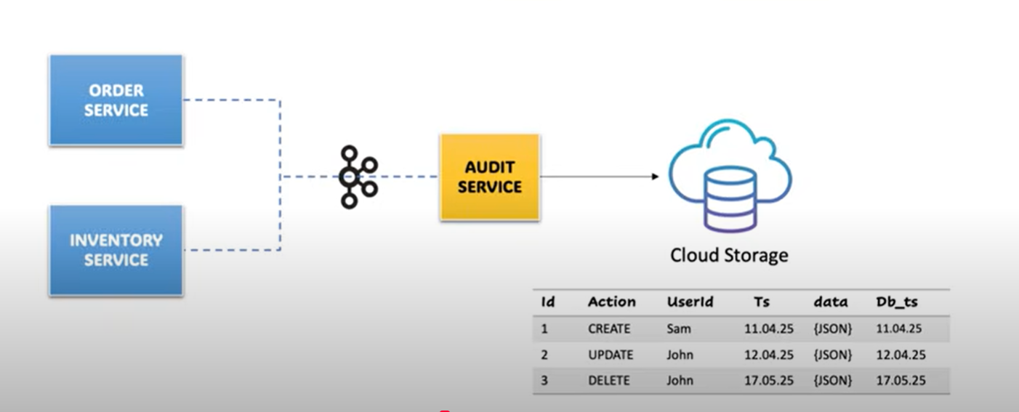

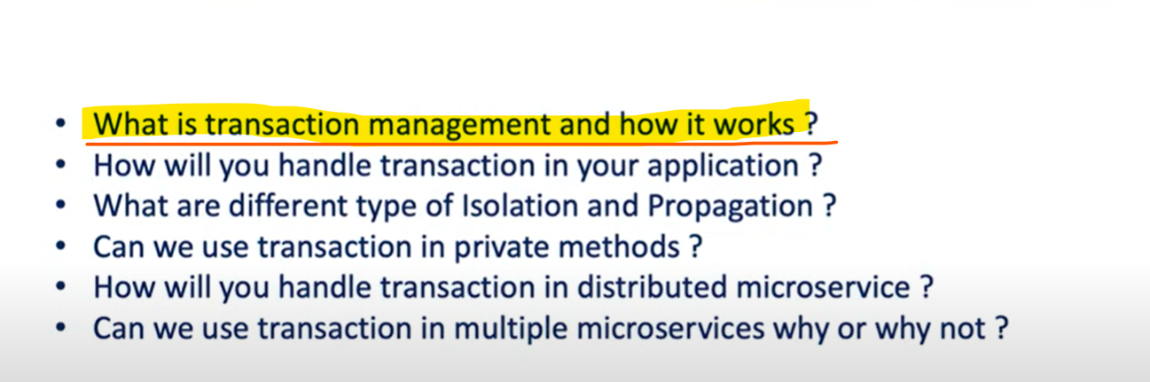

Transaction management is a mechanism to execute group of database operations in a single boundaries which will always guarantees data consistency by committing all the changes together or rolling them back entirely in case of any failure occurred.

Suppose we have an Account Service there is to account and from account. I am using hdfc other person using icici, I am transferring some amount to sam. Now when I sent the amount is deducted from my account but there is some bank issue the amount is not credit to their account so in this case revert or roll back the changes to basant account.

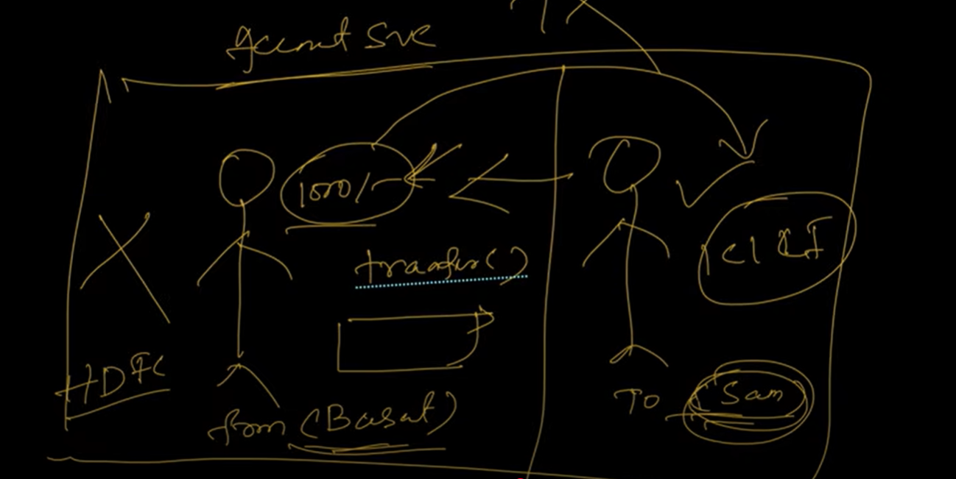

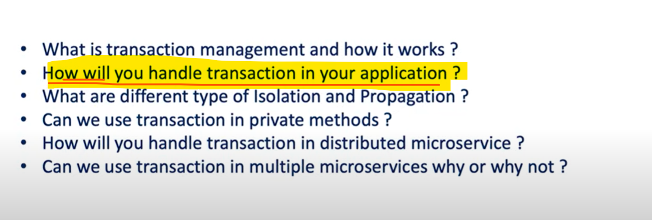

Go to that method and declared @**Transactional** and spring will be take care everything.

If all going good save everything if anything got wrong rolled back everythimg.

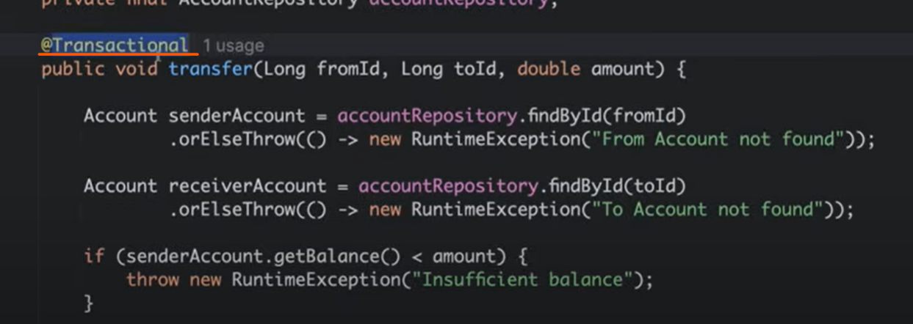

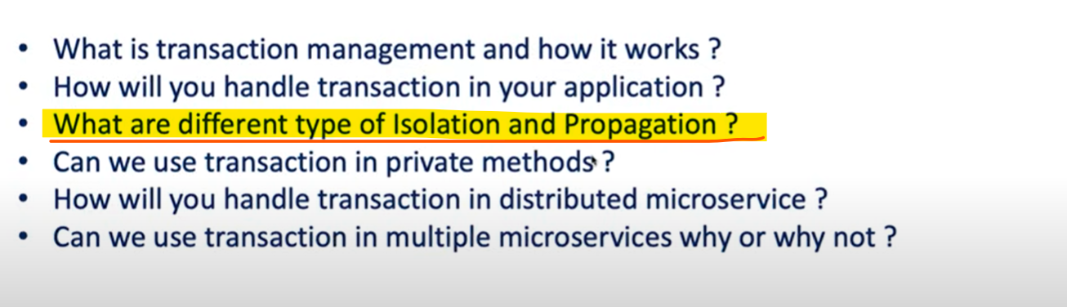

Let say you have a method bookMovieTicket() here we have implemented transaction now suppose 2 threads trying to book the ticket at same time where you have implemented the @**transactional**. Now what data this thread 1 or user 1 did the changes how you want to reflect to the thread 2. That is what you can handle using Isolation.

**ISOLATION**

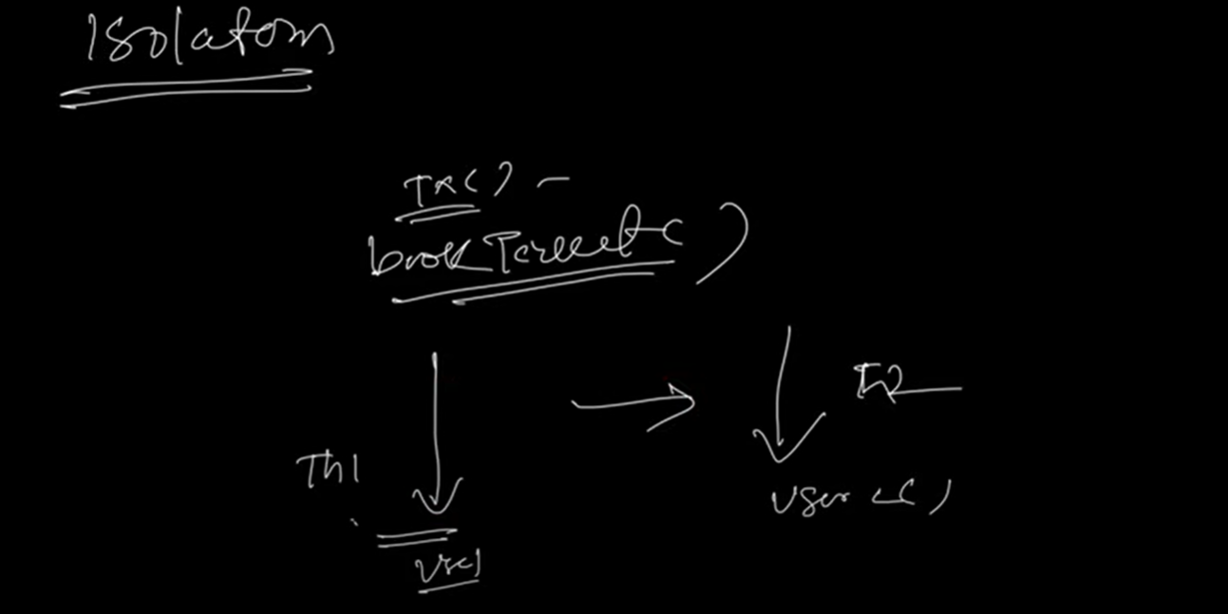

There is 10 ticket available thread 1 trying to book the 4 tickets. Now you want to display to user 2 or thread 2 like there is 6 ticket available or all 10 ticket available when they are working on the same transaction. This what you can handle using isolation.

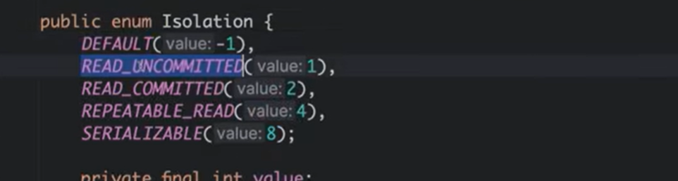

**PROPAGATION**

Propagation is something let’s say you have a method called **m1()** and you have applied the transaction here now you have another method named **m2().** Now you are calling this m2() from m1(), at m1() you have applied the transaction. Now how you want your **m2()** to behave.

In **m1()** if there is any failure do you want **m2(**) method which you called in **m1()** method to execute as it is or In **m1()** if there is any failure do you want **m2()** to be fail or rolled back everything then same for **m2().**

Now if anything goes wrong on **m2()** do you want to continue or want to roll back everything. These kind of permutation and combinations to manage the transaction methods if it is invoke inside a transaction method how you want to deal with that. That is what all abt Propagation.

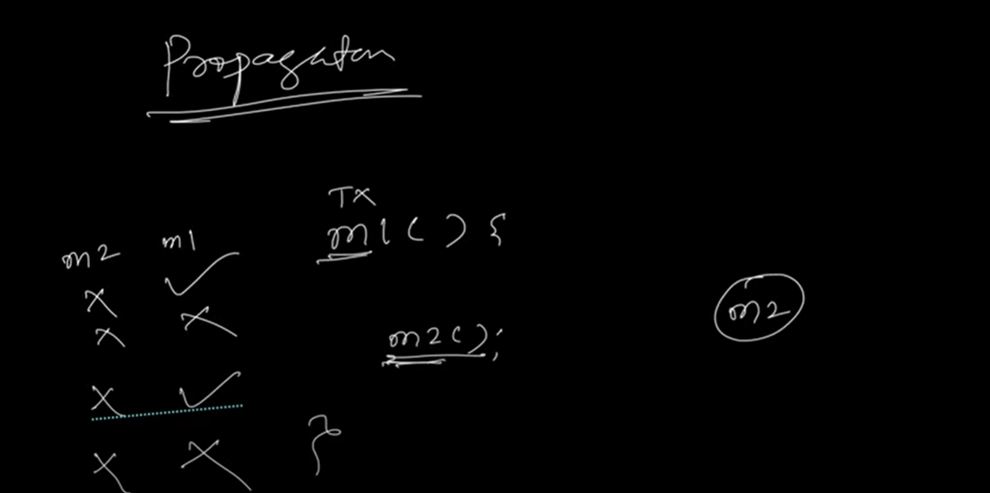

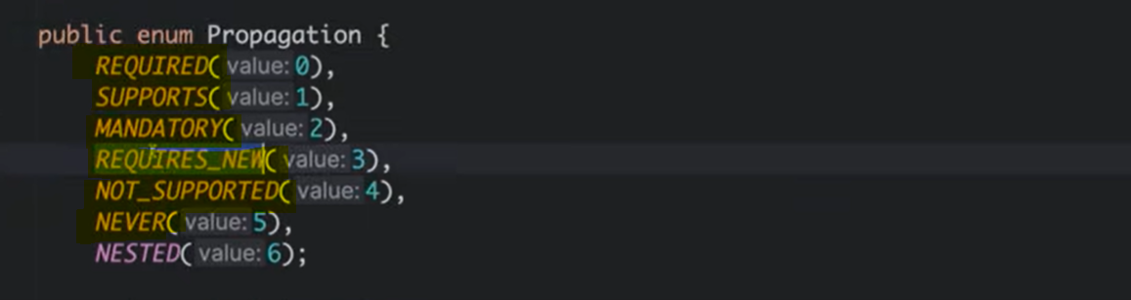

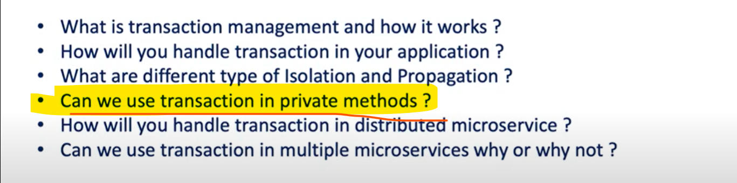

Spring Transaction will not work on private method because internally Spring Transaction will use the **AOP** (Aspect Oriented Programming) Proxy to apply the transaction on target method. But if you define a method as a private then that won’t visible to the proxy.

On High Level when you apply @**Transactional** annotation on your method how spring deal with it??

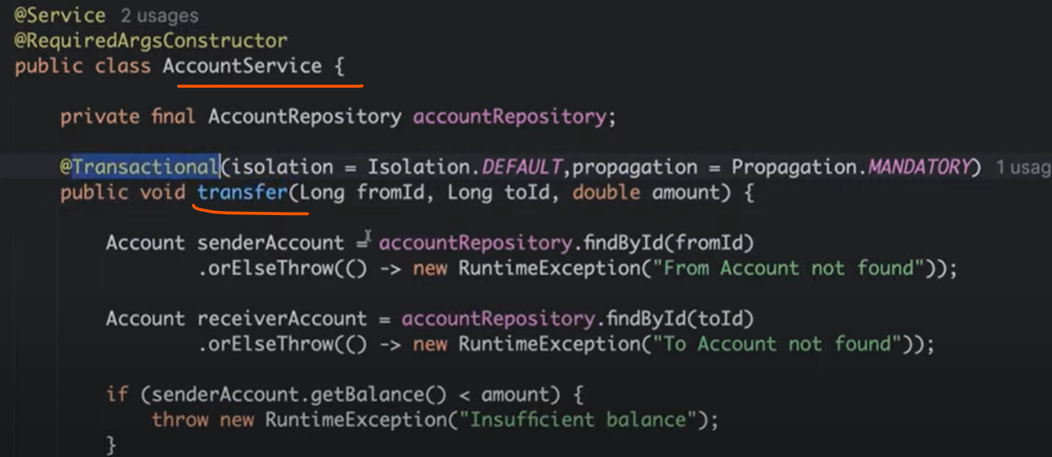

For this Account Service transfer() method you have annotated with the @**Transactional**. Let’s create a private method and apply @**Transactional**.

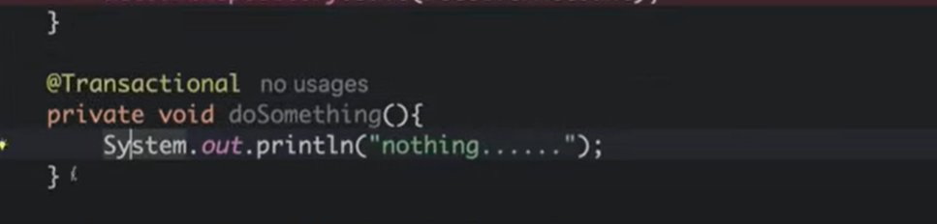

To apply transaction Spring Transaction internally use AOP Proxy so what it will does. It will create a Proxy class and extends that Proxy class with your Target class i.e your **AccountService** and override a target method() where we applied transaction. It will call the super.transfer() but before that what it does.

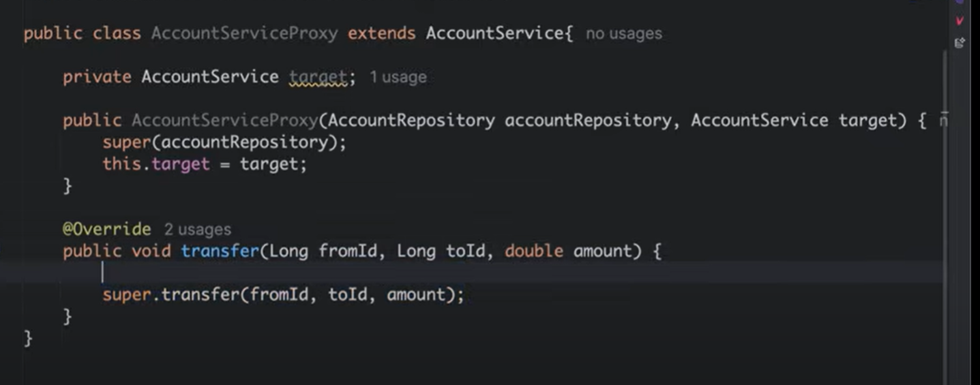

It will begin the transaction either using method **beginTransaction**() or **createTransaction**().

Then it will call your target method in a try catch block if there is any error it will simply rolledback.

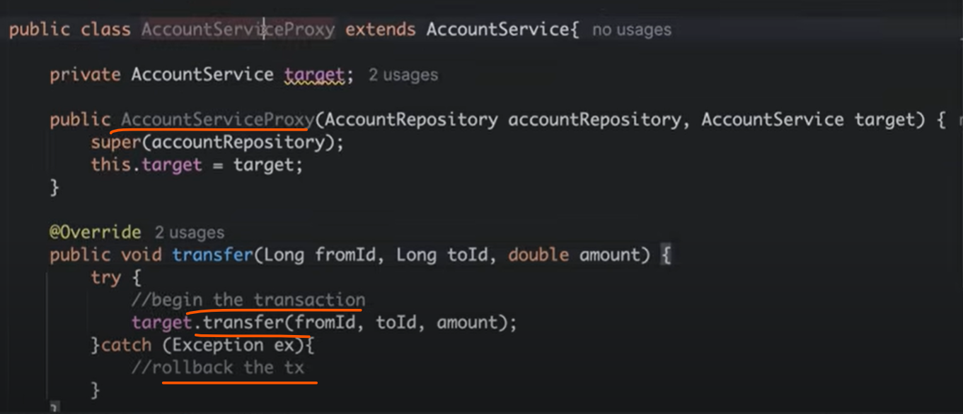

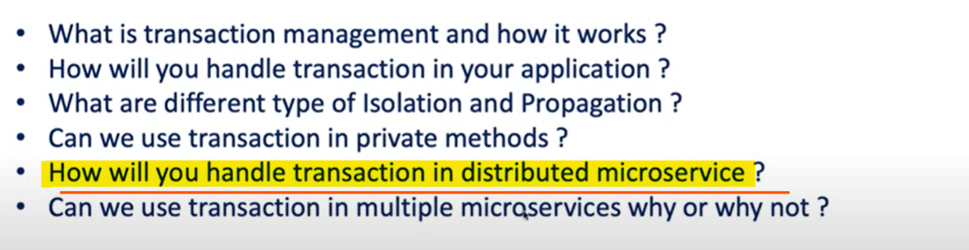

There are multiple ways, either you can go for

* **Saga Design pattern**
* **Two Phase Commit**
* **Out Box Pattern**

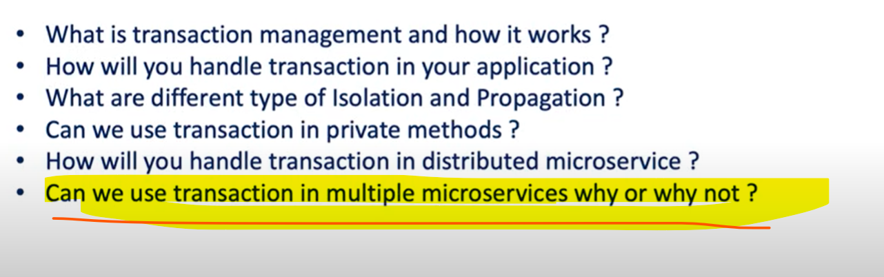

No, Spring Transaction does not work across multiple microservices. As an Order Service and Payment Service they are using their own database. Spring transaction is Local to one Application Context and one database Transaction. It will only work within a boundary of single service and single database connection. The transaction specific to the order service is boundary to this point.

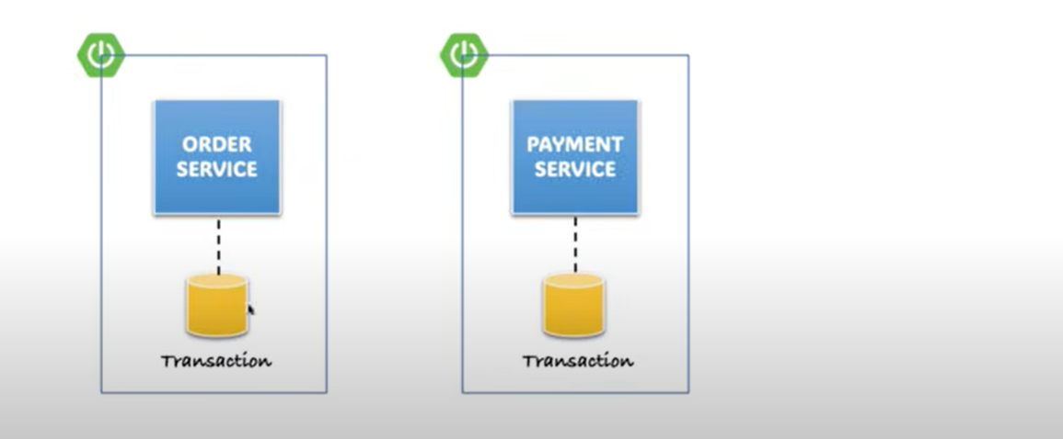

Payment service having this boundary. Order service apply transaction on their own service on his single context same for payment. Once you call another service using http or **grpc** then you are outside of the transaction boundaries.

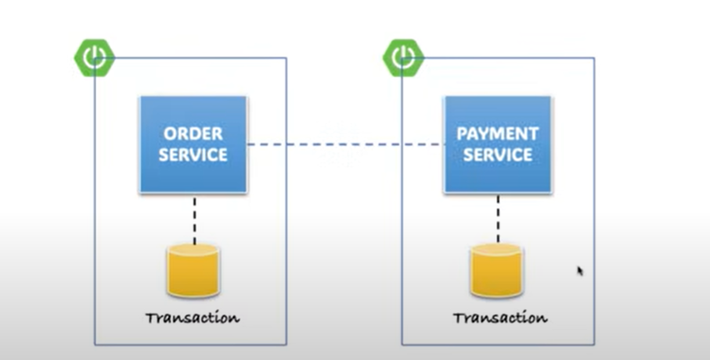

You are expecting if order service failed then rolled back to payment service which is not going to happen because both are running in 2 different transaction boundaries.